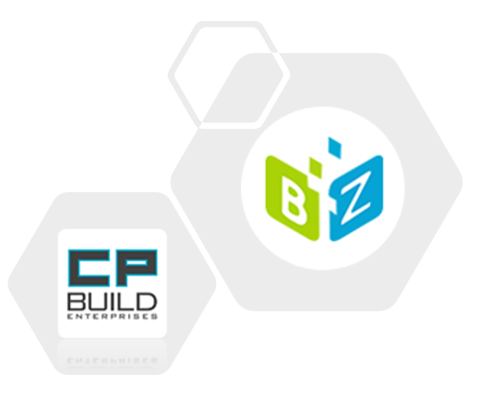

Project Scope Process

CCP USER GUIDE

Version 1.1  
November 10, 2021

|  |  |  |  |
| --- | --- | --- | --- |
| Date | Version | Changed By | Changes |
| October 23, 2021 | Version 1.0 | Maryna Nikolaienko | Original Version |
| November 10, 2021 | Version 1.1 | Keith Brickey | Published Version |

Table of Contents

USER CCP WORKFLOW 5

My Worklist 5

My Opportunities 7

My Projects 8

Additional role features 8

TEMPLATE REPOSITORY 15

REPORT 16

CCP DASHBOARDS 17

CCP HELP 18

PYDIO 19

CCP USER GUIDE 20

Overview tabs Project Scope Process 22

Form images and descriptions 22

Tab Project Scope 23

Tab SD Request 30

Tab New FDD 40

Tab Approval Notes 42

Roles 44

Task form images and instructions 44

Sales 44

5-1 Prepare or Update SD Request for Scope 44

7-1 Upload SD SOP Step 45

8-1 CA Reconciliation Meeting Step 46

16-0 SD Final Review Meeting Step 47

Estimating 49

4-0 Upload Final Takeoff by Phase Step 49

5-0 Prepare SD Request for Scope Step 50

5-2 Review and Approve SD Request For Scope Step 51

15-1 Upload RS-SOV for Scope Step 52

64-0 Evaluate Cost Changes Step 53

72-0 Upload Last-Quote for Scope Step 54

Sage admin 55

76-0 Adjust Quote for Scope Step 55

Draftsman 56

6-0 Upload New or Revised SD Step 56

7-0 Upload Draftsman SD SOP Step 57

9-0 Upload New or Revised SD Final Step 58

17-0 Upload Final Takeoff by Phase Step 59

RFMS Admin 61

74-0 Update SL for Scope Step 61

PM 62

3-0 Upload Phase Plan Step 62

7-1 Upload SD SOP Step 63

8-0 SD DRAFT and SD SOP Review Meeting Step 64

52-1 Orders Field Verification Step 65

52-3 Review Field Verification Step 66

52-4 Notify Customer Step 67

64-1 Send CO Quote to Customer Step 68

64-2 Get Customer Response Step 69

14-0 Review SD Final Step 70

15-2 Upload Phase Plan Step 71

16-0 SD Final Review Meeting Step 72

18-1 Set Spares in Consolidated PO Setup Step 73

19-0 Cost Review Meeting Step 74

PC 76

82-0 Start or Update Procore Submittals Step 76

8-2 Send SD to Customer Step 77

8-3 Indicate SD Customer Response Step 77

15-0 Send SD for Customer Record Step 79

18-0 PO Setup by Phase Step 79

Installation Supervisor 81

52-2 Field Verification Step 81

SD Auditor 82

65-0 SD Audit Step 82

Commercialization Lead 83

18-0 PO Setup by Phase Step 83

Project Scope Process General Schema 84

Designations on the diagram 85

# USER CCP WORKFLOW

This article provides a user guide for the CCP Process that uses the K2 Five application framework. The CCP application consists of two desktops:

• CCP Workflow

• Configuration Management

In the upper right corner of the header, there is a drop-down list for selecting a desktop. The left menu items and dropdown items are limited to limit visibility to selected role members.

### My Worklist

The main working window consists of three parts:

* at the top of the window, the "header" displays the username, and displays basic information about the current task

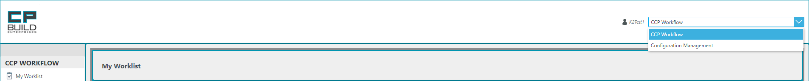

* on the left side, there is a menu with options available to the current user. In this section, we will look at working with the CCP Workflow.

The CCP Workflow user menu consists of seven sections: CCP Workflow; Template repository; Report; CCP Dashboards; CCP Help; Pydio and CCP User Guide.

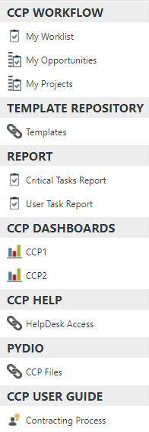CCP Workflow

- The *My Worklist* contains Worklist Item records that each represent a task assigned to the user.

- On the *My Opportunities* item, there are eight tabs, each tab named as one of the opportunity status stages and shows existing opportunities.

*- My Projects* item have two tabs, which shows projects with Contract Negotiation or Closed Won contract status, respectively.

Template repository

- The current subsection contains templates for all uploaded documents of the entire process

Report

- *Critical Task Report* - displays a general report for all tasks, divided by processes.

- *User Task Report* - offers an option to select tasks for any user / role

In the future, this menu can be supplemented with other types of reports.

CCP Dashboards

- On the *CCP 1* item, there is a form with dashboard, which provides information about existing user tasks, sorted by opportunity status.

- Form on the *CCP 2* item shows short information about tasks sorted by contract status.

CCP Help

-Help Desk Access will redirect you to Bytezoom Help Center, where you can submit a request or report a problem.

Pydio

*-* You will be redirected to the Pydio page, where you can open your personal folder.

CCP user guide

- There are links to documents providing training on the use of this system

* In the central part of the work area, current tasks by process which direct the workflow of the launched task are displayed.

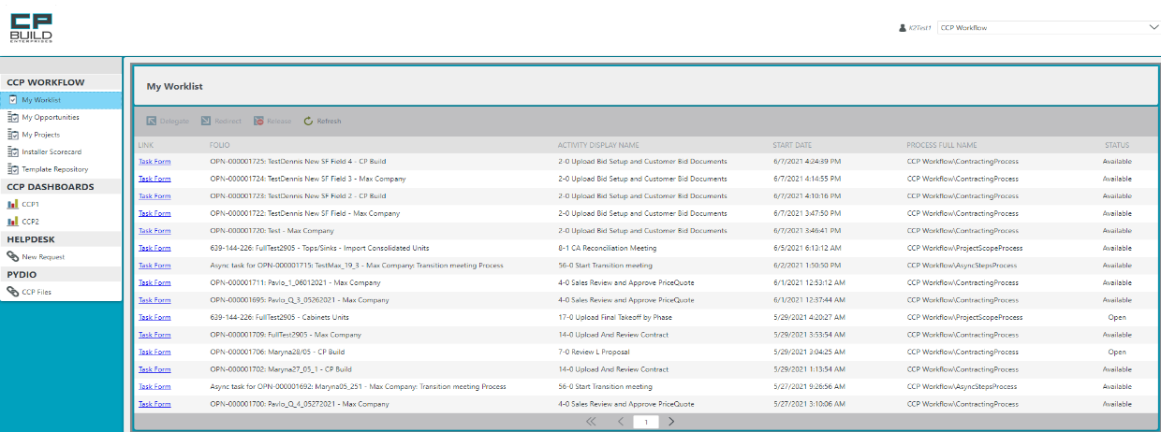

Allocated User is displayed here

At the My Worklist tab, find required task and click on Task Form LINK to open the form.

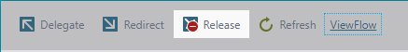

- To add another user to the execution of the current Task, select the Task you are interested in, click the *"Delegate"* button and in the window that opens, you need to enter the name of the desired user and click the "Select" button.

- To redirect the task, select the task you interested in, click on the *“Redirect”* button, in the window that opens. You then need to enter a username and click the Select button.

- To release the task, select the task you interested in, click on the *“Release”* button. Another user can then perform this Task.

- To refresh the list, click *“Refresh”.*

- Select required task and “*View Flow”* button will show up. By clicking on this button, the User will see the All Workflow.

*Screen shot - CCP Workflow – My Worklist*

### My Opportunities

On the My Opportunities item there are eight tabs: All, Qualification, Estimating, Proposal, LOI, Contract Negotiation, Closed Won, Dead and Closed Lost. On the All tab, we can see the following data: Opportunity name, Opportunity number, Activity, Recipient, Sales owner, FDD, Stage, Customer, Probability, Type, Created and Updated. All other tabs will display the Tasks with the corresponding Title Stage.

*Screen shot - CCP Workflow – My Opportunities*

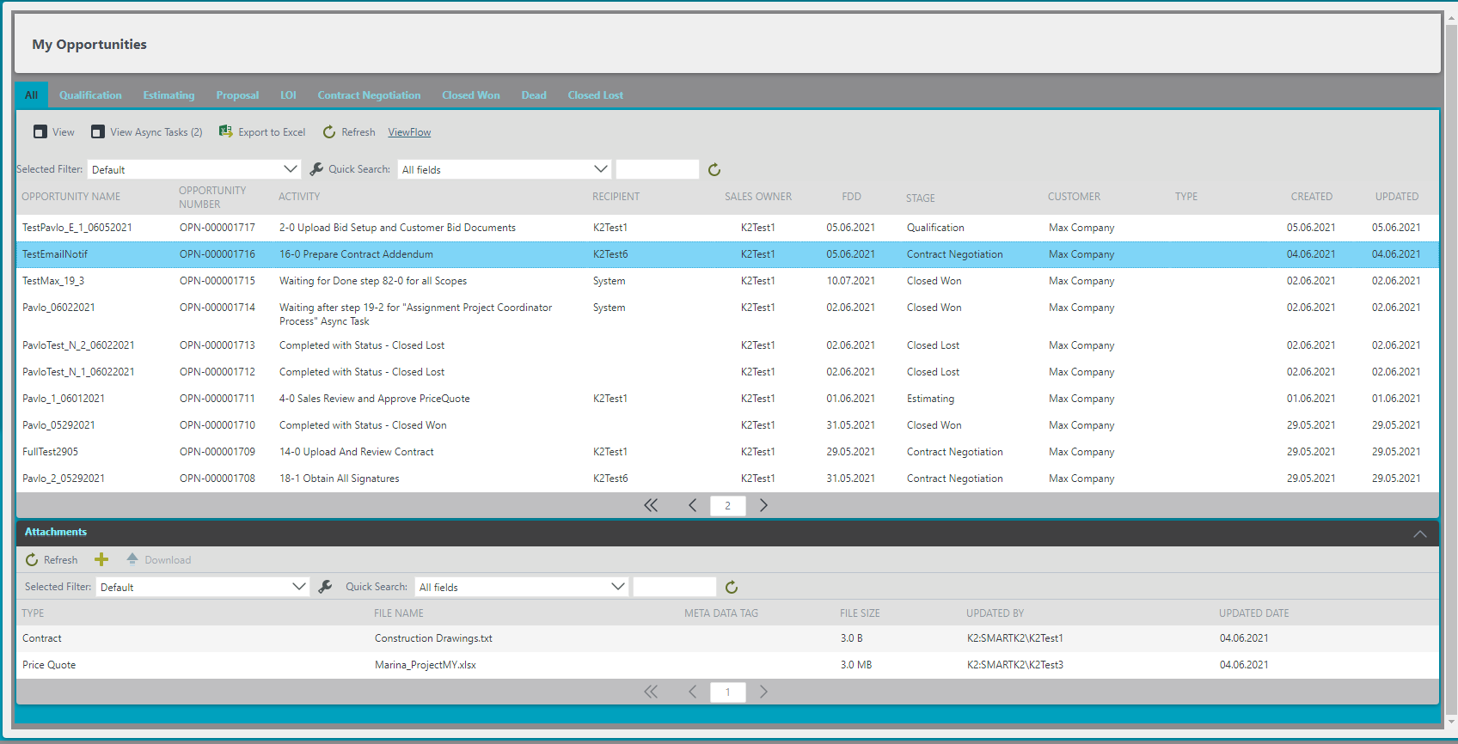

Each tab is named as one of the Opportunity status stages and shows existing tasks, which have status as on the tab name.



To see the corresponding information, the user must select the Opportunity line

- To see the Opportunity Details, click on the *"View"* button.

- To view the Async Tasks for the current Opportunity, click the *"View Async Tasks"* button.

- The *“SD Request”* button can be used to start the SD Request process

- The “*Kill”* button will offer to transfer the Opportunity to the Close-Lost or Dead-New status in the window that opens.

- You can also use the entire opportunities list *Export to Excel* by clicking the corresponding button.

- To refresh the list of opportunities, click the *"Refresh"* button.

- When you click on the required opportunity, the *View Flow* button appears, and the user can see the workflow of the opportunity.

To quickly find the file you need, you can use the filter command line



When the user clicks on the opportunity row, at the bottom of the page the Attachment view appears view with Attachments that have been added to the selected opportunity. The Toolbar contains buttons for:

* *“Refresh”* the list of uploaded documents.
* *“Add”* a new document to Attachments.

- *“Kill”* button will offer to delete the uploaded document for the current process

* button for “*Download*” the required document.

### My Projects

The My Projects item has three tabs, which show project forms with All, Contract Negotiation or Closed Won contract status, respectively.

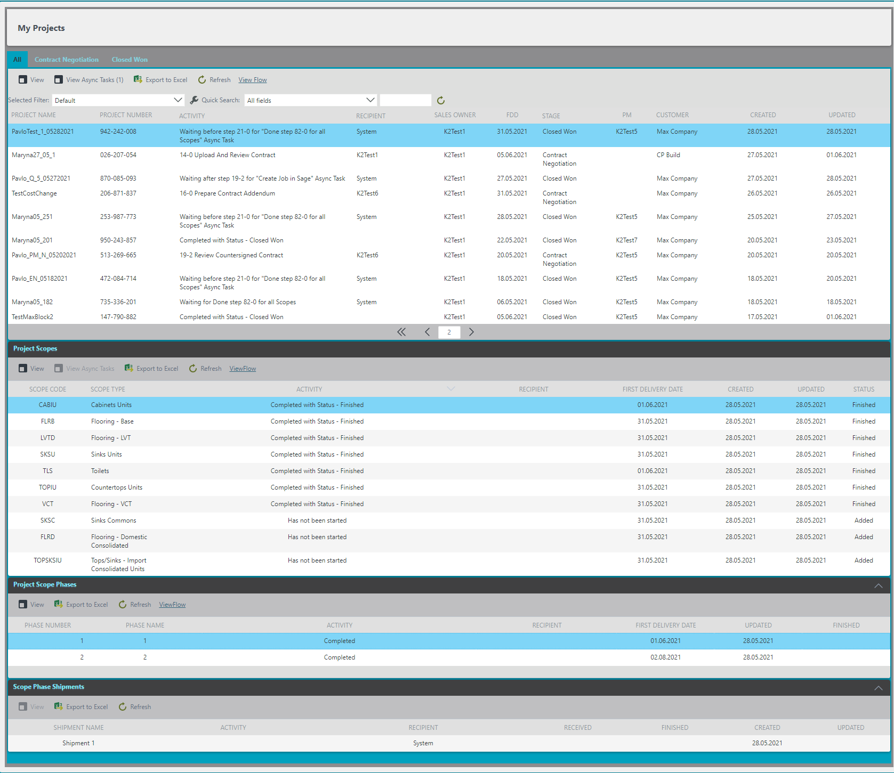

When the user clicks on the Phases row, the Scopes Phases Shipments view appears, where user can see the Shipments.

After the user clicks on the Scope row appeared Project Phases view, where user can see the Phases.

When the user selects the Project row appeared Project Scopes view, where user can see Scopes.



To see the corresponding Project information, the user must select the Project row

- To see the Project Details, click on the *"View"* button.

- To view the Async Tasks for the current project, click the *"View Async Tasks"* button.

- The *"*Contract Review*"* tool allows you to create and upload a checklist for the selected project and make changes to these checklist parameters.

- The *"SD Request"* button can be used to start the SD Request process. And viewing

- The *"New Project Coordinator"* button initiates the process of appointing a new project coordinator

- The *"New Project Manager"* button initiates the process of appointing a new project manager

- You can also see the entire Projects list *"Export to Excel"* by clicking the corresponding button.

- To refresh the Projects list, click the *"Refresh"* button.

- When you click on the required project row, the *"View Flow"* button appears, and the user can see the workflow of the Project.

To quickly find the file you need, you can use the filter command line

*Screen shot - CCP Workflow – My Projects*

### Additional role features

#### View Async Task

While working with an Opportunities or Projects list, you will see similar messages - “Waiting after step 19-2 “Create Job in Sage” Async Task” - in Activity on the My Opportunities, My Projects tabs. This means that a started asynchronous step blocks further progress of the process and must be closed.

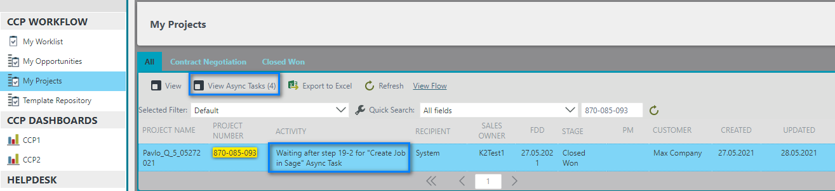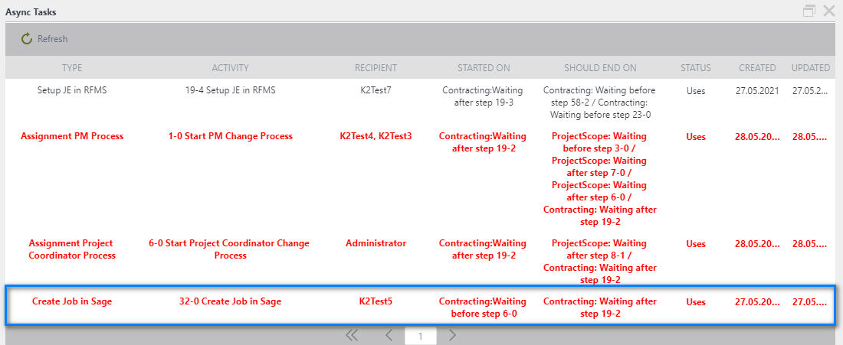

After closing one of the asynchronous tasks, you can click the Refresh button to refresh the page of both the pop-up window and the main one, after which you can see the name of the next blocking step

Blocking Async Tasks are highlighted in red. If several Async Tasks are selected in this way, priority will be indicated in the activity of the main Task

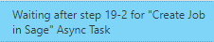

*Screen shot - CCP Workflow – Button View Async Tasks*

#### Upload file in the Attachment list

When adding a file using this method, an additional window opens.

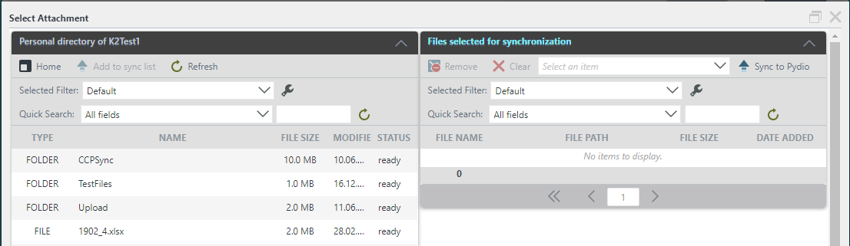

To return from a folder, click the *Home* button on the toolbar. To load the selected document, click the *Add to sync list* button (or double-click the left mouse button on the required file). Files in a personal folder can have two statuses: "Loading" and "Ready". At the first status, file synchronization is impossible, you must wait for the "Ready" status. To update the File Status, use the *Refresh* button.

To remove the selected file from the synchronization sheet, click the *Remove* button on the toolbar. To completely clear the sync sheet, click the *Clear* button; to upload the file as an attachment, select the Type of Document (*Select an item*) from the dropdown list and click the *Sync to Pydio* button.

To quickly find the file you need, you can use the filter command line.

***To add new attachment to Attachment’s view:***

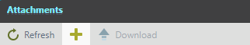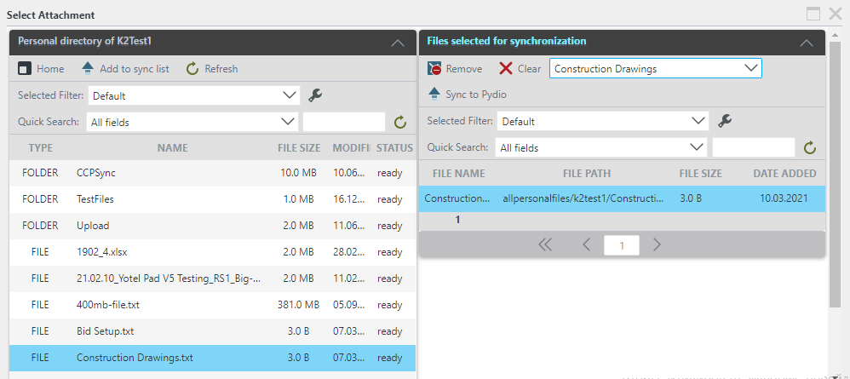

1. Select required file or folder from the Personal directory and click on *Add to sync* list button.

3. Files will appear in the Files selected for synchronization view.

4.On the Files for synchronization, view select from drop-down list file type.

5. Click on *Sync to Pydio*.

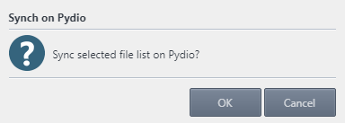

6. After clicking Sync to Pydio Click the *OK* button in the message box and a new file will appear in the Attachments list.

1. Click the button in the toolbar and an auxiliary form will open.

#### New Project Coordinator

The Project Coordinator Manager can initiate the New Project Coordinator assignment process using the New Project Coordinator button on the My Project menu.

*Screen shot - CCP Workflow – My Projects- New Project Coordinator*

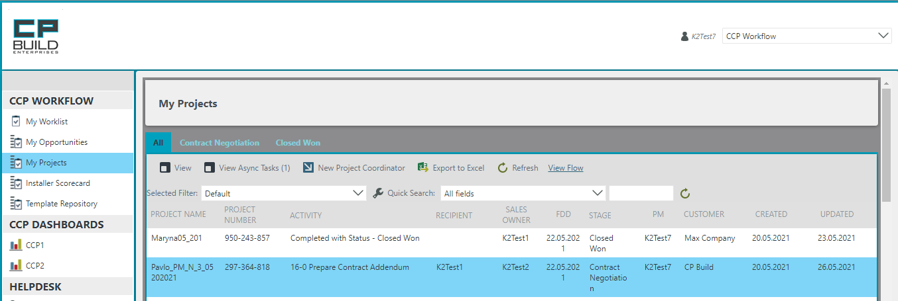

1. To do this, in your CCP Workflow, select the My Project menu and in the Project list, highlight the required Project.

2. After that, the New Project Coordinator button will become available in the Toolbar

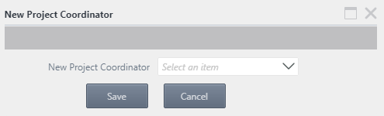

3. After that, a dialog box will appear in which the drop-down list New Project Coordinator will be offered

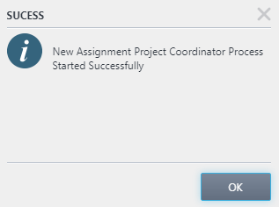

4. By clicking the Save button, a dialog box will appear confirming the successful completion of the action

#### New Project Manager

The Operations Manager can initiate the New Project Manager assignment process using the New Project Manager button on the My Project menu.

*Screen shot - CCP Workflow – My Projects- New Project Manager*

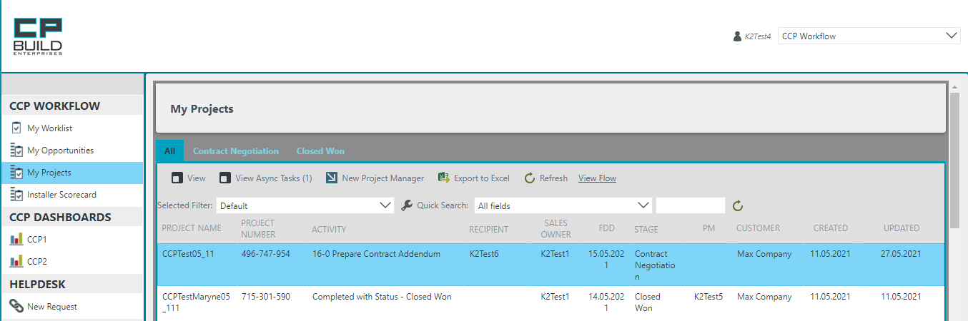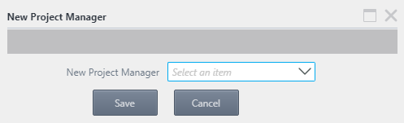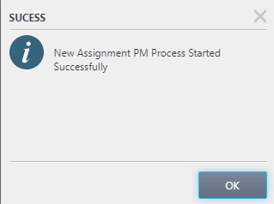

4. By clicking the Save button, a dialog box will appear confirming the successful completion of the action

1. To do this, in your CCP Workflow, select the My Project menu and in the Projects list, highlight the required Project.

3. After that, a dialog box will appear, in which the drop-down list New Project Manager will be offered

2. After that, the New Project Manager button will become available in the Toolbar

#### SD Request Form

For each Scope in the Project for which the SD is required, a Shop Drawing Form is displayed in a separate area. There are three scheme types for the SD Form, depending on the Scope: 3D Cabinets, 2D Flooring, 2D Countertops, 2D Bath and 2D Mirrors.

The SD Request form consists of three separate areas: a Project Information, Document Needed and Shop drawing form for each Scope. There are two role users who will work with the SD Request Form: Estimator and Sales, which are assigned to the current project. The estimator is the first to fill out the form and can start the SD Request process using the "SD Request" button on the My Project menu.

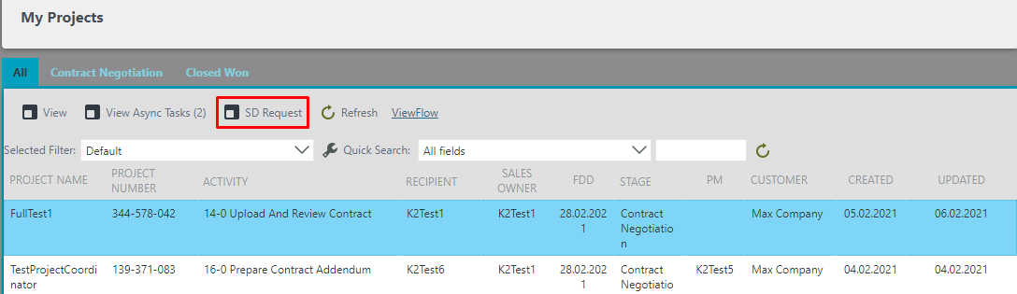

After filling in all the fields to start the process, use the Start SD Request Process button.

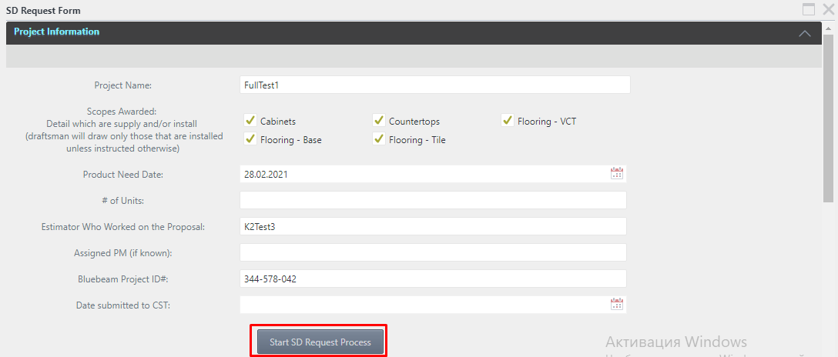

At the same time, the estimator has an unlimited possibility of editing and saving the form before starting the process. After starting the process, the form moves through the workflows and gets into the work of the Sales. Other users can see the form, only after the start of the SD Request process in read mode using the same "SD Request" button on the My Project menu. The SD Request form is also available in the separate steps of the Project Scope Process in the tab «SD Request».

#### Contract Review

This button is only available for the Sales Owner role in My Project menu.

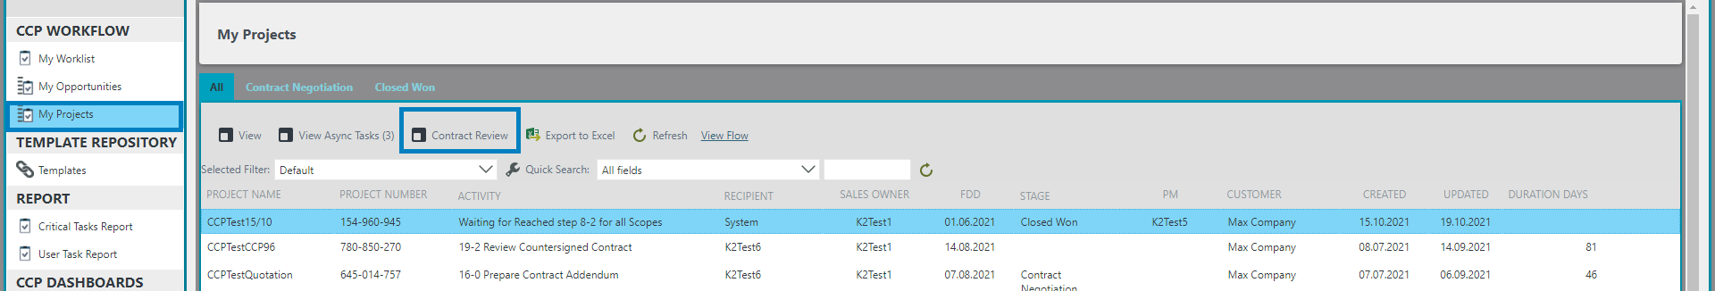

When you click on the "Contract Review Checklist" button, a window opens in which the current checklist for the project is displayed filled with the latest saved data.

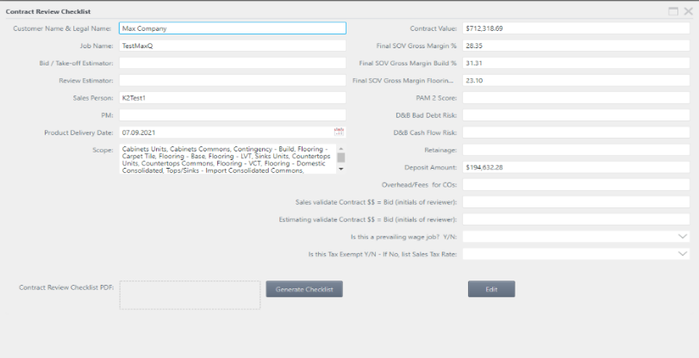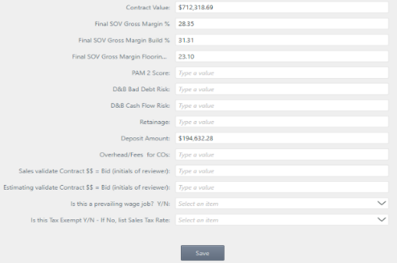

*Screen shot - CCP Workflow – My Projects- Contract Review Checklist*

The user can, by clicking on the "Edit" button, make corrections to the data in the checklist, "Save" them and, if necessary, generate "Contact Review Checklist PDF".

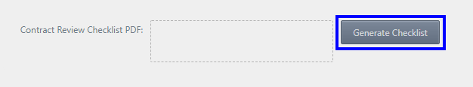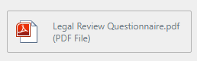

After loading, the document will look like

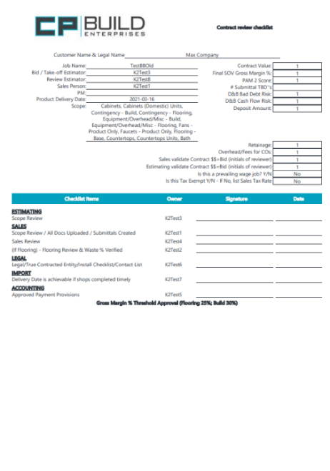

If in the future, the loading of the C-file, CA-file, or RS-file with data differs by a certain percentage set in the configuration by the Administrator, this user will receive messages about data inconsistency.

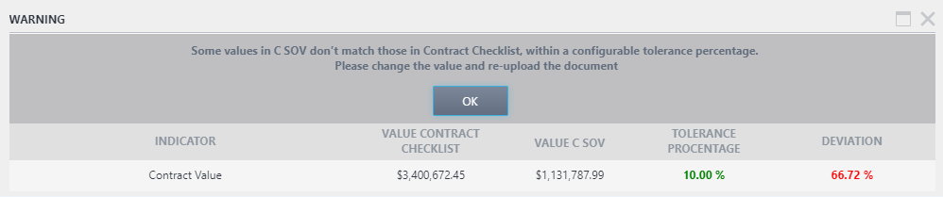

To continue working, you will need to make changes to the current file or correct the data in the checklist by clicking the "Contract Review Checklist" button for this process.

#### Change FDD

This button is only available for the PM role in the My Project menu for Project Scope.

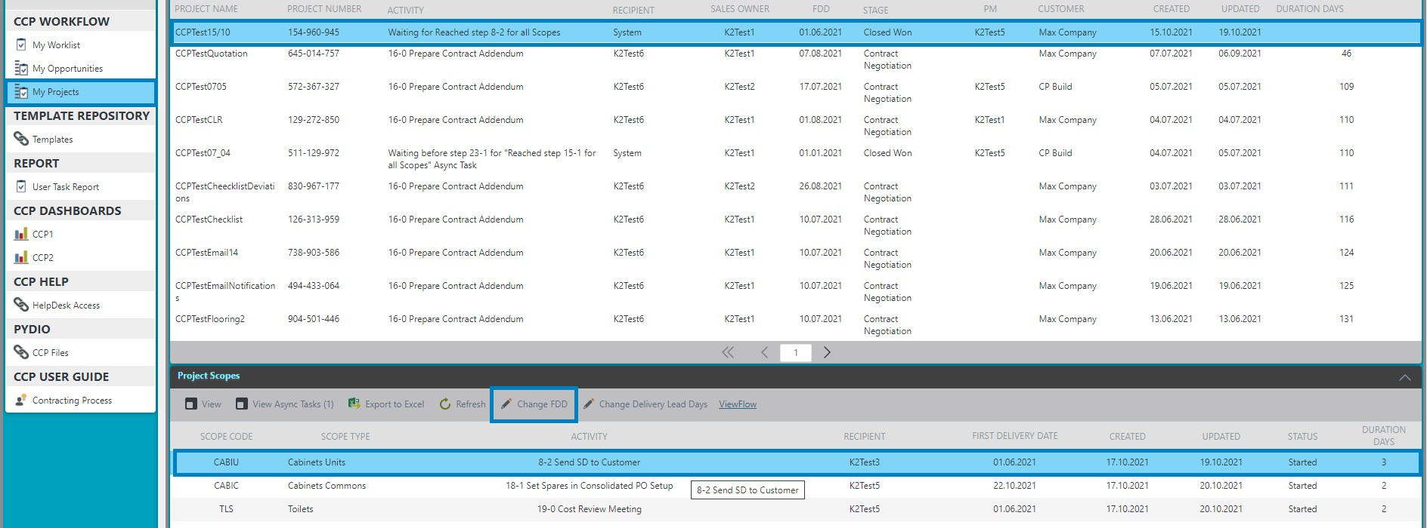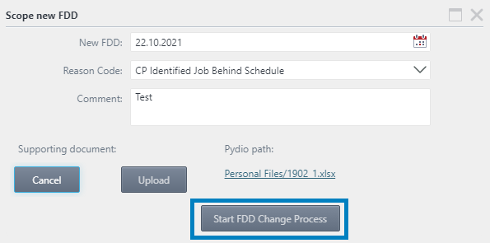

When you have selected the required Scope process, click on the Change FDD button. A pop-up window Scope new FDD will then open, which will need to be filled in. After filling in all the data and uploading the files, click on the Start FDD Change Process button. After that, the window can be closed and you can wait until the change date is confirmed.

The further solution of this process is described in more detail on the New FDD tab.

#### Change Delivery Lead Days

This button is only available for the PM role in My Project menu for Project Scope.

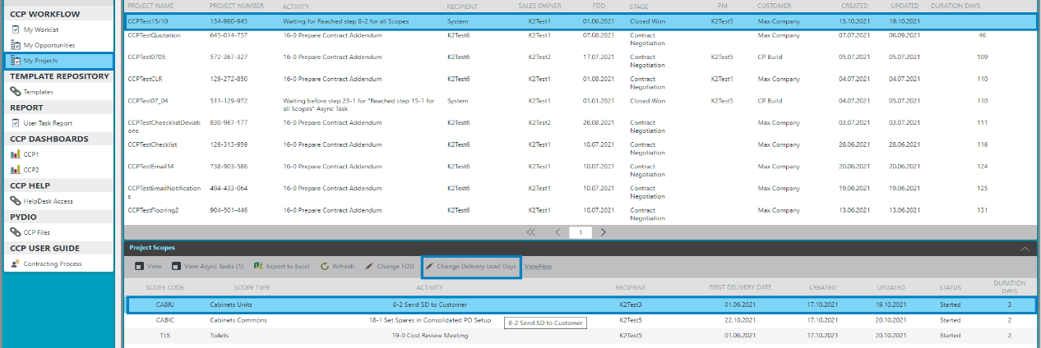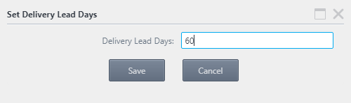

To change the new Delivery Lead Days value for a specific Scope, you need to leave Scope, click on the button in the Change Delivery Lead Days menu toolbar and set the required value in the pop-up window. Then click the Save button.

#### Filtering

On the CCP Workflow the User can use different filtering and quickly search for the project that they are interested in. The User can use filtering by default or configure their own filtering.

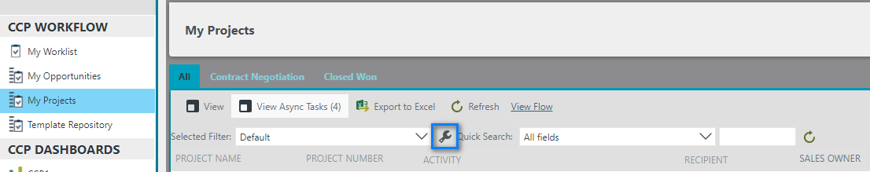

In order to customize the filter for yourself Press the “Configure” button, after which the subordinate form “Configure User Filters” will open.

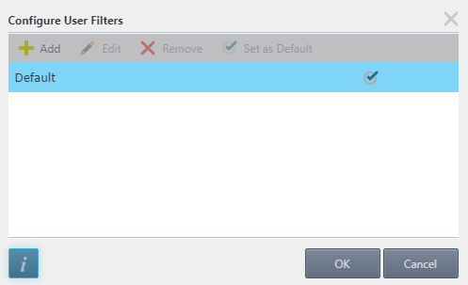



- To add a new filter, click the *“Add”* button.

- To edit a filter, select the one you need and click the *"Edit"* button.

- To remove a filter, click the *“Remove”* button.

- To use a filter every time, select the filter you want and click the *"Set as default"* button.



- The button will open the support page.

- If you want to save your changes, click the “*OK”* button in the sub form.

- By clicking on the *"Cancel"* button, you will lose all settings

*Screen shot - CCP Workflow – Configure User Filters*

After clicking on the Add button on the Configure User Filters sub-form, a new Configure User Filters sub-form will open. There are two tabs on the Configure User Filters sub-form: Filter, Sort.

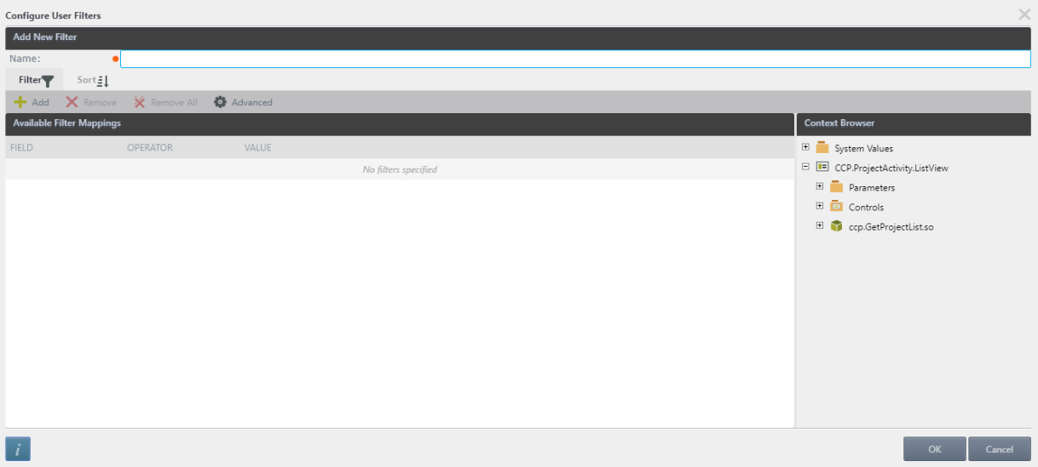

Enter the filter name and then configure filtering.

On the Filter tab



- *"Add"* button to create new rules

- *"Remove"* button to delete single selected rule

- "Remove All" button to delete all rules

- *"Advanced"* button to more difficult filter configures.

On the Sort tab



- Click on the *“Add”* button to add sort column, select required column from the drop-down list and select sort order.

- To delete single sort rule, choose one and click on the *“Remove”* button.

- To delete all sort rules, click on the *“Remove All”* button.

- User can choose the order of sorting using *“Move up”* button to lift up the rule or *“Move down”* button to let down the rule.

*Screen shot - CCP Workflow – Configure User Filters*

# TEMPLATE REPOSITORY

This menu displays all available templates for uploads. Determine the type of template by the value of the File Type field. Download it by left clicking on the link (document name in the TEMPLATE NAME column).

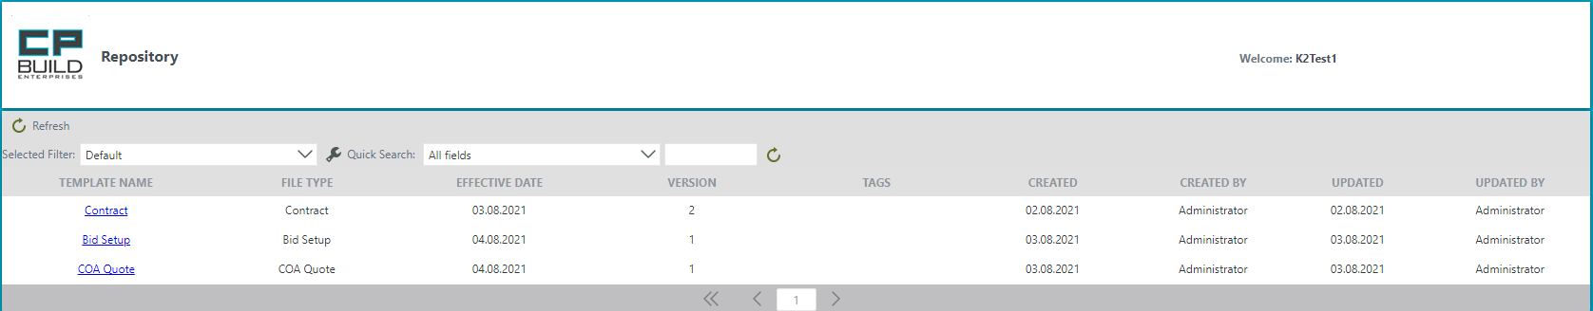

When working at any stage of uploading documents, there is a link icon with which you can download the required document template.

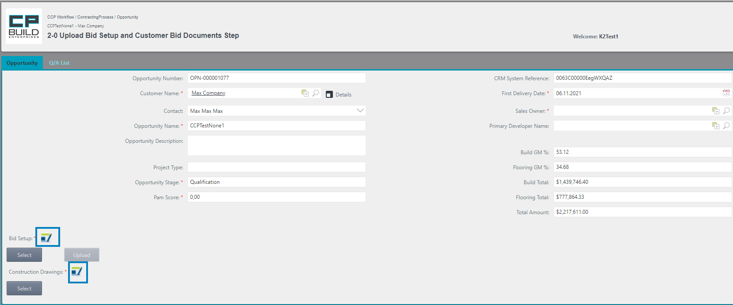

If there is no template for this document, the system will display a message

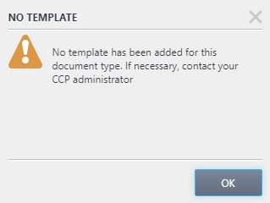

To add the required template, contact your administrator.

# REPORT

This area contains reports (the number of which may be replenished in the future).

* + - * Critical Tasks Report displays all active tasks for all users by default sorted by the duration of days from the moment the task was started. The report is divided by process tabs. For each process, the fields Folio, Step, Allocated User, FDD, Sales Person, Project Manager, Project Coordinator, Install Manager, Probability (only for Contracting Process), as well as Start Date and Duration Days are available. 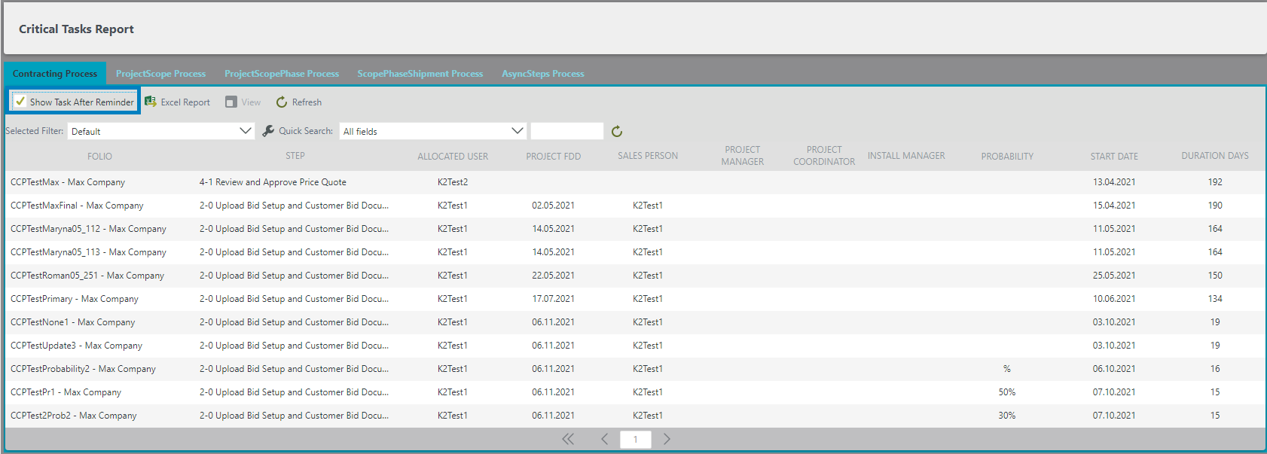

*Screen shot - Report – Critical Tasks Report*

When the Show Task After Reminder checkbox is set, only tasks for which a reminder was sent are displayed. It is possible to export the report in Excel, as well as view each task separately using the View button. The task form will open in a separate window.

* User Task Report displays all tasks for all users with the Allocated User and Role filters set. Any of these filters can be set to zero, in which case the list will not use this value for filtering. To display the results after setting the filter values, click the Show button.

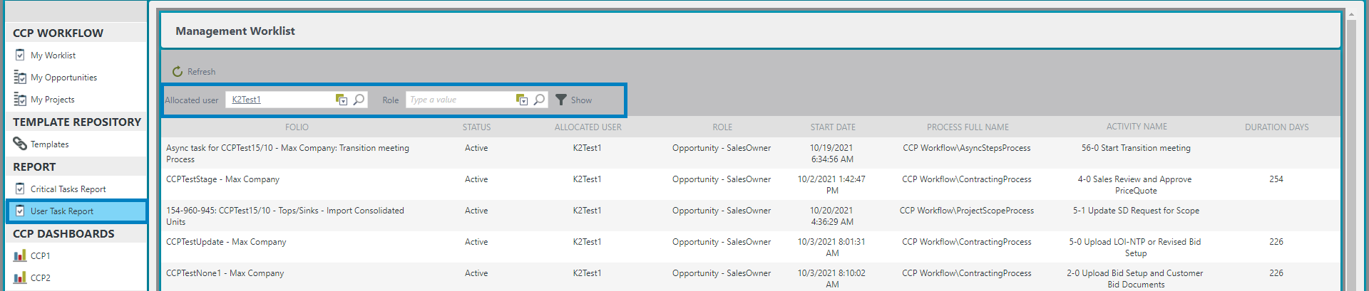 *Screen shot - Report – User Tasks Report*

# CCP DASHBOARDS

There are two dashboards in this section:

* The first dashboard of the CCP1 Pipeline displays information on projects that are distributed for execution by the current user, according to the location of the Stages and Closed Lost processes.

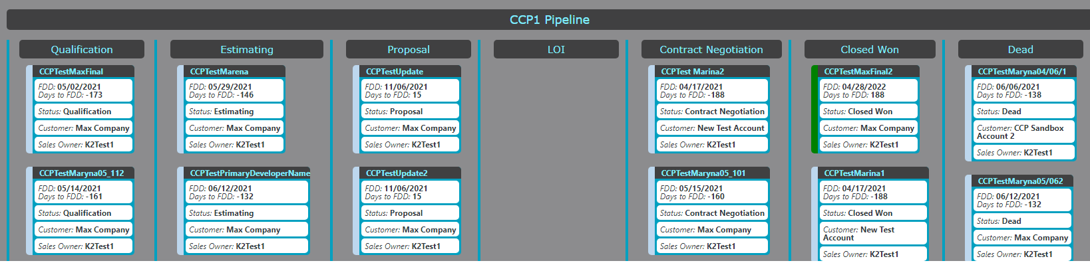

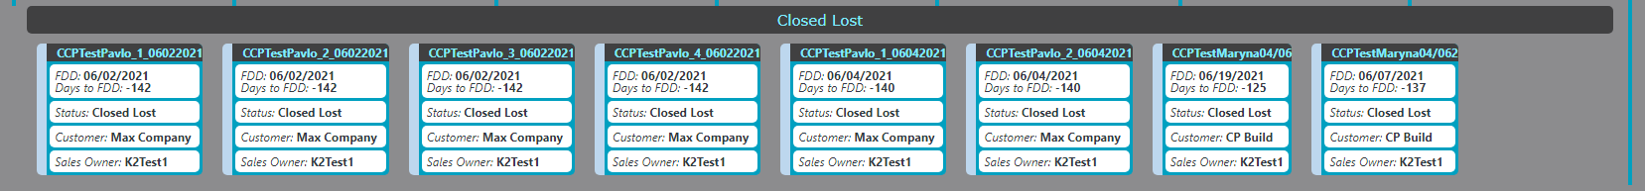

*Screen shot – CCP Dashboards – CCP1*

* The second dashboard CCP2 Contract Status displays the location of projects in two statuses, Contract Negotiation and Closed Won.

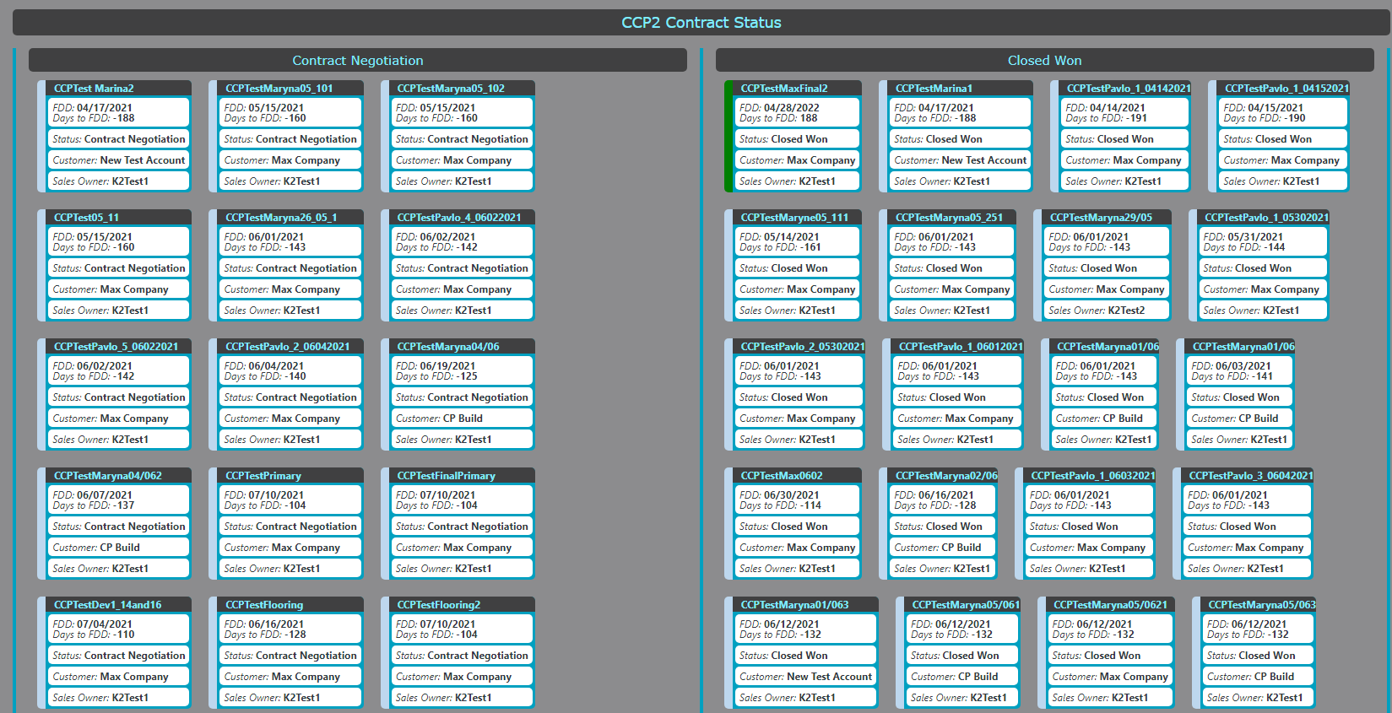

*Screen shot – CCP Dashboards – CCP2*

# CCP HELP

When problems arise with the system, you can send a request to the support service. To do this, you need to fill out the form that opens and click send.

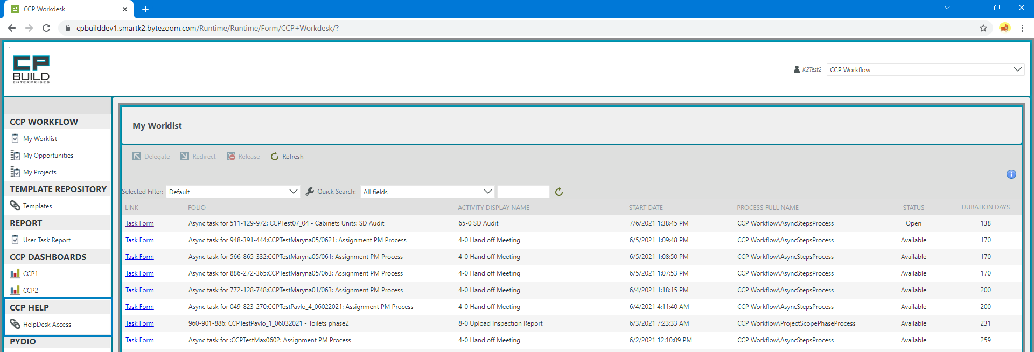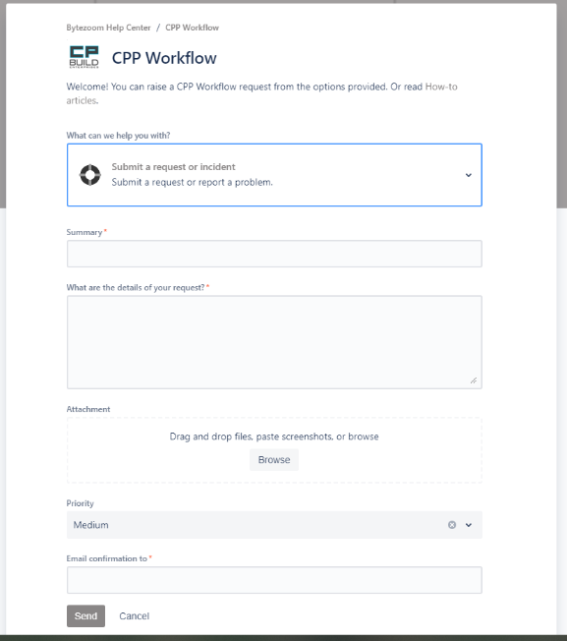

*\*Note: if you don't see a pop-up window when you click on a link in your browser, check your browser's pop-up permissions.*

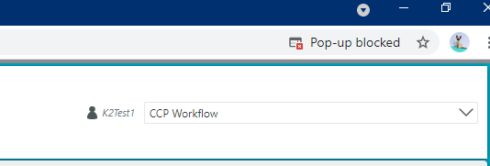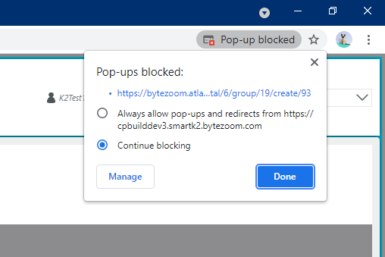

# PYDIO

**Standard Operating Procedure “SOP” for adding files to Pydio**

When a CCP task requires adding files, such as Shop Drawings to CCP, remember that CCP files can be added to CCP only after they are first uploaded to your Personal Files folder in Pydio. This SOP describes how to upload files to Pydio.

It should be noted that files uploaded to Pydio should remain there long enough for them to finish uploading and copied to CCP. For users with marginal internet speeds, this may take longer. Therefore, it is best to leave files in Pydio Personal Files until the day after they are added to CCP.

The operation for uploading files to Pydio requires these five steps:

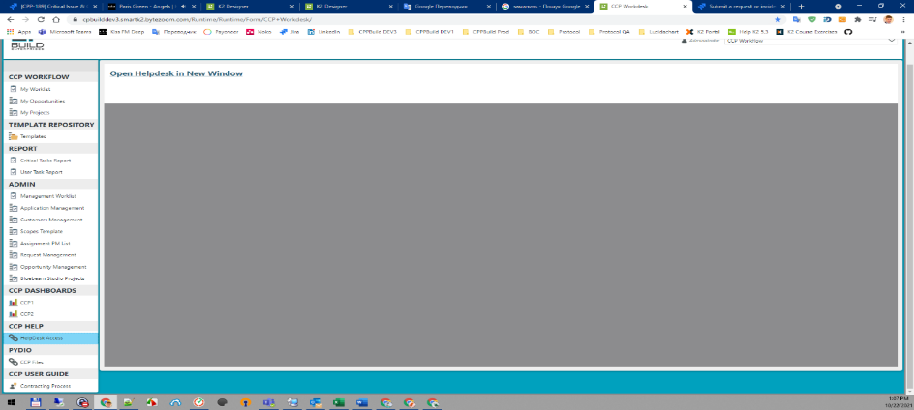

1. From CCP Workdesk, click on CCP Files under the PYDIO heading.
2. In the center pane at the top, click on Open Pydio in New Window

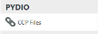

After opening the Pydio resource in a new window, fill out the "Enter login / password".

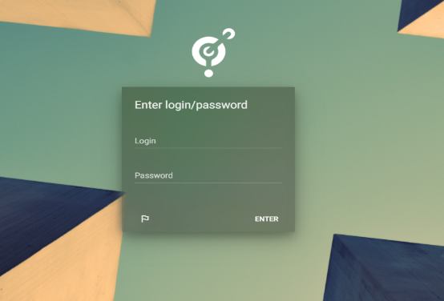

1. From the login page, enter your username and password, then click ENTER

After authorization, you will be taken to your personal account on the Pydio server, where you will need to upload the necessary documents to work in CCP.

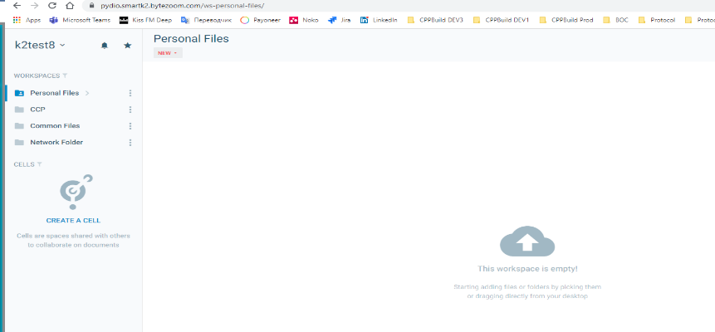

4. In the left pane of Pydio, select Personal Files and in the center pane, click Upload.

5. On the Upload Personal Files page, drag files to the center pane.

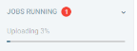

After that, the upload of the document will begin, the progress of which you can see in the lower left corner. File upload is completed when this progress bar shows 100% and disappears

# CCP USER GUIDE

In this menu, you can read the instructions for each process. Each process is divided into roles and according to the steps related to this role. There is also a separate instruction for the administrator.

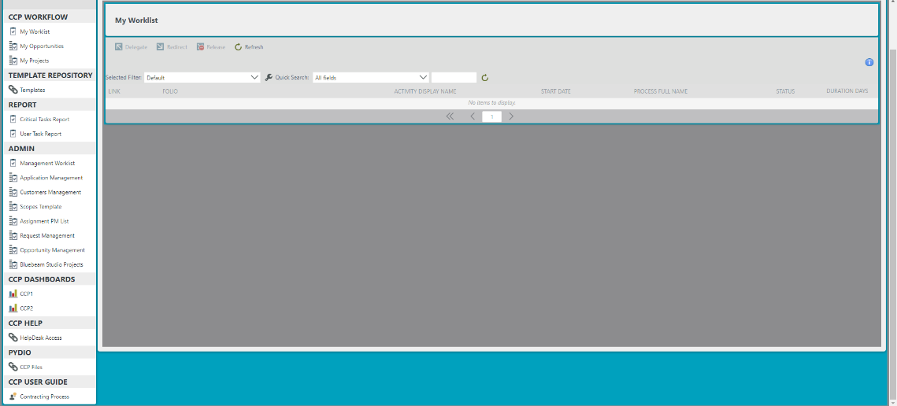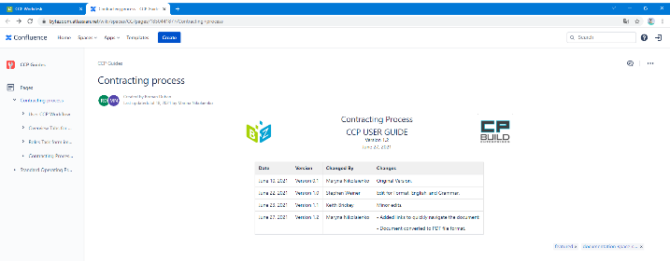

When you click on the link, the instructions that were prepared in the Confluence environment will open for you in a separate tab. On the left side of the screen, there will be a navigation menu, with which you can familiarize yourself with a more detailed description of working with tabs, steps and the program in general.

When working with the instruction page, you can zoom in on the diagrams and download them.

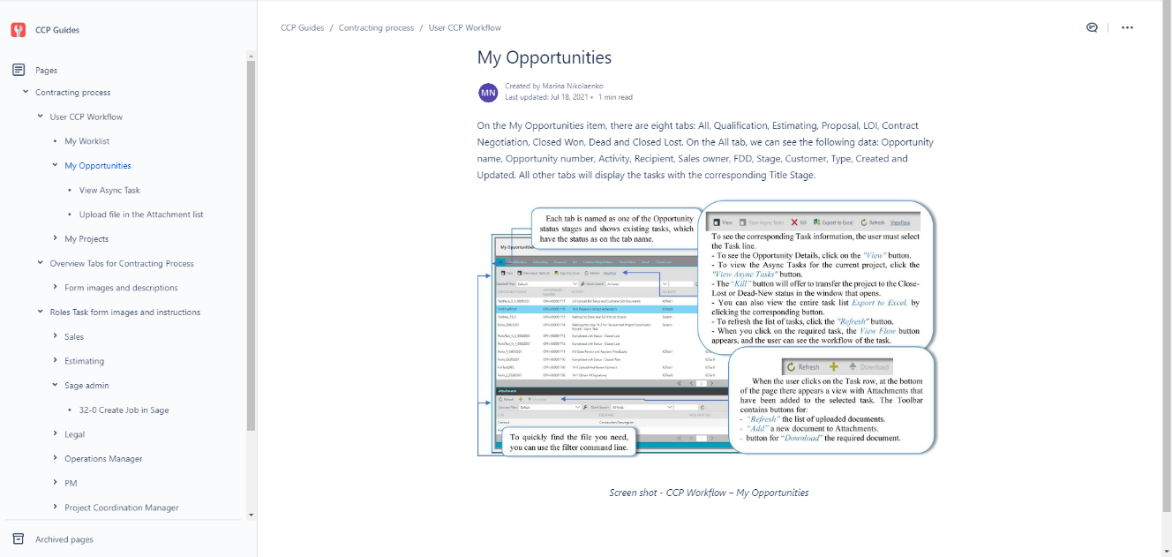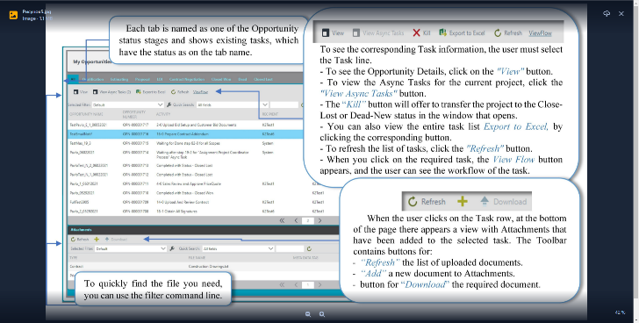

When you click on a picture or diagram located in the text, the picture will be enlarged. Press Esc to return

Here is a detailed menu divided into processes, roles, steps, etc.

There are also additional features:

- searching through all the tabs of the information you are interested in

- downloading the page into the PDF or Word document format you are interested in;

- leave a comment on the article or a question.

…and other.

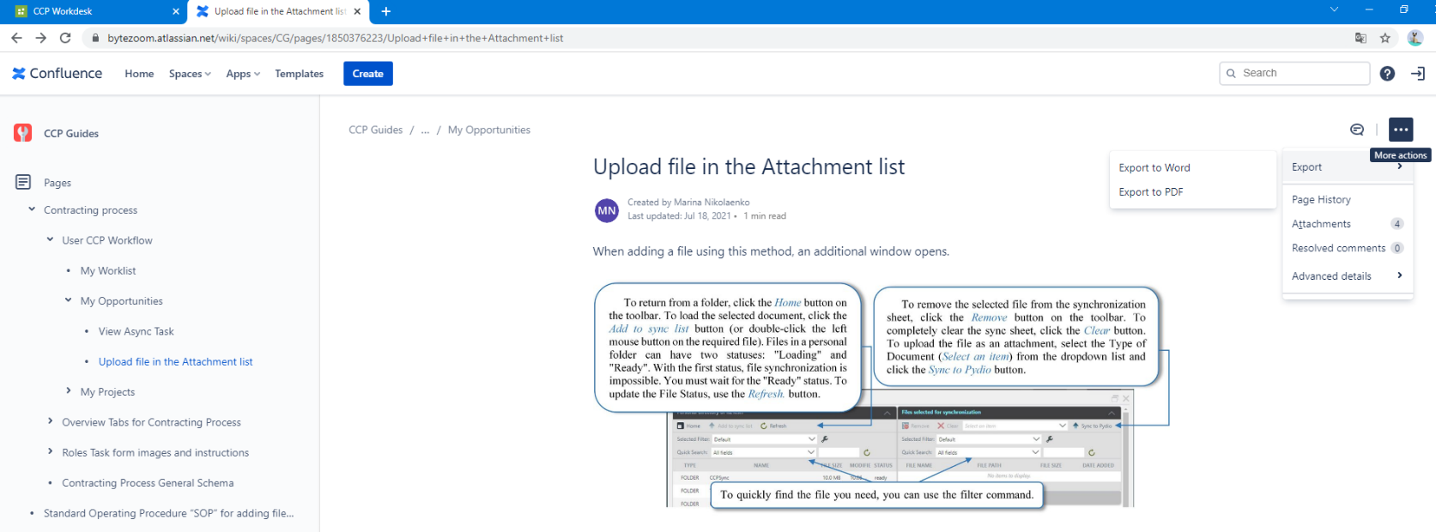

Throughout the document Links are organized, with the help of which you can quickly go to another section of the document, where the necessary actions are described in more detail.

In the system there are also help icons-links. When you click on them, a page opens with a description of the work of this page or area

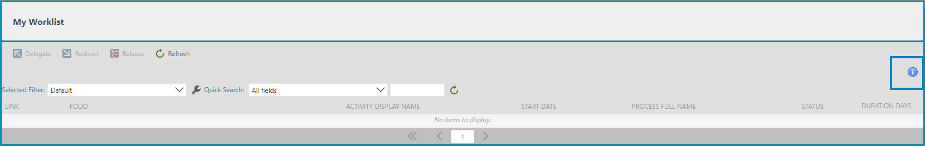

There are also hints inside the system - when you see a similar sign, it means that when you click on it, you will be taken to the instruction page for this menu or page

# Overview tabs Project Scope Process

The start of the Multi-process New Project Scope Process can occur after the following steps of the Contracting Process: Step 7-0 Review L Proposal; Step 14-0 Upload and Review Contract; Step 14-1 Upload C Proposal and SOV; Step 19-3 Upload CA Proposal; Step 23-2 RS Proposal.

## Form images and descriptions

Scope The process can start from the step:

* From step 2-0, Scope starts if in the Scope Template configuration in the “No Workflow Process field” is set to “true” value. This means that the Scope process will not start. 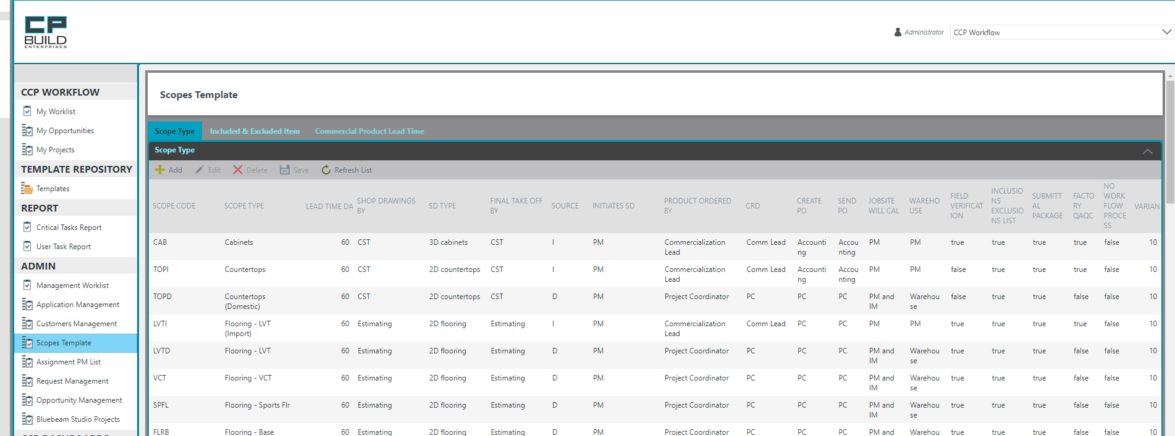
* From step 3-0 Upload Phase Plan provided, if in the Scope Template configuration in the “Shop Drawings By” field is set to None. This means that the Scope process will be started, but the steps for preparing the SD documents will not be used.

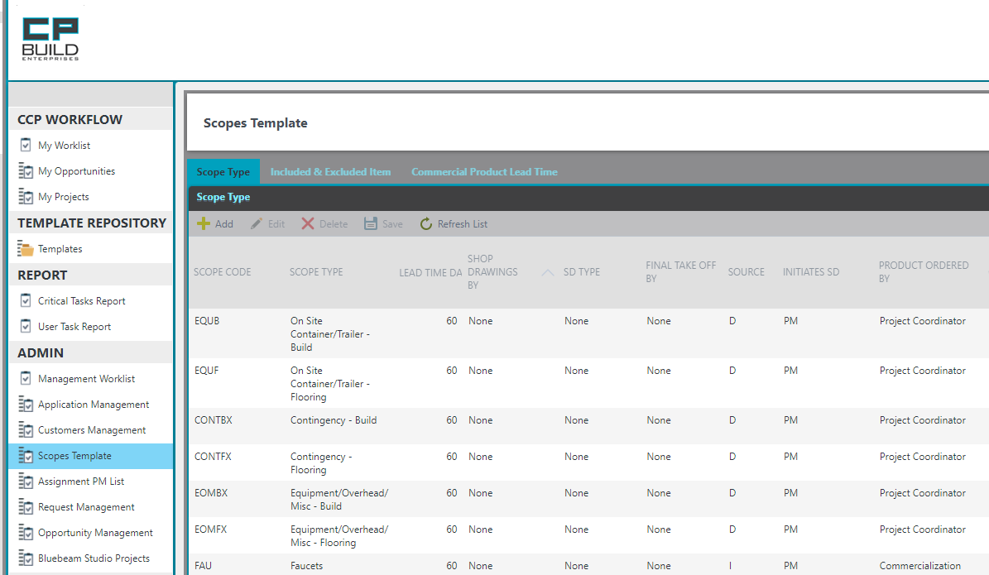

* Starting from step 5-0 Prepare SD Request for Scope for all Scopes that are not Build
* Starting from step 5-1 Prepare or Update SD Request for Scope for Build Scopes
* Starting with step 6-0 Upload New or Revised SD, provided that the SD Request form was started through the menu and before the start of the Scope Process was completed.

In the form for the Scope Process there are five tabs (Project Scope, SD Request, New FDD, Submittals, Tab Approval Notes) that are active at certain steps.

From the beginning of the start of the Scope Process, two tabs are available to us for work: Project Scope and SD Request. The SD Request tab is available for editing only at steps 5-0 Prepare SD Request for Scope, 5-1 Prepare or Update SD Request for Scope, 5-2 Review and Approve SD Request for Scope. After that, it becomes available only for viewing at steps, such as 6-0 Upload New or Revised SD, 7-0 Upload Draftsman SD SOP, 7-1 Upload SD SOP, 8-0 SD DRAFT and SD SOP Review Meeting, 8-1 CA Reconciliation Meeting, 9-0 Upload New or Revised SD Final, 14-0 Review SD Final. Then it hides altogether. The "New FDD" tab becomes available after the first change in the FDD value. The Submittals tab becomes available after the Contracting process goes through Step 22-0 Procore Submittals Approved. The Tab Approval Notes become available in steps 64-2 Get Customer Response and 64-0 Evaluate Cost Changes.

### Tab Project Scope

On the Project Scope tab, some fields are already filled in automatically with information from Contracting Process. All other fields will be filled in automatically after uploading documents, which will contain this information, or manually by the user.

Header section, which displays current information about: process name, project name, step number with its name and username.

This is the main user's work area in which tabs, fields with data information and a block for uploading the necessary documents for a specific step are available.

Action to represent a step. The user can enter a comment and select an action from the Task Action drop-down list, and the user can also see a prompt for the current step in this view.

Action History view shows step name, comment, action, display name, date, and time for activity in previous steps.

On the Attachment view you may see added attachments, download them, or add new one.

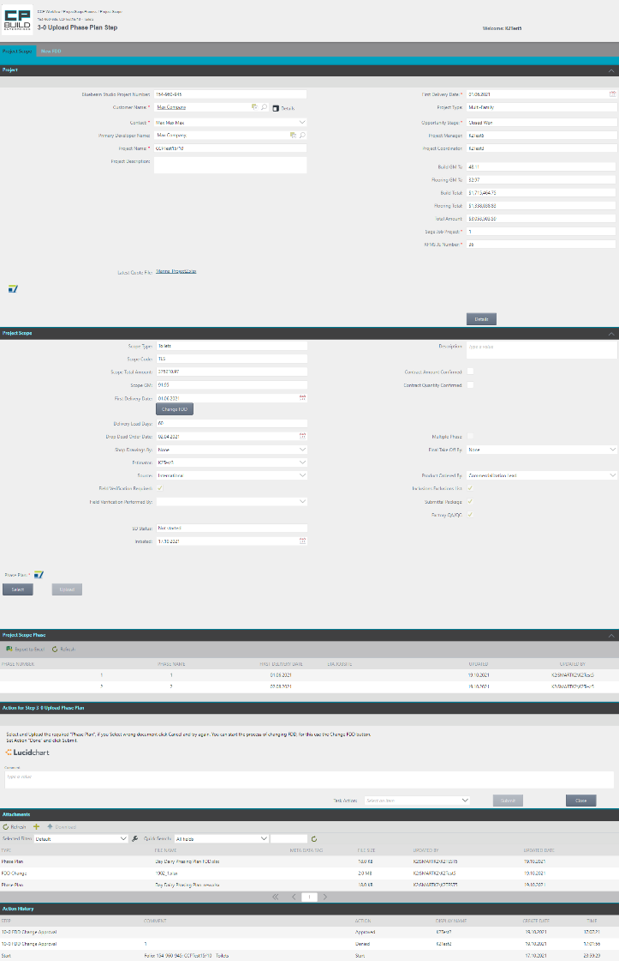

On the Attachment view, you may see added attachments, download them, or add a new one.

Action History view shows step name, comment, action, display name, date, and time for activity in previous steps.

Action to represent a step. The user can enter a comment and select an action from the Task Action drop-down list. The user can also see a hint for the current step in the form of a description of the required actions and a link to a schematic map of a step in the overall process.

This is the main user's work area in which tabs, fields with data information and a block for uploading the necessary documents for a specific step are available.

Header section, which displays current information about process name, project name, step number with its name and username.

In this area, you can review all the information for this project and, if necessary, make changes to the current data.

After the successful uploading of the Phase Plan document, the Project Scope Phase area becomes available in which all information on phases for the current Scopes Process.

*Screen shot - Estimating – Step 5-0 Prepare SD Request for Scope – Project Scope Process*

*Header section*

This area is displayed at each step and is the same for all tabs. This area is informative and is not changed by anyone.

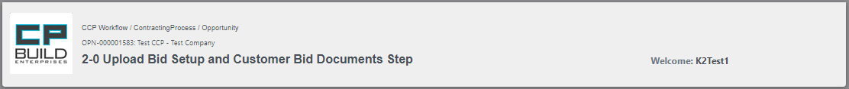

This part displays: Process Full Name, Folio, Activity Name

Allocated User is displayed here.

*Project*

In the Contracting process, after the process proceeds to the stage of contract negotiations at step 14 “Load and view the contract”, the “Project” tab replaces the “Opportunities” tab. The data are displayed according to the current draft contract and works the same as the Opportunities tab.

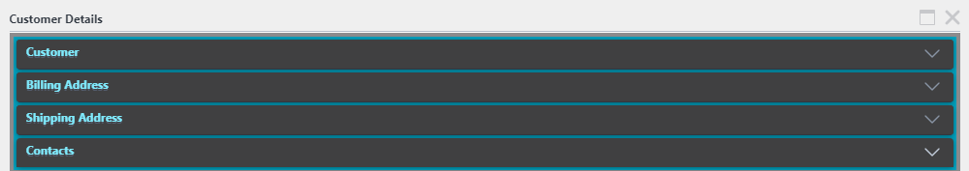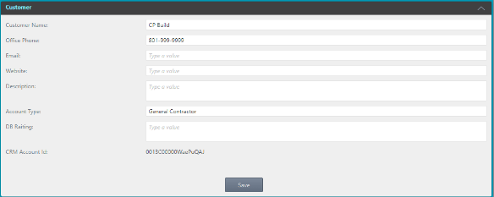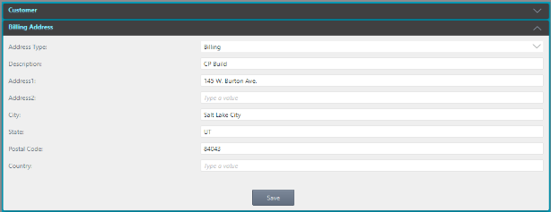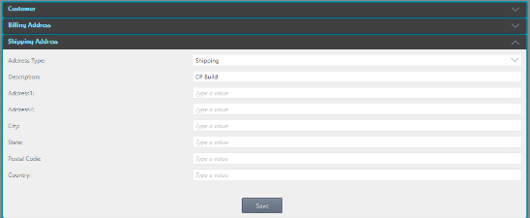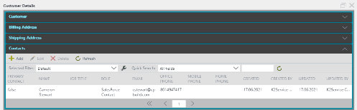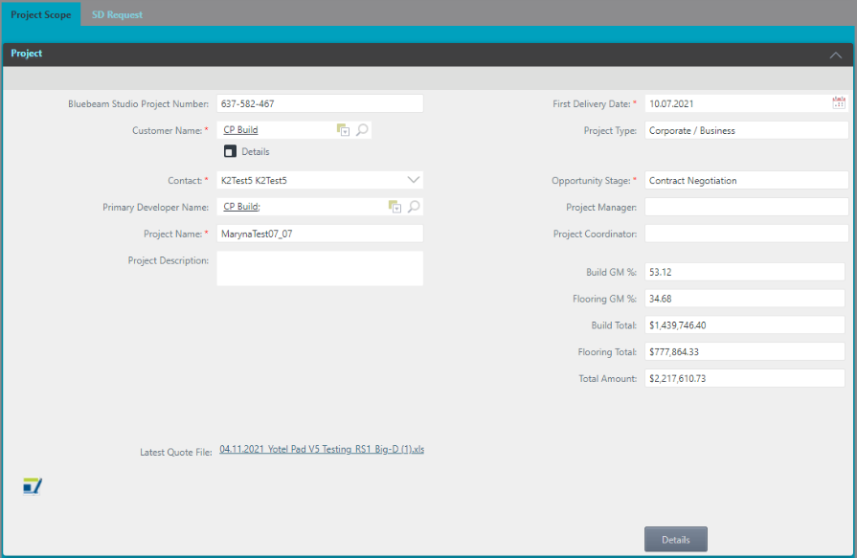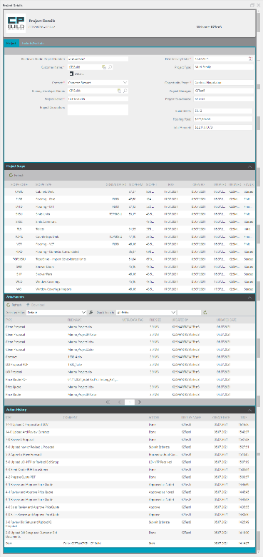

When you click on the Details icon, a pop-up window “Customer Details” will open, in which four areas with relevant information will be available: Customer; Billing Address; Shipping Address; Contacts.

When you click on the Details button, the "Project Details" pop-up window will open with available tabs Project and Include / Exclude in which all information about the project will be available.

To view the last uploaded quotation file for the current project, click on the link, and the document will be downloaded.

*Screen shot – Project tab – Project Scope Process*

In the Project Scope Process, on the Project tab, we have access to Project Information, Client Information, as well as the ability to view the last uploaded quotation file and more.

*Project Scope*

There are three active parts in this area: the upper part shows the available tabs to work with; in the middle part there are fields for viewing project data transferred from Sales Force, extracted from uploaded files, and manually entered by the user; and the third part is also available to upload the necessary documents for this contract. Some fields will be hidden or added for a specific step.

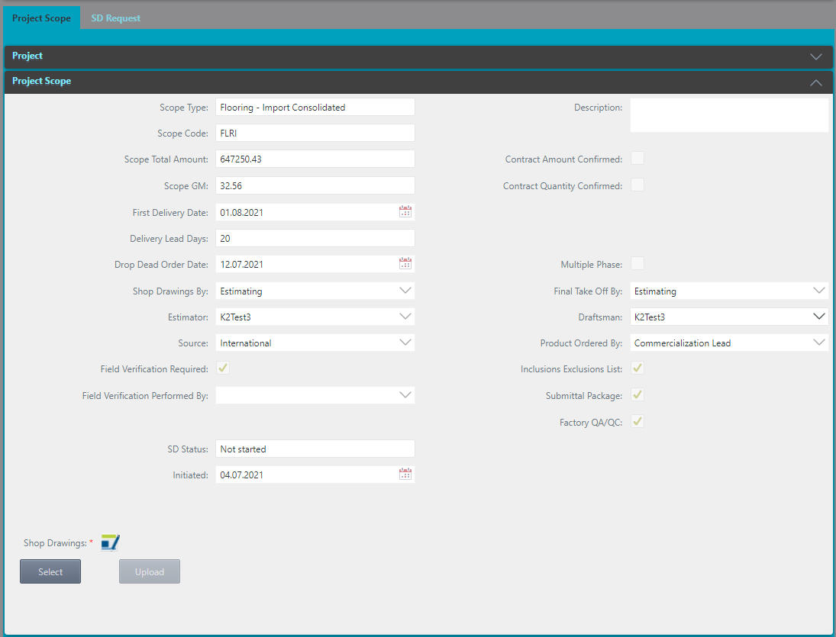

Here you can upload files from the Pydio personal folder. By clicking on the icon next to the name of the document, you can download the template of the required document for uploading. In this part, * also means the mandatory upload of this type of documents.

This block displays information about the current process. Fields that must be filled in before proceeding to the next step will be marked *

Tabbed area to work with. Highlighted the currently active tab Project Scope.

*Screen shot – Project Scope tab – Project Scope Process*

***To add attachments:***

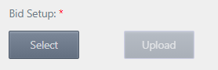

1. Click on the Select button and view will open.
2. Choose the file user needed and click on the Select button. This action will add the document to the form.

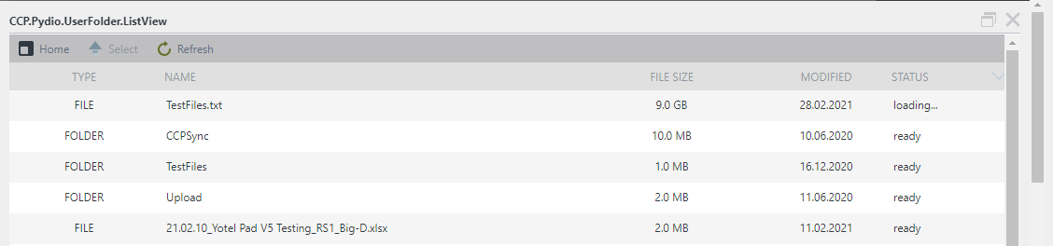

To return from a folder, click the *Home* button on the toolbar. To upload the selected document, click the *Select* button (or double-click the left mouse button on the required file). To update the File Status, use the *Refresh* button.

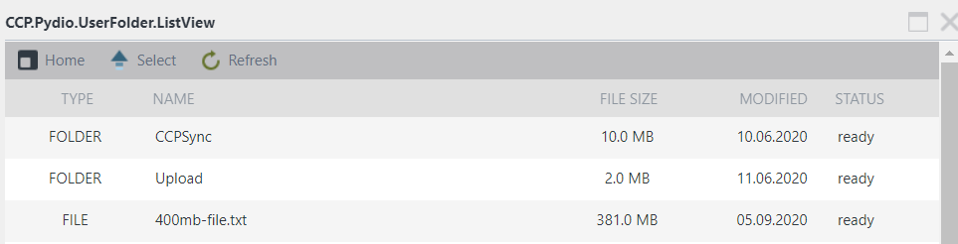

3. Click “Upload” to upload the file. If the user does not do it, it will be done automatically after selecting Task Action and clicking “Submit”.

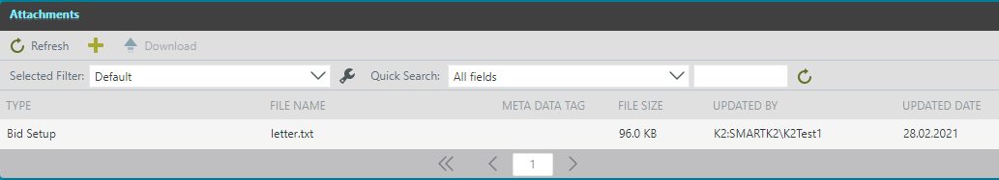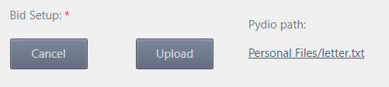

The location of the file on Pydio that was selected for upload is indicated.

You may click the Cancel button, if you select wrong Document, and add another one.

After clicking the Upload button, the selected file will be displayed in the Attachments and Saved as Attachment in Process.

*Project Scope Phase*

In 3-0 Upload Phase Plan Step and 15-2 Upload Phase Plan Step, you must upload the Phase Plan document. After a successful upload, the Project Scope Phase area becomes available, in which there is information on all phases of the current Scopes Process.

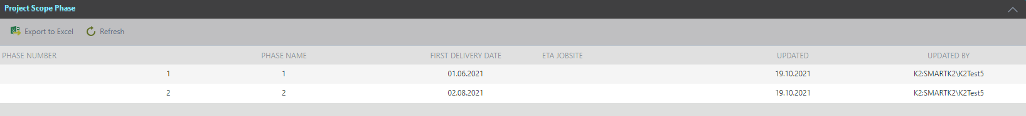

*Action for Step*

This part gives a short description of the current step including: its name; a description of the actions that need to be performed; a list of the documents that need to be uploaded and a description of the Task Action.

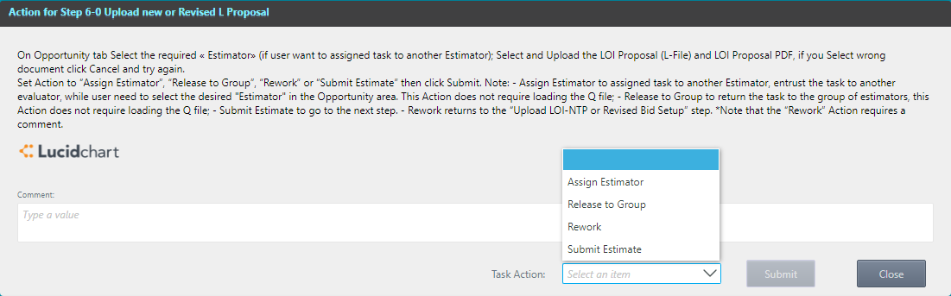

A brief description of the tasks at this stage. There is also a description of a possible transition by Task Action

Area for entering comments, especially when the action in a step is performed Rework - a comment is required. If you want a specific user to see this comment, you need to specify the username after the @ (Example: @NameUser). This message will be shown in Salesforce chat.

To move the current step further, select "Task Action" from the drop-down list. After selecting "Action", click the "Submit" button. Or "Close" to close the current window.

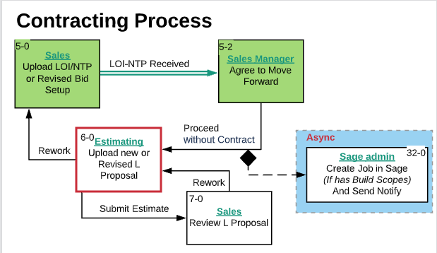

Full name of the Step

If the user clicks Submit without completing all of the required tasks for the current step, the user will see a warning window. There will be a proposal to perform an action.

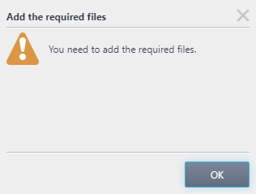

For example: You need to add the required files. Click OK and upload the required files. Then repeat the Action to go to the next Step.

*Attachments*

This section shows all the documents that were uploaded in the previous steps. The command line also gives us additional options for Upload and Download the selected document.



After clicking the Upload button, the selected file will be displayed in the Attachments and Saved as Attachment in Process. On the Attachment view, the user may see added attachments and can download them or add new ones.

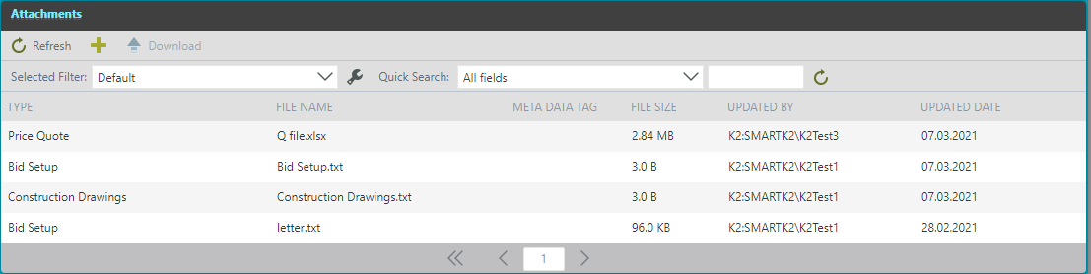

To quickly find the file you need, you can use the filter command line.

The toolbar contains buttons for *Refresh* the list of uploaded documents; *Add a new document* to Attachments; button for *Download* the required document.

When adding a file using this method, an additional window opens.



To return from a folder, click the *Home* button on the toolbar. To upload the selected document, click the *Add to sync list* button (or double-click the left mouse button on the required file). To update the File Status, use the *Refresh* button.

To remove the selected file from the synchronization sheet, click the *Remove* button on the toolbar. To completely clear the sync sheet, click the *Clear* button. To upload the file as an attachment, *Select an item* from the dropdown list and click the *Sync to Pydio* button.

To quickly find the file you need, you can use the filter command. line.

***To add new attachment to Attachment’s view:***



1. Click the button in the toolbar and an auxiliary form will open.



3. Files will appear in the Files selected for synchronization view.



6. After clicking Sync to Pydio Click the *OK* bottom in the message box and new file will appear in the Attachments list.

1. Select the required file or folder from the Personal directory and click on *Add to sync* list button.

4. On the Files for synchronization view, select from the drop-down list file type.

5. Click on *Sync to Pydio*.

*Action History*

This area is displayed at each step in the Opportunity tab. This area is informative and is not changed by anyone.

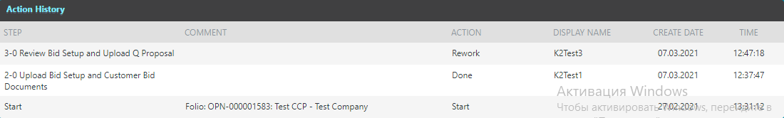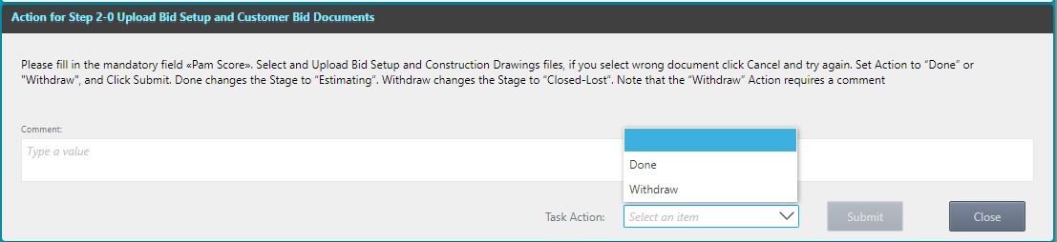

It shows a list of the completed steps with their names, what comment was entered at the corresponding steps, what Action was selected for each Step, which user performed the action and on what day and time it was performed.

The bottom line in the Action History displays information on when the process started and with which Folio.

### Tab SD Request

**Main areas of SD Request form**

For each Scope in the Project for which the SD is required, a Shop Drawing Form is displayed in a separate area. There are three scheme types for the SD Form, depending on the Scope: 3D Cabinets, 2D Flooring, 2D Countertops. CD forms for Bath Accessories, Mirrors and Sinks Skopov will be configured in the near future. The configuration of the binding of Scope to a specific scheme of the SD Request is configured in the Scopes Template menu.

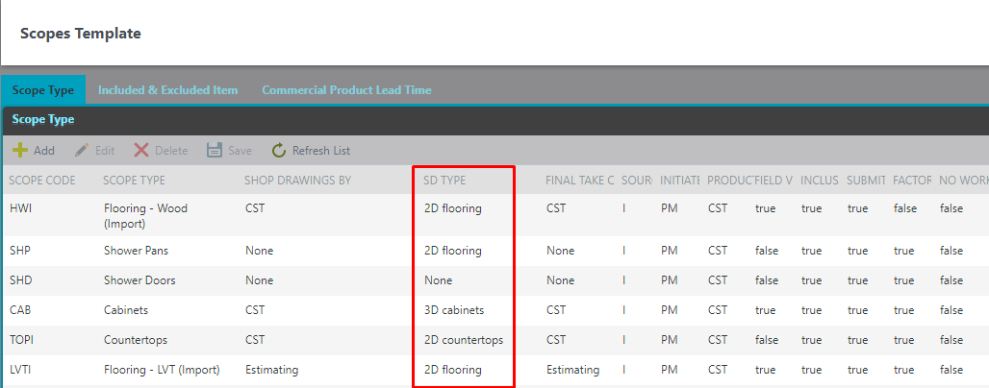

The SD Request form consists of three separate areas: Project Information, Document Needed and Shop drawing form for each Scope. There are two role users who will work with the SD Request Form: Estimator and Sales, which are assigned to the current project. The estimator is the first to fill out the form and is able to start the SD Request process using the "SD Request" button on the My Project menu.



After filling in all the fields to start the process, use the Start SD Request Process button.



At the same time, the estimator has an unlimited opportunity to edit and save the form before starting the process. After starting the process, the form moves through the workflows and gets into the work of the Sales. Other users can see the form only after the start of the SD Request process in read mode using the same "SD Request" button on the My Project menu. The SD Request form is also available in the separate steps of the Project Scope Process in the tab «SD Request». If the SD Request process has not been previously started by the Estimator and filling out the SD form for a specific Scope is necessary, Project Scope Process proceeds to steps 5-0, 5-1 and 5-2, where the work with the SD Request form takes place. The only difference is that the Shop Drawing area is only displayed for a specific Scope of the current Project Scope Process. After passing the specified steps and confirming the SD form, the SD Request tab is displayed for all users in read mode at individual steps of the Project Scope Process.

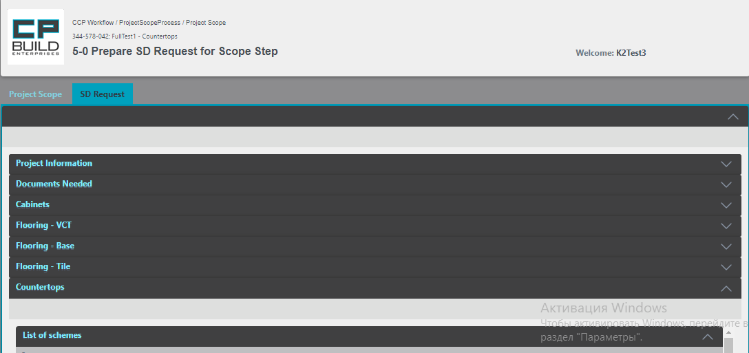

The Shop Drawing area of specific Scope has several statuses. Depending on the process, there are 3three options for status: Initiated, Started, Approved.

|  |  |  |
| --- | --- | --- |
|  | SD Request process | Project Scope process |
| Initiated | after saving the first Version in My Project Menu | after saving the first Version in step 5-0 |
| Started | after the Start of the process | after Submit in step 5-0 |
| Approved | after the Finish of the process | after Submit in step 5-2 |

**Project Information**

In the Project Information area, you can see general information on this project, including Project Name, Product Need Date etc. You will also see all scopes for which SD Request schemes have been created in the project. This area is not editable.

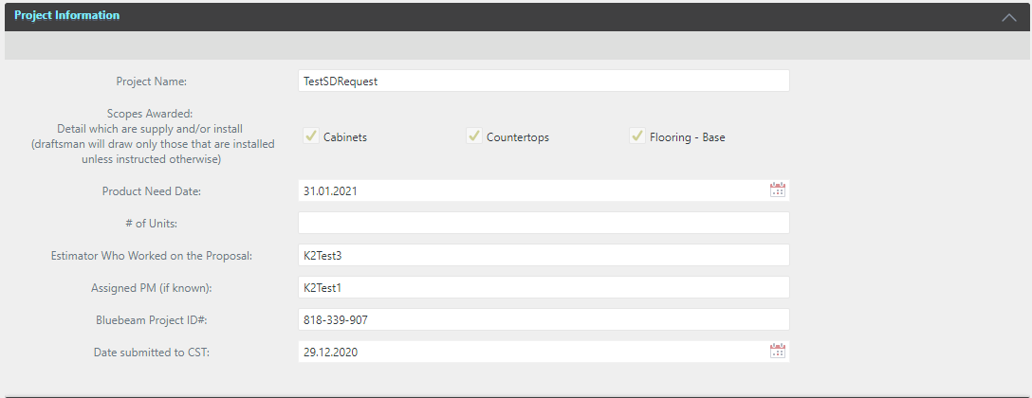

**Document Needed**

The Documents Needed area offers the ability to link files to a specific document type. Type of document contains a complete list of all possible document types for use in an SD Request.

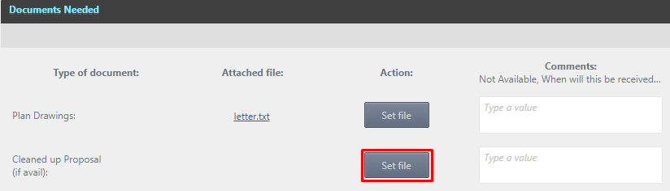

When you click the Set File button, the Mapped Attachment sub form opens with a complete list of attachments that were previously added to the project displayed. It is for the current scope of the process. It is also possible to immediately add a new Pydio attachment using the ADD button. To map an attachment, select it with one click of the left mouse button and press Select(mapping).

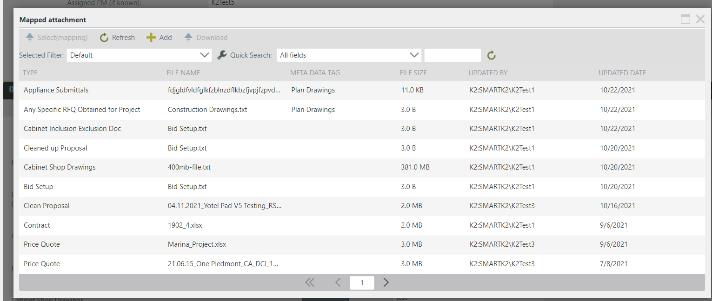

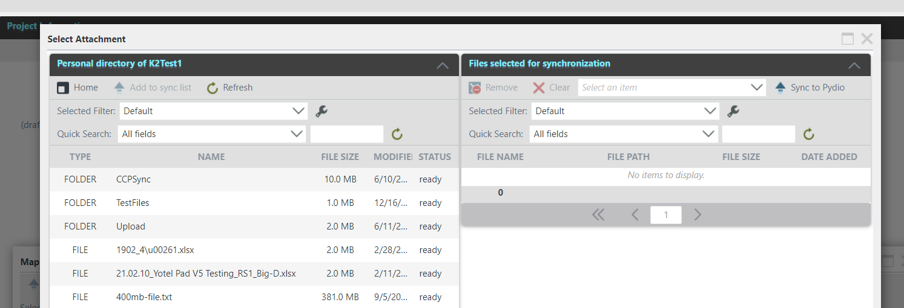

The "Attached file" field for a certain type of document will display the file that was mapped with the ability to download it, if necessary (the file download link is highlighted in the file name).

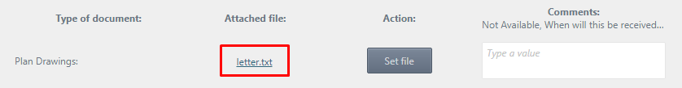

After this action, all Attachment Lists Project will display information about the mapped file to SD Request, indicating the document type in the Meta Data Tag field.

By clicking the Set File button again, you can re-map another document in the selected file type. In the Comments field, you can add a comment for each file type

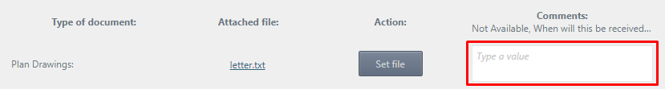

**Shop Drawing Form**

At the very top of the SD Form, its status is displayed, and the number of Lead Time Days is indicated. For scopes without consolidation, changing the Lead Time Days value is allowed in the same control. For consolidated scopes, a separate view is added on the form, described below.

The Shop Drawing form for scopes consists of two areas: List of Schemes and a direct Shop Drawing form with a list of items.

***List of schemes***

This part shows general Comments on the SD Form for Scope.

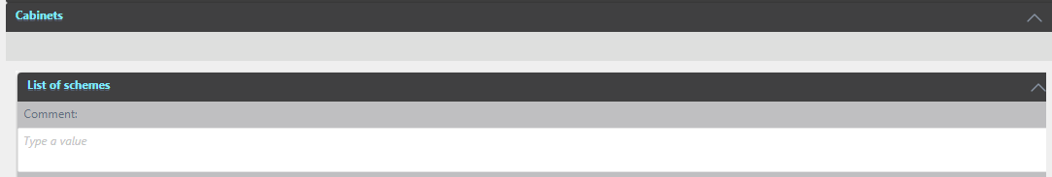

This part displays schemes related to the SD Form for Scope.

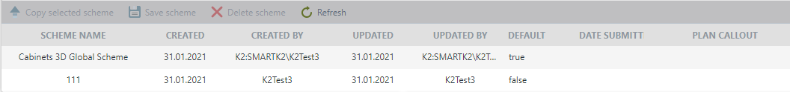

The toolbar menu shows buttons responsible for managing schemes. To do this, it is necessary to select the necessary scheme, with which we will carry out manipulations.



Copy selected scheme – this button will copy the selected scheme. To do this, select a scheme to copy and click Copy Selected Scheme.



A new line will then appear where you will need to enter the desired Scheme Name. Submission Date Submit, Plan Callout - optional.

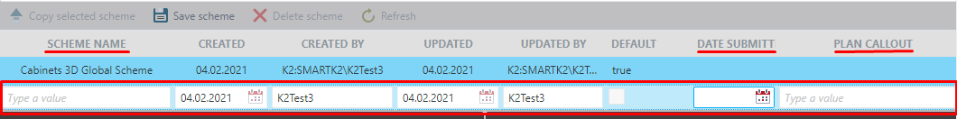

Save scheme – After filling in these fields, click the Save Scheme button.



*\*Note that there are two statuses in Default: true - which indicates that this is a global scheme; false - shows that this is one of the copies of the global scheme.*

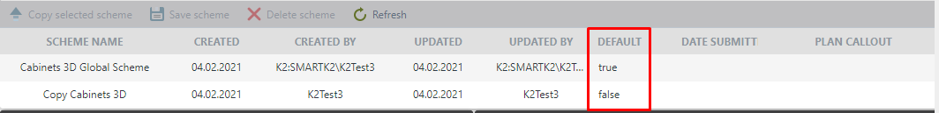

**Cabinets and Countertops Shop Drawing Schemes for Scope**

The next block is divided into right and left panels. The left one is the workspace of the current user with a choice of scheme versions and the presence of form editing fields. The right panel is used to compare changes made by another user. The first time filling out the form, the right side will be blank.

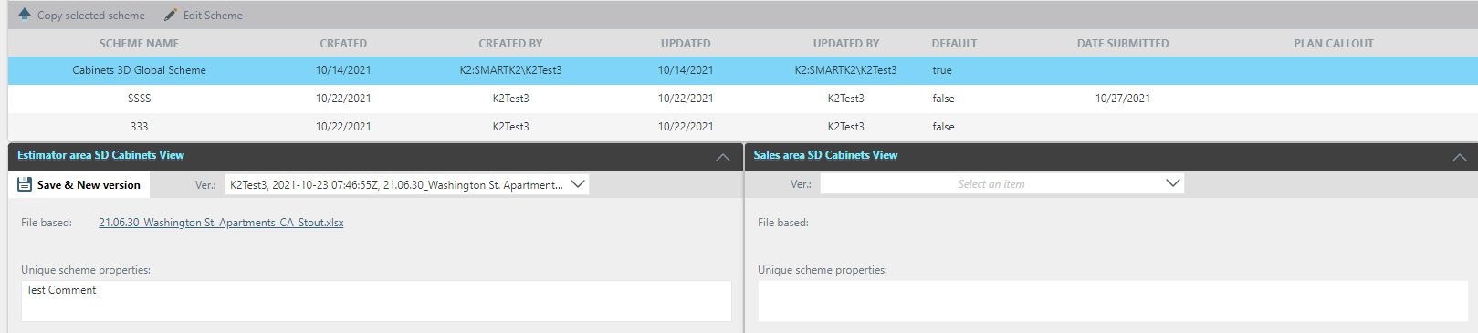

To work with the Scheme - you need to select the scheme with which the work will be performed, and go to the next block, in which on the left it is necessary to enter values for all the required items of the form. If some value in the form is selected and Lock a Field is set, then the following users will not be able to change this record.

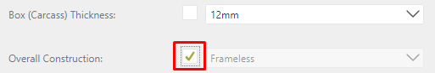

After weighing all the changes in the form, you save it. In this case, press the Save button.

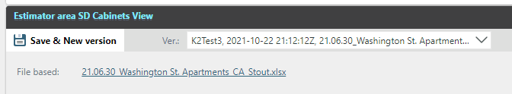



A message will be displayed to confirm that the form has been saved.

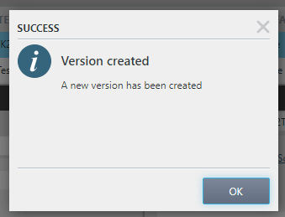

Every time the form is saved, a new version is created. This can be found in the Version list. When loading a global scheme, the last saved version is always displayed first in the Version list.

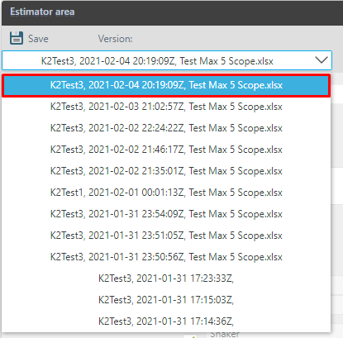

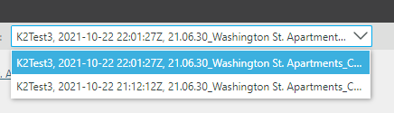

At the top of this area, File Based also shows the name of the last file displayed in the "Quotation File" field. The link to download this file is below.

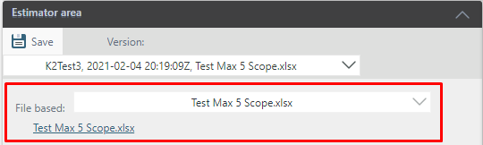

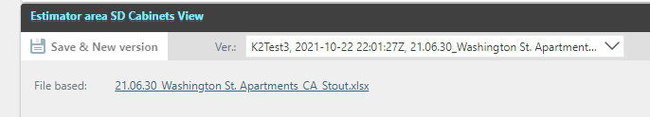

The next part shows the general comments on the SD form for Scope. In Scheme Comments, a comment is added for each scheme. If we change the version, the comment does not change.

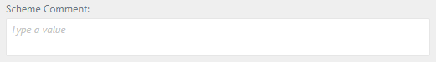

When there is a discrepancy between data records, a "Function arrow" appears on the right and left panels. This is necessary for convenient fast data transfer. When you click on it, the data on the right side of the work area is filled in the corresponding fields on the left side of the work area.

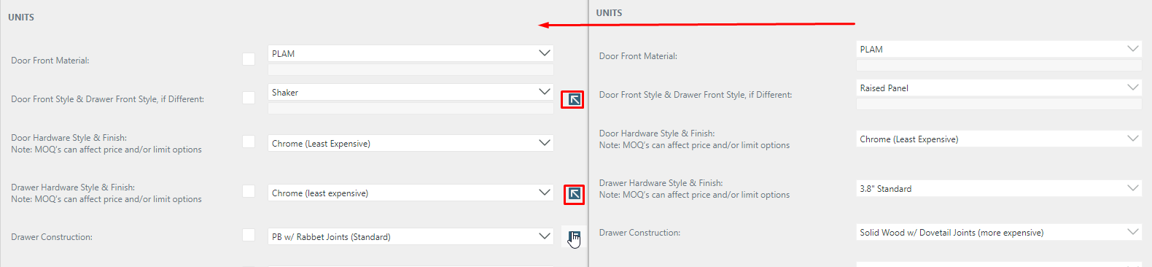

**Flooring SD** **Scheme for Scope**

Controls for Version, File Based, Scheme Comment fields are identical to those in Cabinets and Countertops.

The data in the Flooring Shop Drawing form is imported from the last Quotation file and formed into a list view. In the rework process, the user can edit, add or delete existing lines, after importing data. After making changes to the list and clicking the refresh button, the changes will be canceled. Click the Save button to save your changes. A new version will be created every time the data is saved.

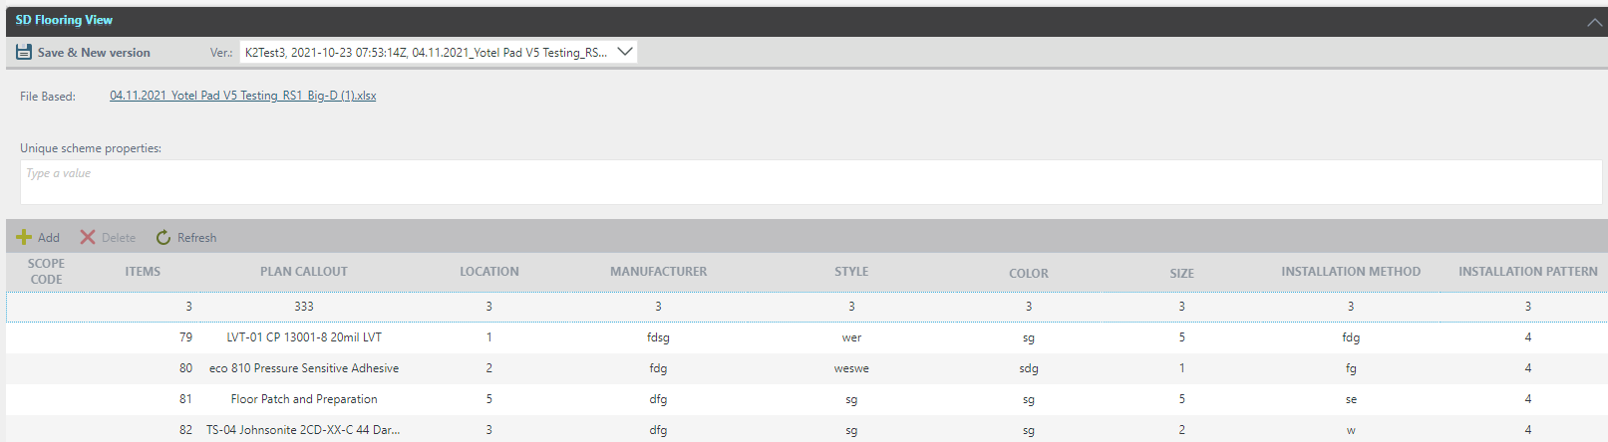

If the Sd Request Form is launched for a consolidated Scope, then in addition, the form displays a view with a list of all consolidated Scopes and the ability to change Lead Time Days for each Scope in the consolidation.

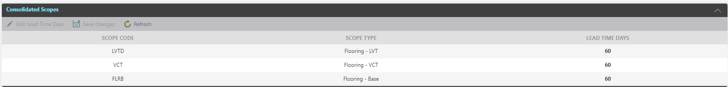

To do this, on the Consolidated Scopes view, use the Edit Lead Time Days button and after the change, use the Save button to save.



The editing panel contains tools for adding a record. Editing is done by double-clicking the left mouse button on the required entry and deleting an existing record with preliminary highlighting of the required record. Refreshing the workspace without first saving, will reset all records to the original and ported version. To work with a record (add new row in list), the required fields are Items, Plan Callout and Manufacturer.

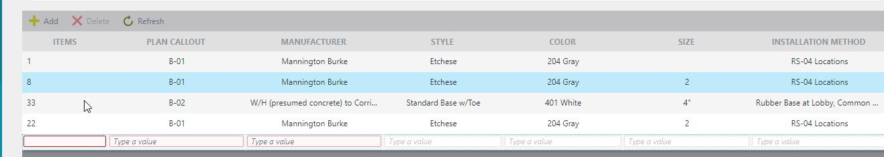

To save all the changes made, click on the Save button. Each time you save, a new version is created.

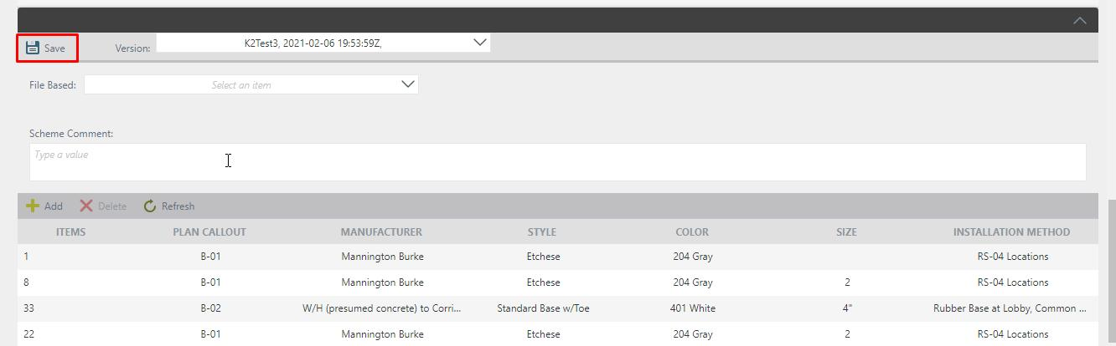

To configure the list of values in the SD form, there is a separate menu in the Configure panel called SD Options. This makes it possible to edit, add or remove options for selecting values ​​for data entry. This configuration menu is available exclusively for the CCP administrators.

*Configuration menu for filling SD form template*

In Configuration Management, select Application Configuration. In the list that opens, select SD Options.

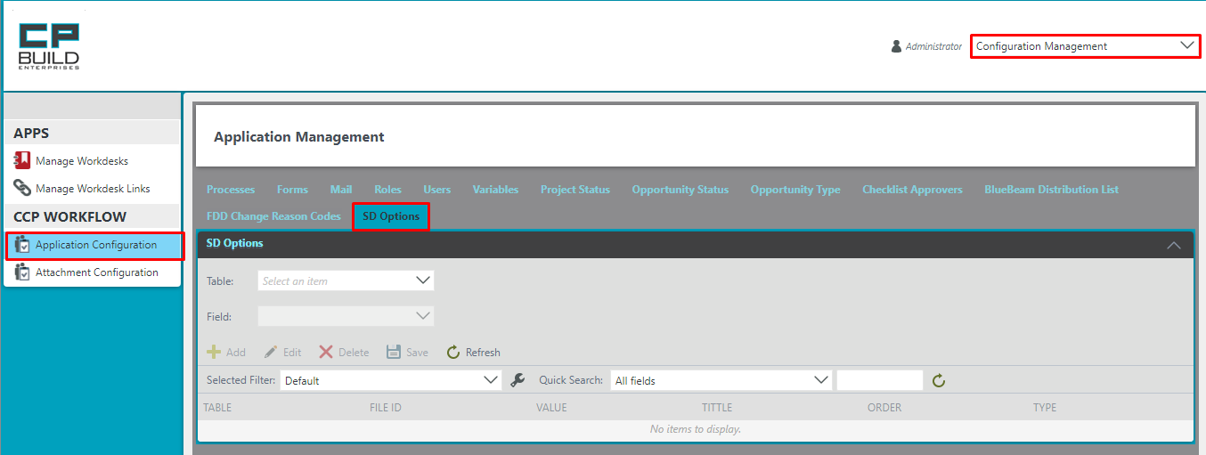

To make the work more convenient, the configuration menu contains filters: selection of the Scheme for editing and selection of the table, the data values ​​for which should be changed.

The meaning of the fields is as follows:

* table: an area on the diagram of the SD form that contains data with a common parameter
* value: the value that will be transmitted and written as a system value to the database
* title: the name of the value that is displayed on the form
* order: a numeric value which is responsible for the order of placing items. Items with the

lowest order value is displayed first.

* type: informative field for displaying the type of field for data entry (checkbox, radio button,

text field, etc.)

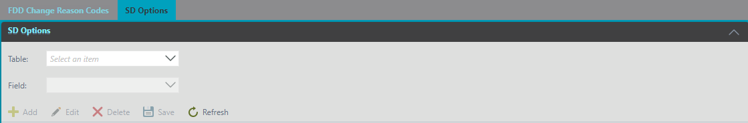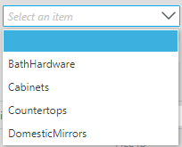

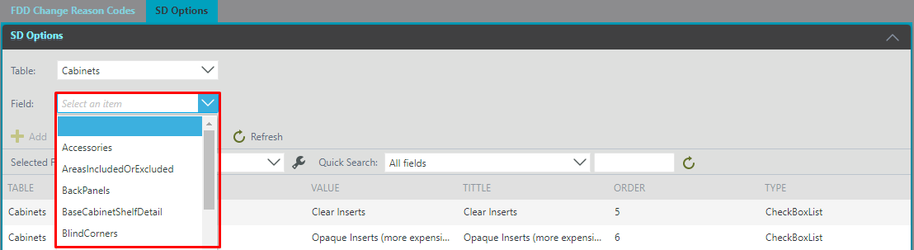

The toolbar panel contains tools for adding a record; editing or deleting an already existing entry, while pre-highlighting the desired entry; saving editing and workspace update.

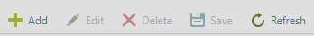

### Tab New FDD

In the Scopes process, there is an opportunity for the PM to change the FDD. This can be done in two ways:

* using the Change FDD button at any step of the Process Scope available for the PM
* in the My Project menu, when you select the entry of the corresponding Scope in the project (insert link)

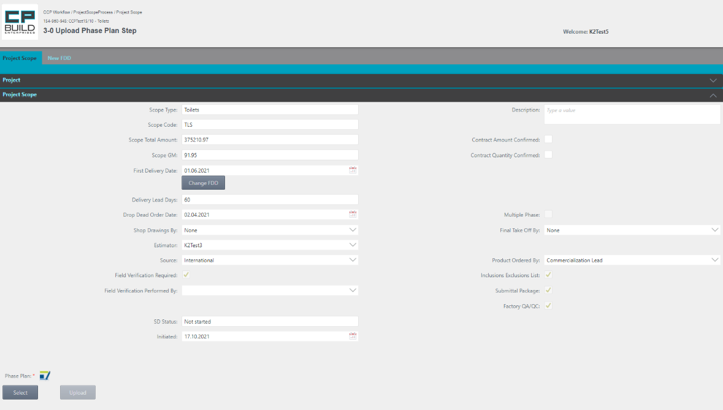

To change the FDD value, click the Change FDD button. Then the Change FDD form will open.

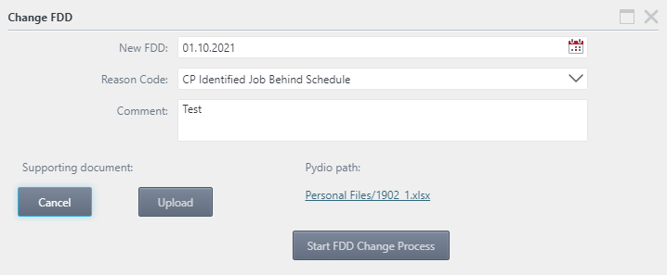

1. Fill in all the fields of the form

2. Attach the Supporting document

3. Press the button Start PDD Change Process

4. Two messages will appear confirming the successful start of the PDD change

5. Close the Change FDD form

For both methods, it is mandatory to have supporting documents that are attached as Attachment, when starting the Change FDD Process.

It is also obligatory to indicate the reason for the change of the FDD. The launched Change FDD Process must pass the FDD Change Approving stage.

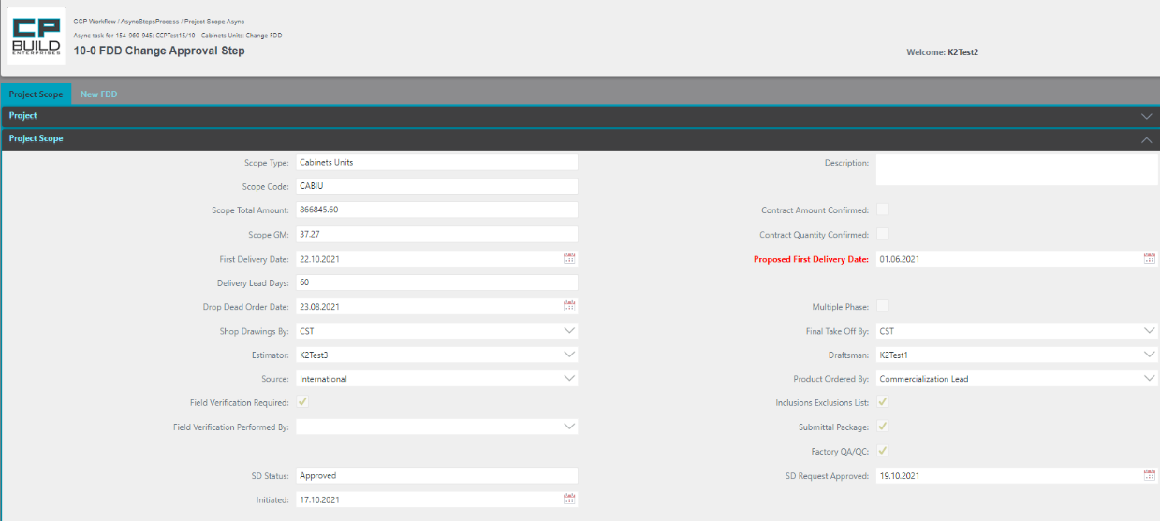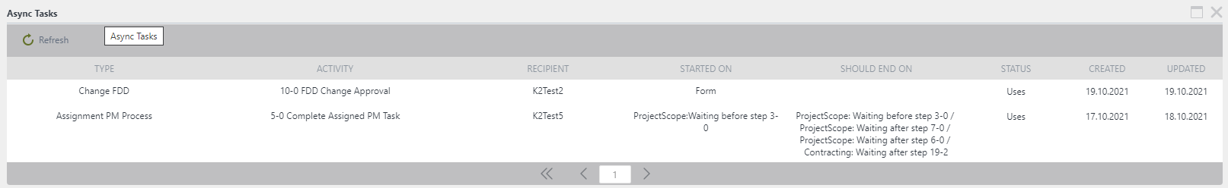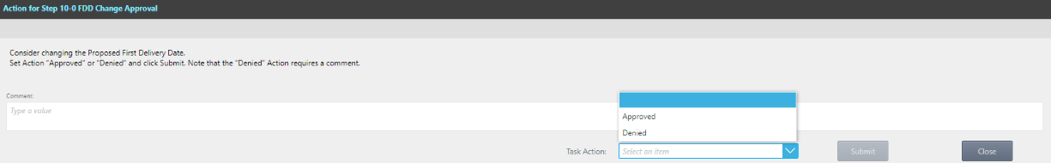

To display the final solution, select the Task Action that matches the given solution. Approved or Denied.

To validate the FDD change decision The asynchronous step "10-0 FDD Change Approving step" starts.

After deciding, the Initiator will receive a letter with the decision by mail.

Until the approval of the change in FDD, the process scope form displays both the old FDD and the new FDD simultaneously.

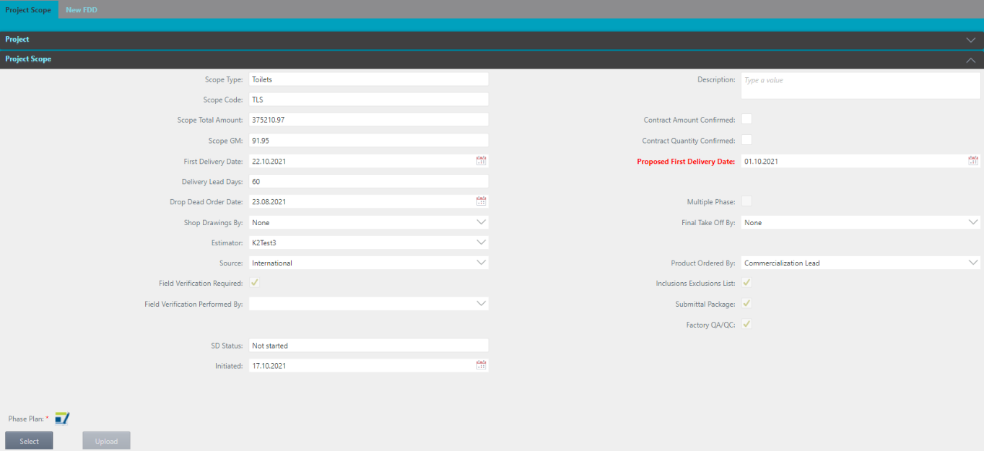

After the decision at the FDD Change Approving step in the Scopes Form, the FDD tab will display the history of changes with the status for each record.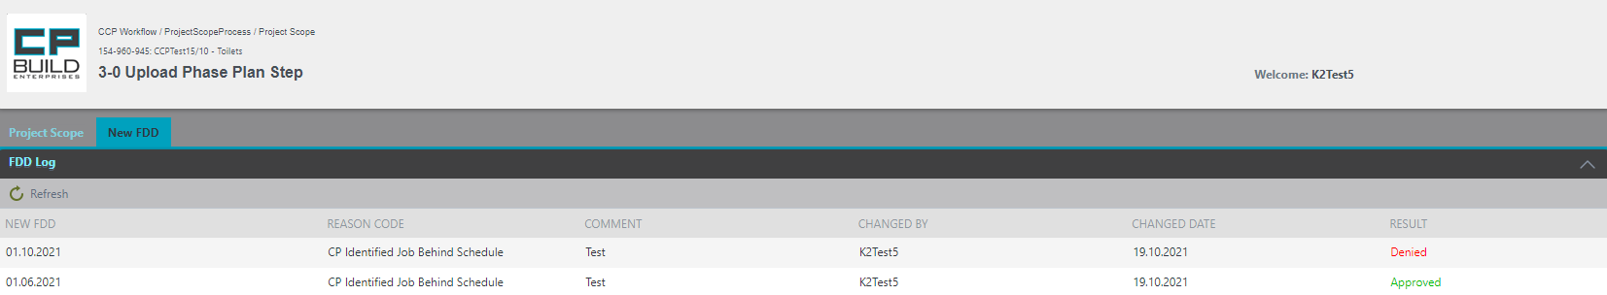

*\*Note: if after a change the FDD for Scope is set earlier than the existing FDD for the project, the corresponding FDD of the project will be updated on a shorter date. The data will be updated in Sales Force.*

### Tab Approval Notes

Tab Approval Notes becomes available in Step 64-2, Get Customer Response. The Approval Notes tab works with the files with the type of Price Quotation. The Attachment List view user may see added attachments and download them. The Attachment List works similarly to the Attachment Q/A area in the Q/A List tab.

*Screenshot - Sales – Step 4-0 Sales Review and Approve Price Quotation – Contracting Process*

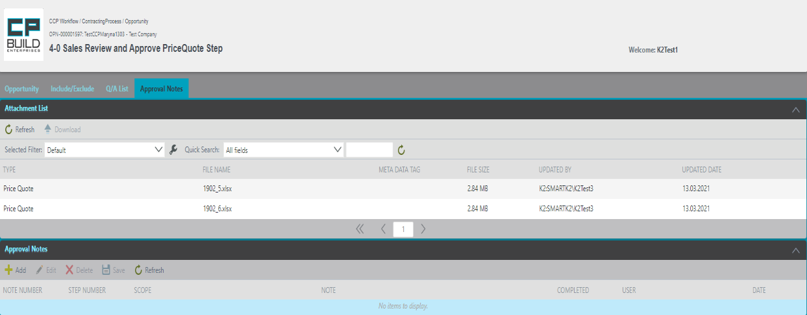

On the Attachment List view, you may see added attachments, which you can download.

In the "Approval Notes" area, you can add Notes to each Scope.



The toolbar contains buttons responsible for creating a new Notes click the "Add" button; deleting Notes with the "Delete" button; edit Notes using the "Edit" button and refresh the window with the "Refresh" button.

At this stage, you can change two fields: select Scope from the dropdown list and enter Note for these Scope.

***To add notes:***

1. On the Note column, enter the note text.

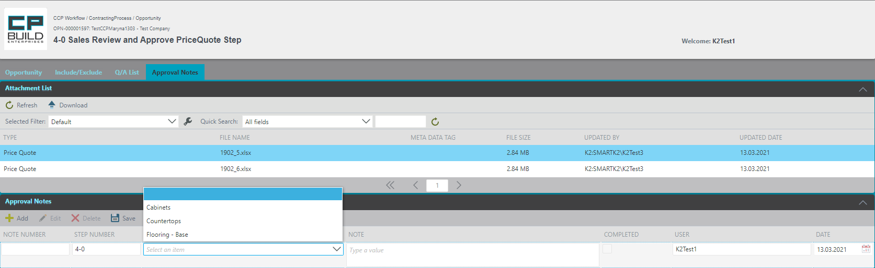

1. From the Attachments List, view select required Price Quotation file.
2. On the Approval Notes, click the Add button and a new row will appear.
3. In the Scope column, select from the drop-down list scope name that you need.
4. Click the Save button.

After saving, the status will be displayed with the inscription "Completed" - No.



In Step 64-0 Evaluate Cost Changes, On the Approval Notes tab, if approval notes were created in previous steps, the user needs to Complete the approval notes.

***To Complete approval notes:***

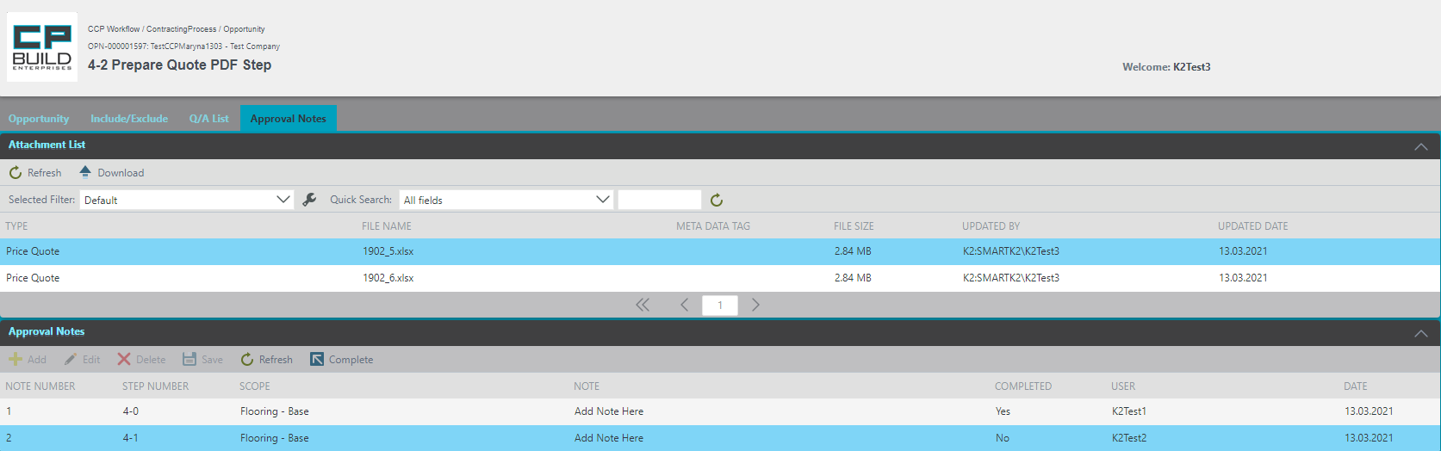

1. From the Attachments List, view select required Price Quote file.
2. Select needed note on the Approval Notes.
3. Click on the Complete button.

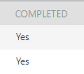

After pressing the Complete button, the completed column will change from “No” to “Yes”.

After that, this tab works only for viewing.

# Roles

# Task form images and instructions

### Sales

For the Sales role in the My Project menu, there are additional functional buttons Contract Review and SD Request (provided that the SD Request process was previously launched by the Estimator) located in the Toolbar. This is displayed when you select a Process Contracting project. The user can learn how to work with the corresponding buttons in the section "Images and descriptions of forms", which is described above.

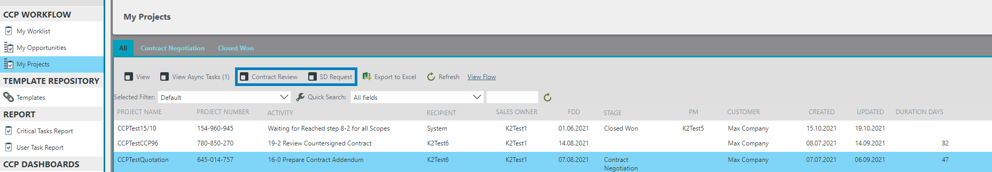

### **5-1 Prepare or Update SD Request for Scope**

Starts Step 5-1 from the SD Request tab. After filling in all the necessary information, the user needs to go to the Project Scope tab, where further navigation through the process takes place. On this tab, you can see all the information about the process from the very beginning process in the collapsed Project section. The user can learn how to work with the corresponding tabs in the section "Images and descriptions of forms", which is described above.

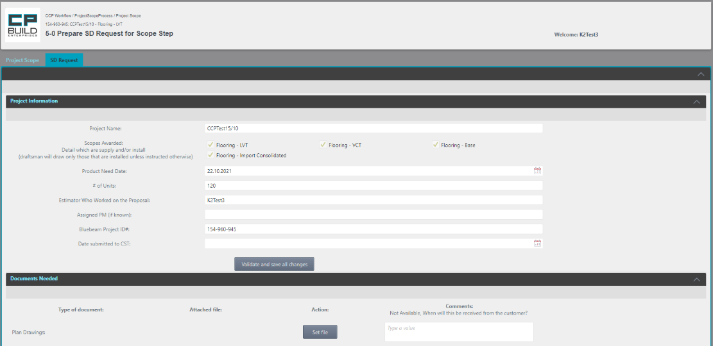

After filling in the SD Request tab, click the "Validate and save all changes" button.

*Screen shot - Sales – Step 5-1 Prepare or Update SD Request for Scope – Project Scope Process*

**Action for** **Step 5-1 Prepare or Update SD Request for Scope**

At this step, user must:

1. Fill in the SD Request tab and click the "Validate and save all changes."
2. After that, go to the Project Scope tab, where information on the current scope will be available.
3. Then Set the Action "Done" and click Submit.

The Action **"Done"** takes the process to the next step.

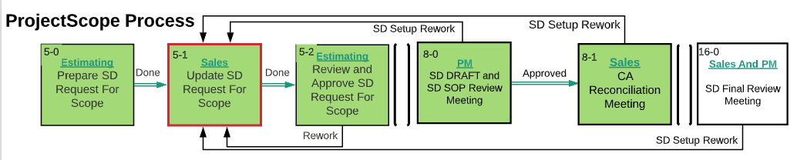

*Screen shot –* *Lucid Chart**– Step 5-1 Prepare or Update SD Request for Scope – Project Scope Process*

### **7-1 Upload SD SOP Step**

Step 7-1 starts from the Project Scope tab, where you can navigate further through the process. On this tab, you can also see all the information about the process from the very beginning of the process in the collapsed Project section. The SD Request and Submittals tabs is available for viewing. The user can learn how to work with the corresponding tabs in the section "Images and descriptions of forms", which is described above.

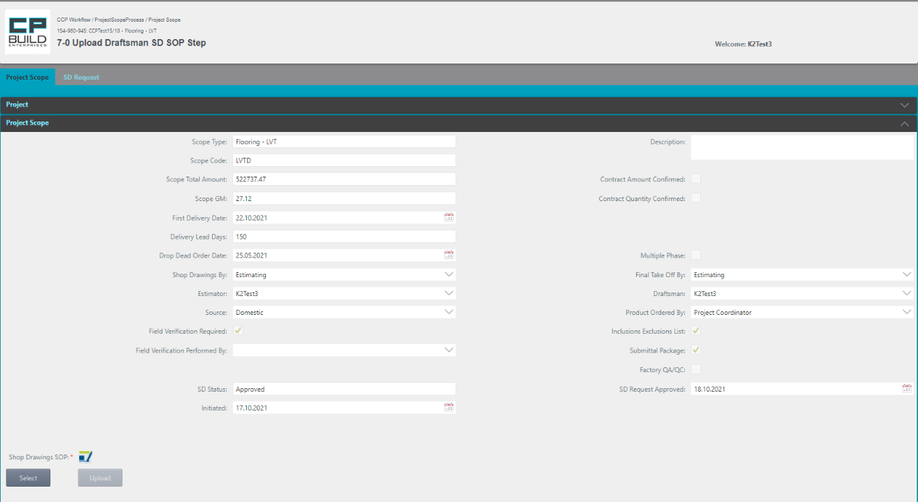

If necessary, by clicking on the icon, you can download the latest version of the document template, which must be attached to this step. After uploading the required of the file, Shop Drawings SOP will appear in the list of Attachments

*Screen shot - Sales – Step 7-1 Upload SD SOP – Project Scope Process*

**Action for Step 7-1 Upload SD SOP**

In this step, user must:

1. Select and upload the “Shop Drawings SOP.” If you Select wrong document, click Cancel and try again.
2. Then Set the Action "Done" and click Submit.

The Action **"Done"** takes the process to the next step.

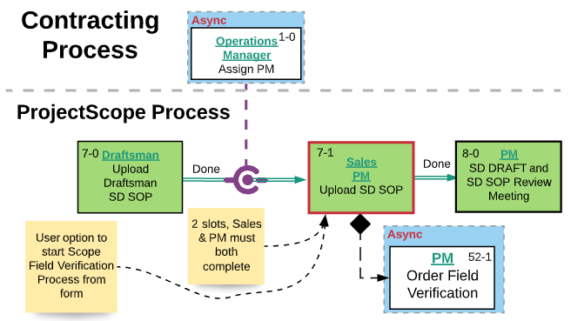

*Screen shot –* *Lucid Chart**– Step 7-1 Upload SD SOP – Project Scope Process*

### **8-1 CA Reconciliation Meeting Step**

Step 8-1 starts from the Project Scope tab, where you can navigate further through the process. On this tab, you can also see all the information about the process from the very beginning of the process in the collapsed Project section. The New FDD tab becomes available for viewing after the first change to the First Delivery Date. The SD Request and Submittals tabs is available for viewing. The user can learn how to work with the corresponding tabs in the section "Images and descriptions of forms", which is described above.

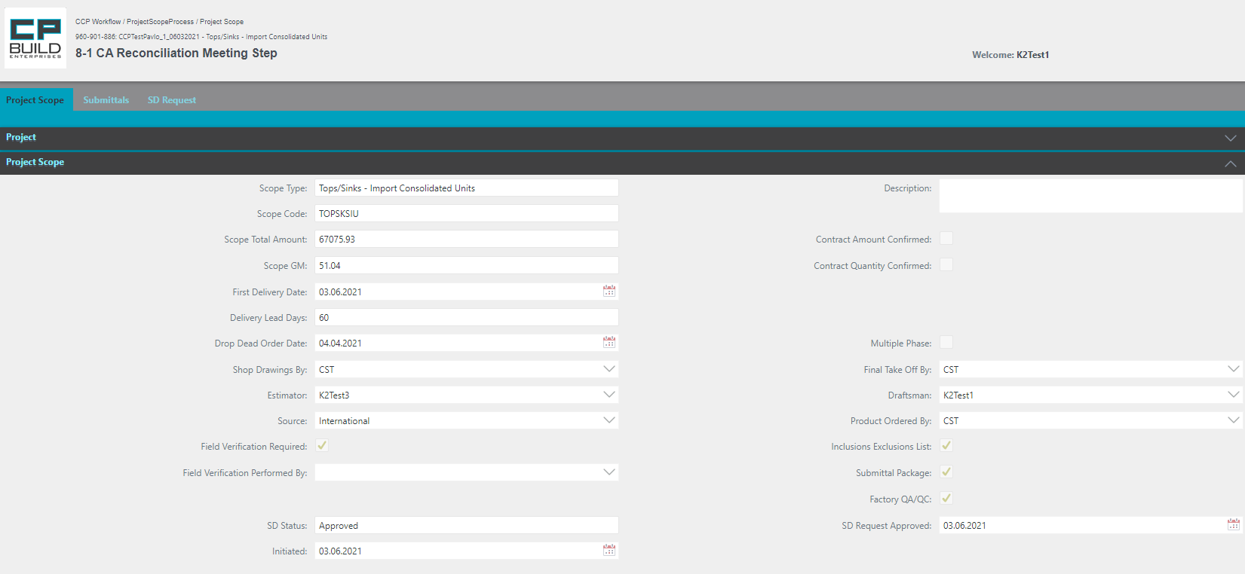

*Screen shot - Sales – Step 8-1 CA Reconciliation Meeting – Project Scope Process*

**Action for Step 8-1 CA Reconciliation Meeting**

At this step, user must:

1. Hold meeting with Sales, Estimating, and PM to Compare Shop Drawings with CA Quote
2. Set Action "Send SD to Customer" or “SD Setup Rework” and click Submit.

* The "Send SD to Customer" action will proceed to the next step “Send SD to Customer;”
* Action “SD Setup Rework” returns to the “Update SD Request for Scope” step.

*\*Note that the “SD Setup Rework” Actions requires a comment.*

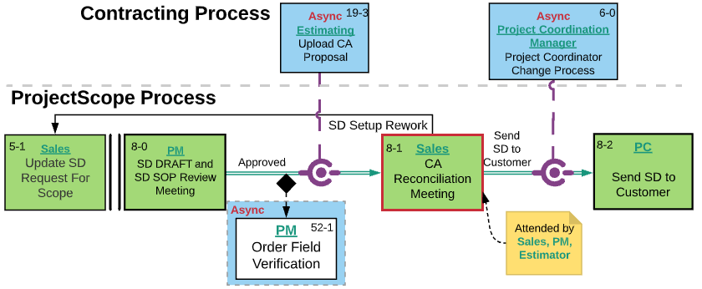

*Screen shot –* *Lucid Chart* *– Step 8-1 CA Reconciliation Meeting – Project Scope Process*

### **16-0 SD Final Review Meeting Step**

Step 16-0 starts from the Project Scope tab, where you can navigate further through the process. On this tab, you can also see all the information about the process from the very beginning of the process in the collapsed Project section. The Submittals tabs is available for viewing. The user can learn how to work with the corresponding tabs in the section "Images and descriptions of forms", which is described above.

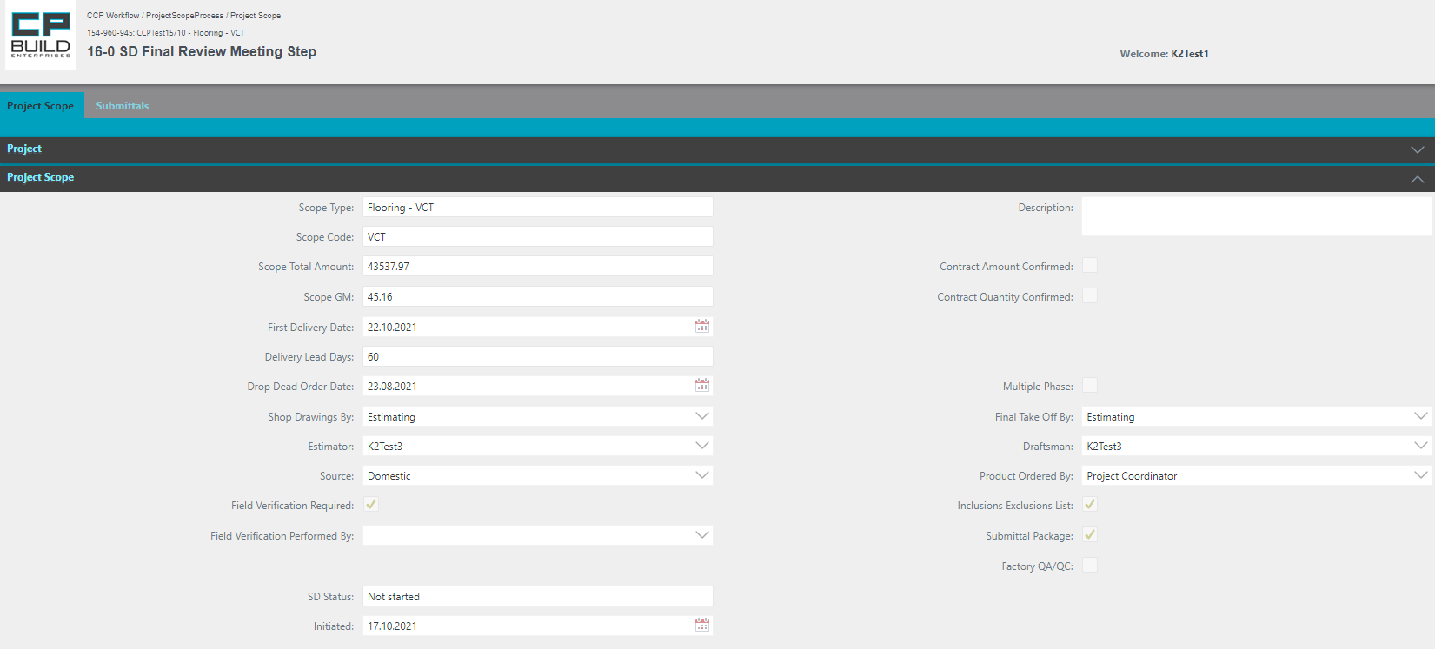

*Screen shot – Sales – Step 16-0 SD Final Review Meeting –Project Scope Process*

**Action for Step 16-0 SD Final Review Meeting**

At this step, the user must:

1. Follow-up to the Final SD Review Meeting.
2. User can add Description and Confirmed Contract Amount, Contract Quantity.
3. Set Action to “Approved”, “SD Setup Rework” or “Rework” and Click Submit.

* Action “Approved” goes to the next step “Upload Phase Plan”;
* Action “SD Setup Rework” returns to step “Update SD Request For Scope”;
* Action “Rework” returns to step “Upload New or Revised SD Final”.

*\*Note that the “Rework” Action requires a comment.*

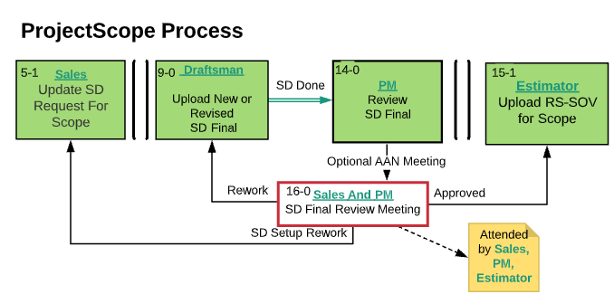

*Screen shot -* *Lucid Chart**– Step 16-0 SD Final Review Meeting –Project Scope Process*

### Estimating

For the Estimating role in the My Project menu, there is an additional functional button SD Request located in the Toolbar. It is displayed when you select a Process Contracting project. The user can learn how to work with the corresponding button in the section "Images and descriptions of forms", which is described above.

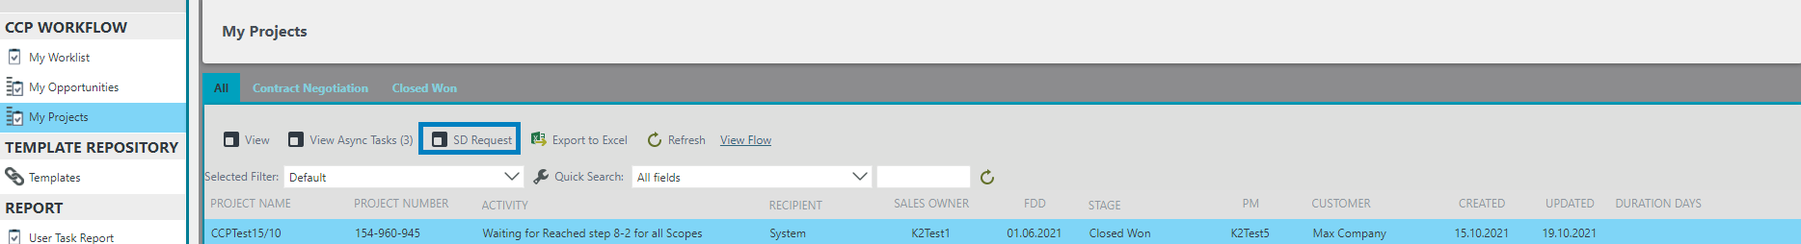

### **4-0 Upload Final Takeoff by Phase Step**

Step 4-0 starts from the Project Scope tab, where you can navigate further through the process. On this tab, you can also see all the information about the process from the very beginning of the process in the collapsed Project section. The Submittals tabs is available for viewing. The user can learn how to work with the corresponding tabs in the section "Images and descriptions of forms", which is described above.

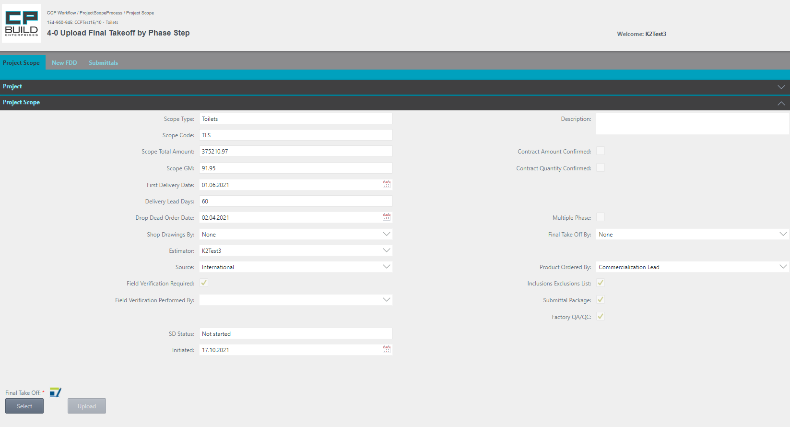

If necessary, by clicking on the icon, you can download the latest version of the document template, which must be attached to this step. After the uploading the required of the file, Final Take Off will appear in the list of Attachments.

You can add Description, Confirmed Contract Amount and Contract Quantity

*Screen shot - Estimating – Step 4-0 Upload Final Takeoff by Phase –Project Scope Process*

**Action for Step 4-0 Upload Final Takeoff by Phase**

In this step, the user must:

1. Select and Upload “Final Take Off.” If you select the wrong document, click Cancel and try again.
2. You can add Description and Confirmed Contract Amount, Contract Quantity.
3. Set Action to "Done" and Click Submit.

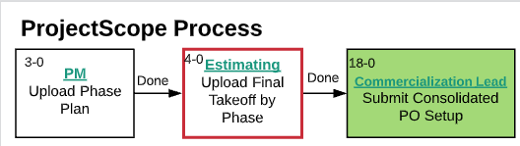

*Screen shot -* *Lucid Chart* *– Step 4-0 Upload Final Takeoff by Phase –Project Scope Process*

### **5-0 Prepare SD Request for Scope Step**

Starts Step 5-0 from the SD Request tab. After filling in all the necessary information, the user needs to go to the Project Scope tab, where further navigation through the process takes place. On this tab, you can also see all the information about the process from the very beginning process in the collapsed Project section. The user can learn how to work with the corresponding tabs in the section "Images and descriptions of forms", which is described above.



After filling in the SD Request tab, click the "Validate and save all changes" button.

*Screen shot - Estimating – Step 5-0 Prepare SD Request for Scope–Project Scope Process*

**Action for Step 5-0 Prepare SD Request for Scope**

In this step, the user must:

1. Fill in the SD Request tab and click the "Validate and save all changes"
2. After that, go to the Project Scope tab, where information on the current scope will be available
3. Set the Action "Done" and click Submit.

The Action **"Done"** takes the process to the next step.

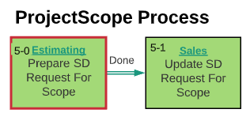

*Screen shot -**Lucid Chart* *– Step 5-0 Prepare SD Request for Scope–Project Scope Process*

### **5-2 Review and Approve SD Request For Scope Step**

Starts Step 5-2 from the SD Request tab. After filling in all the necessary information, the user needs to go to the Project Scope tab, where further navigation through the process takes place. On this tab, you can also see all the information about the process from the very beginning process in the collapsed Project section. The user can learn how to work with the corresponding tabs in the section "Images and descriptions of forms", which is described above.

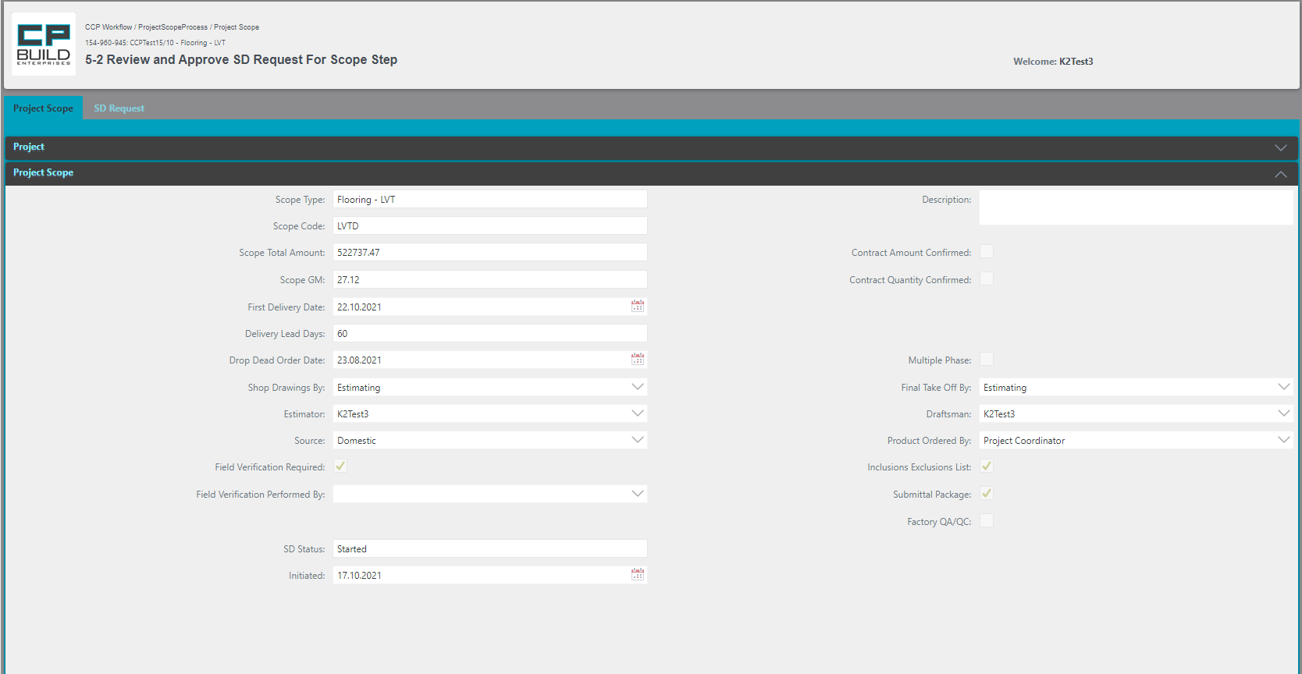

*Screen shot - Estimating – Step 5-2 Review and Approve SD Request For Scope–Project Scope Process*

**Action for Step 5-2 Review and Approve SD Request For Scope**

In this step, the user must:

1. Fill in the SD Request tab
2. After that, go to the Project Scope tab, where information on the current scope will be available
3. Set Action to “Done” or “Rework” and click Submit.

The Action **"Done"** moves on to the next step.

The Action **"Rework"** returns to the “Update SD Request for Scope” step.

*\*Note that the “Rework” Action requires a comment.*

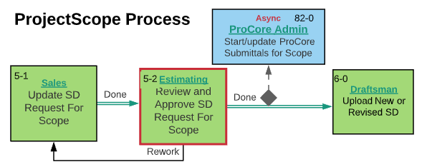

*Screen shot -* *Lucid Chart* *– Step 5-2 Review and Approve SD Request for Scope –Project Scope Process*

If after Step "5-2 Review and Approve SD Request for Scope Step " the asynchronous step "6-0 Start Project Coordinator Change Process" is not yet closed, the process will be blocked, and the user will not be able to get to "6-0 Upload New or Revised SD Step".

### **15-1 Upload RS-SOV for Scope Step**

Step 15-1 starts from the Project Scope tab, where you can navigate further through the process. On this tab, you can also see all the information about the process from the very beginning of the process in the collapsed Project section. The Submittals tabs is available for viewing. The user can learn how to work with the corresponding tabs in the section "Images and descriptions of forms", which is described above.

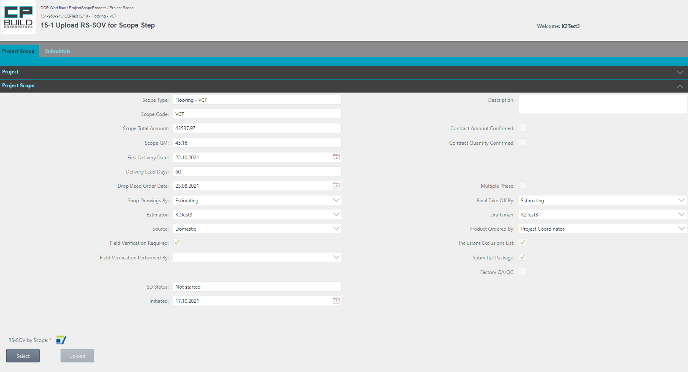

If necessary, by clicking on the icon, you can download the latest version of the document template, which must be attached to this step. After uploading the required of the file, RS-SOV by Scope will appear in the list of Attachments

*Screen shot - Estimating – Step 15-1 Upload RS-SOV for Scope –Project Scope Process*

**Action for Step 15-1 Upload RS-SOV for Scope**

In this step, the user must:

1. Select and Upload “RS-SOV by Scope.” If you select the wrong document, click Cancel and try again.
2. Set Action “Done” and click Submit.

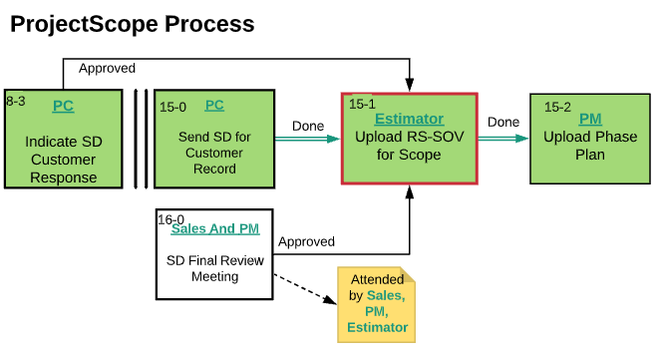

*Screen shot -* *Lucid Chart* *– Step 15-1 Upload RS-SOV for Scope –Project Scope Process*

### **64-0 Evaluate Cost Changes Step**

Step 64-0 starts from the Project Scope tab, where you can navigate further through the process. On this tab, you can also see all the information about the process from the very beginning of the process in the collapsed Project section. The Submittals tabs is available for viewing. In Approval Notes tab, check notes complete. The user can learn how to work with the corresponding tabs in the section "Images and descriptions of forms", which is described above.

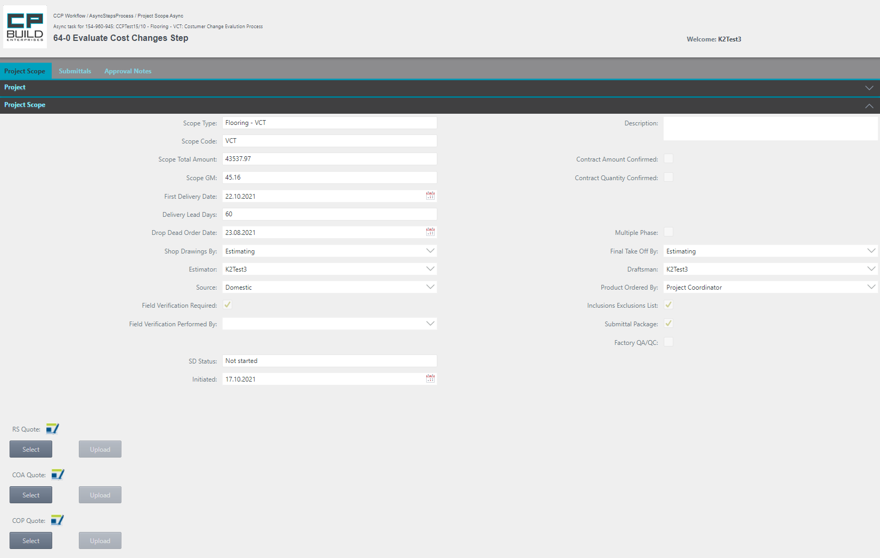

If necessary, by clicking on the icon, you can download the latest version of the document template, which must be attached to this step. After uploading the required of the file, modified quote file and/or “CO Quote” will appear in the list of Attachments

*Screen shot - Estimating – Step 64-0 Evaluate Cost Changes –Project Scope Process*

**Action for Step 64-0 Evaluate Cost Changes**

In this step, the user must:

1. In the Project Scope tab, the Estimator evaluates customer changes to determine cost and prepares a modified quote file and/or “CO Quote” for a change order.
2. In the Approval Notes tab, check notes complete. Select Action, depending on the uploaded file.
3. Set Action “RS Quote", “COA Quote" or “COP Quote" and click Submit.

* if the user selects Action “COP Quote,” it will go to the next step, “Send CO Quote to Customer.”;
* if the user selects Action “COA Quote” or “RS Quote Process,” it will go to the Main Process and to the next step.

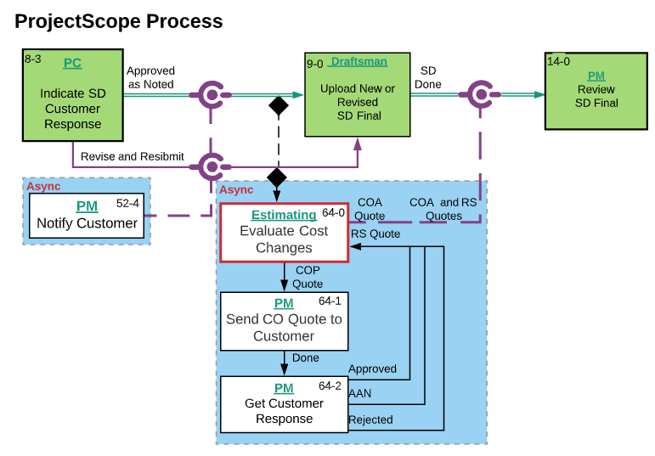

*Screen shot -* *Lucid Chart* *– Step 64-0 Evaluate Cost Changes –Project Scope Process*

### **72-0 Upload Last-Quote for Scope Step**

Step 72-0 starts from the Project Scope tab, where you can navigate further through the process. On this tab, you can see all the information about the process from the very beginning of the process in the collapsed Project section. The user can learn how to work with the corresponding tabs in the section "Images and descriptions of forms", which is described above.

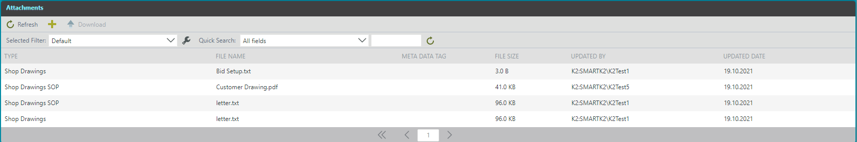

*Screen shot - Estimating – Step 72-0 Upload Last-Quote for Scope –Project Scope Process*

**Action for Step 72-0 Upload Last-Quote for Scope**

In this step, the user must:

1. Upload Last-Quote for Scope
2. Then Set the Action "Done" and click Submit.

The Action **"Done"** takes the process to the next step.

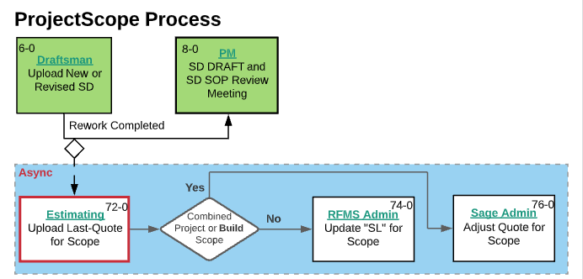

*Screen shot -* *Lucid Chart* *– Step 72-0 Upload Last-Quote for Scope –Project Scope Process*

### Sage admin

### **76-0 Adjust Quote for Scope Step**

The process gets to this step, provided that the project is Combined or Build Scope. Step 76-0 starts from the Project Scope tab, where you can navigate further through the process. On this tab, you can also see all the information about the process from the very beginning of the process in the collapsed Project section. The user can learn how to work with the corresponding tabs in the section "Images and descriptions of forms", which is described above.

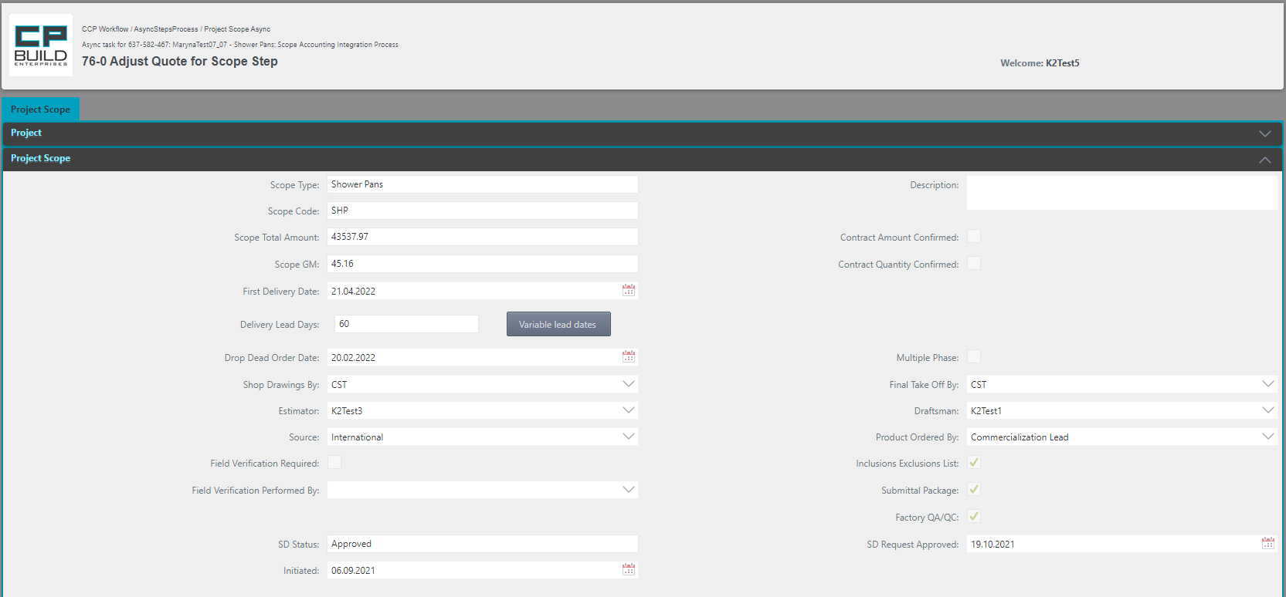

*Screen shot - Sage admin – Step 76-0 Adjust Quote for Scope –Project Scope Process*

**Action for Step 76-0 Adjust Quote for Scope**

At this step, user need:

1. In Sage, adjust the Quotation SOV for this Scope.
2. Then Set the Action "Done" and click Submit.

The Action **"Done"** takes the process to the next step.

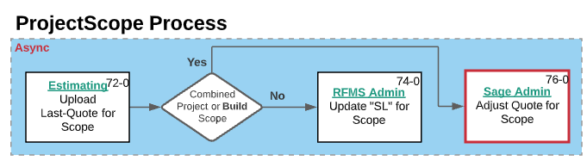

*Screen shot -* *Lucid Chart* *– Step 76-0 Adjust Quote for Scope –Project Scope Process*

### Draftsman

### **6-0 Upload New or Revised SD Step**

Step 6-0 starts from the Project Scope tab, where you can navigate further through the process. On this tab, you can also see all the information about the process from the very beginning of the process in the collapsed Project section. The SD Request and Submittals tabs is available for viewing. The user can learn how to work with the corresponding tabs in the section "Images and descriptions of forms," which is described above.

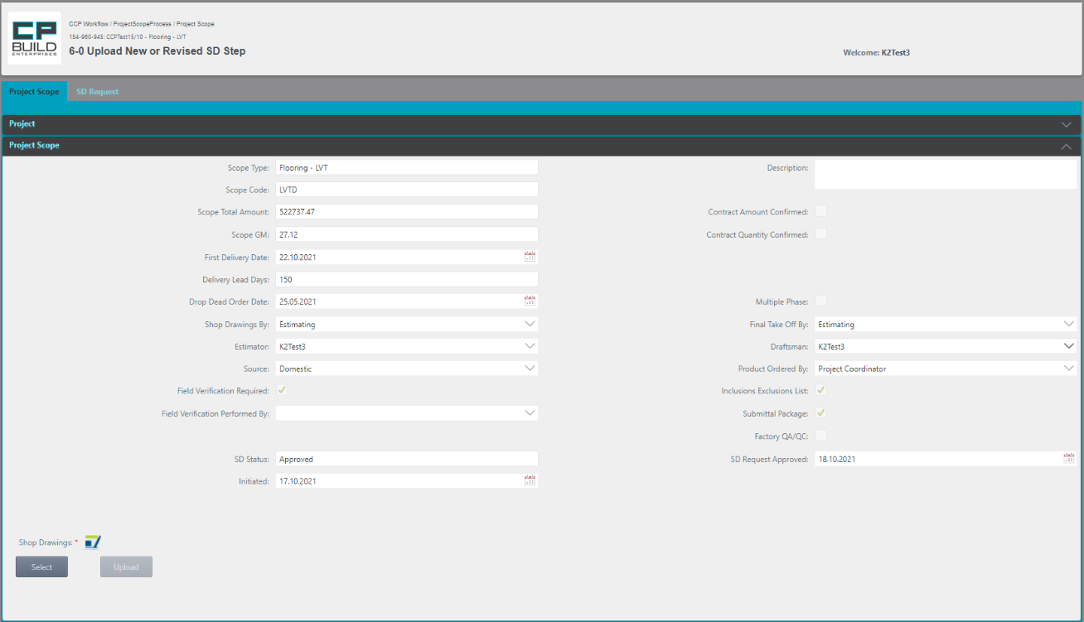

At this point, you can modify Draftsman, as needed.

If necessary, by clicking on the icon, you can download the latest version of the document template, which must be attached to this step. After uploading the required file, Shop Drawings will appear in the list of Attachments

*Screen shot – Draftsman – Step 6-0 Upload New or Revised SD –Project Scope Process*

**Action for Step 6-0 Upload New or Revised SD**

In this step, the user must:

1. Select the required «Draftsman» (if user wants to assign the task to another Draftsman);
2. Select and upload the “Shop Drawings.” If you select wrong document, click Cancel and try again.
3. Set Action to “Assign Draftsman”, “Release to Group”, “SD Draft Completed” or "Rework Completed," then click Submit.

- if needed, Select from drop-down list another Draftsman, and set Action “Assign Draftsman”;

- to return the task to the group of draftsmen's, set Action to “Release to Group”

- the “SD Draft Completed" action will proceed to the “Upload Draftsman SD SOP” step

- to Complete the Rework process, select "Rework Completed". This item of the task action menu becomes available only if the action “Rework” was previously selected from the step “SD Draft and SD SOP Review Meeting”

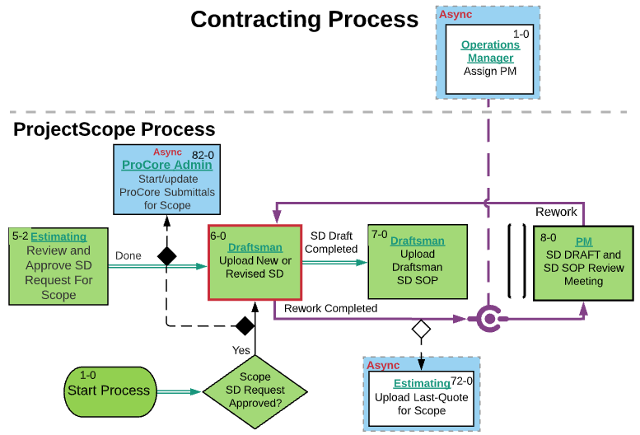

*Screen shot -* *Lucid Chart* *– Step 6-0 Upload New or Revised SD –Project Scope Process*

### **7-0 Upload Draftsman SD SOP Step**

Step 7-0 starts from the Project Scope tab, where you can navigate further through the process. On this tab, you can also see all the information about the process from the very beginning of the process in the collapsed Project section. The SD Request and Submittals tabs is available for viewing. The user can learn how to work with the corresponding tabs in the section "Images and descriptions of forms", which is described above.



If necessary, by clicking on the icon, you can download the latest version of the document template, which must be attached to this step. After uploading the required of the file, Shop Drawings SOP will appear in the list of Attachments

*Screen shot – Draftsman – Step 7-0 Upload Draftsman SD SOP –Project Scope Process*

**Action for Step 7-0 Upload Draftsman SD SOP**

In this step, the user must:

1. Select and upload the “Shop Drawings SOP.” If you select the wrong document, click Cancel and try again.
2. Then Set the Action "Done" and click Submit.

The Action **"Done"** takes the process to the next step.

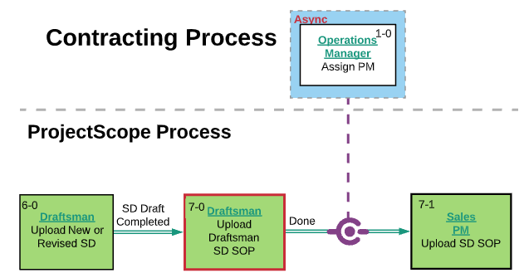

*Screen shot -* *Lucid Chart* *– Step 7-0 Upload Draftsman SD SOP –Project Scope Process*

If after Step "7-0 Upload Draftsman SD SOP Step " the asynchronous step "1-0 Start PM Change Process " is not yet closed, the process will be blocked and will not be able to get to "7-1 Upload SD SOP Step ".

### **9-0 Upload New or Revised SD Final Step**

Step 9-0 starts from the Project Scope tab, where you can navigate further through the process. On this tab, you can also see all the information about the process from the very beginning of the process in the collapsed Project section. The SD Request and Submittals tabs is available for viewing. The user can learn how to work with the corresponding tabs in the section "Images and descriptions of forms," which is described above.

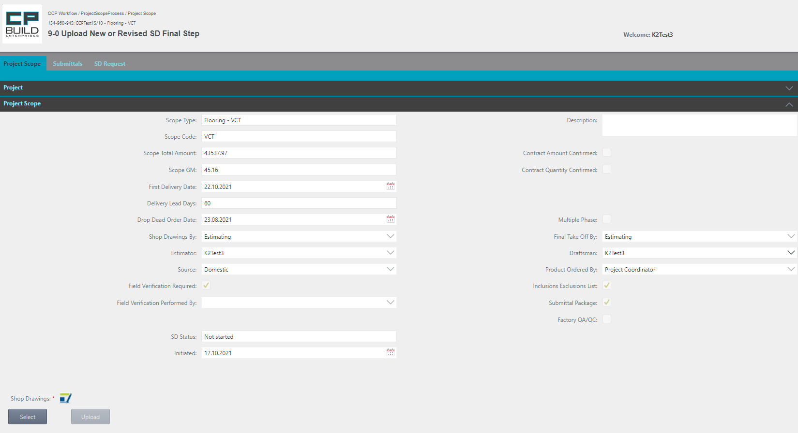

If necessary, by clicking on the icon, you can download the latest version of the document template, which must be attached to this step. After uploading the required file, Shop Drawings will appear in the list of Attachments.

At this point, you can modify Draftsman, as needed.

*Screen shot – Draftsman – Step 9-0 Upload New or Revised SD Final –Project Scope Process*

**Action for Step 9-0 Upload New or Revised SD Final**

In this step, the user must:

1. Select the required «Draftsman» (if the user wants to assign the task to another Draftsman);
2. Select and upload New or Revised “Shop Drawings.” If you select the wrong document, click Cancel and try again.
3. Set Action to "SD Done," "Assign Draftsman" or "Release to Group" and Click Submit.

* if needed, select from the drop-down list another Draftsman, and set Action “Assign Draftsman;”
* To return the task to the group of draftsmen's, set Action to “Release to Group.”
* The “SD Done” action will proceed to the step “Review SD Final”

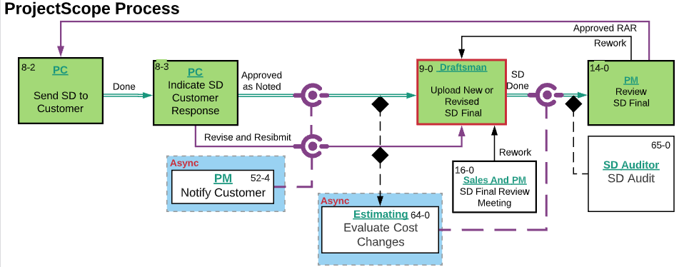

*Screen shot -* *Lucid Chart* *– Step 9-0 Upload New or Revised SD Final –Project Scope Process*

### **17-0 Upload Final Takeoff by Phase Step**

Step 17-0 starts from the Project Scope tab, where you can navigate further through the process. On this tab, you can also see all the information about the process from the very beginning of the process in the collapsed Project section. The Submittals tab is available for viewing. The user can learn how to work with the corresponding tabs in the section "Images and descriptions of forms", which is described above.

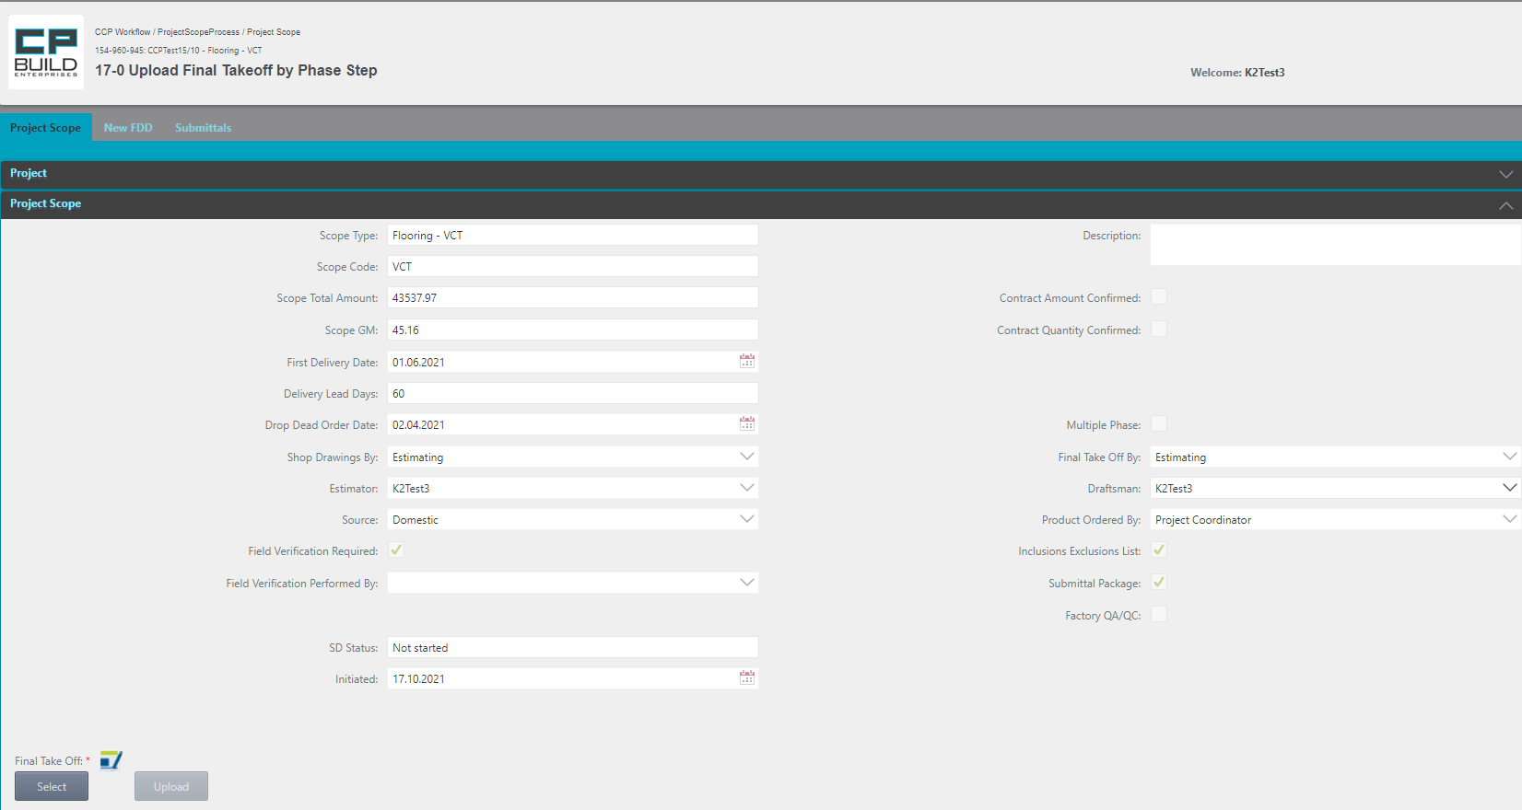

If necessary, by clicking on the icon, you can download the latest version of the document template, which must be attached to this step. After uploading the required of the file, Final Take Off will appear in the list of Attachments.

At this point, you can modify Draftsman, as needed.

*Screen shot – Draftsman – Step 17-0 Upload Final Takeoff by Phase –Project Scope Process*

**Action for Step 17-0 Upload Final Takeoff by Phase**

In this step, the user must:

1. Select the required «Draftsman» (if the user wants to assign the task to another Draftsman);
2. Select and Upload “Final Take Off” by Phase. If you select the wrong document, click Cancel and try again.
3. Set Action as "Done", "Assign Draftsman" or "Release to Group" and Click Submit.

* If needed, select from the drop-down list another Draftsman, and set Action to “Assign Draftsman”;
* To return the task to the group of draftsmen's, set Action to “Release to Group”;
* The “Done” action will proceed to the step “Submit Consolidated PO Setup”

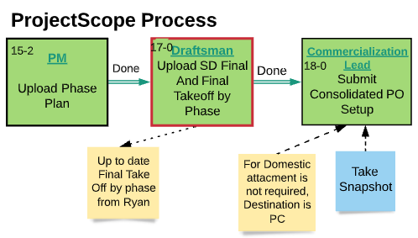

*Screen shot -* *Lucid Chart* *– Step 17-0 Upload Final Takeoff by Phase –Project Scope Process*

### RFMS Admin

### **74-0 Update SL for Scope Step**

The process gets to this step, provided that the project does not meet the "Combined project" condition or "Build Scope". Step 74-0 starts from the Project Scope tab, where you can navigate further through the process. On this tab, you can also see all the information about the process from the very beginning of the process in the collapsed Project section. The user can learn how to work with the corresponding tabs in the section "Images and descriptions of forms", which is described above.

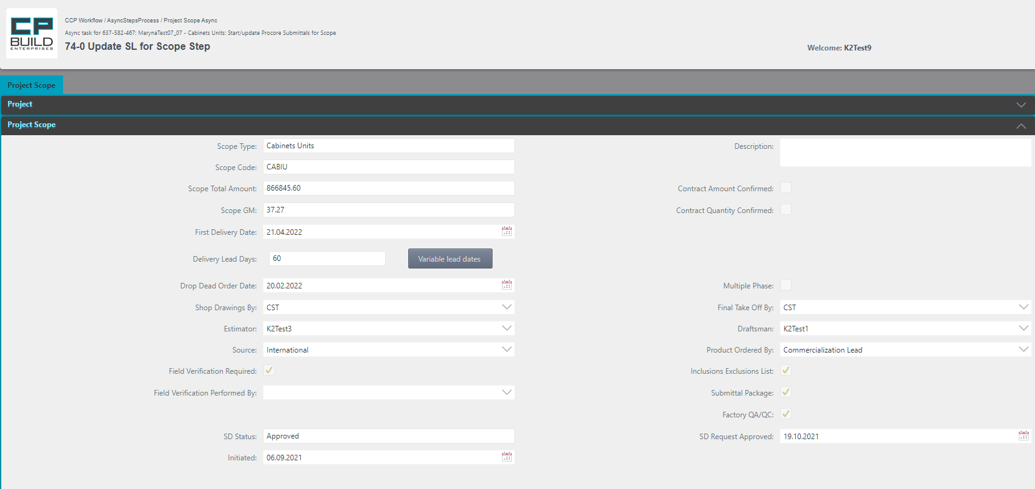

*Screen shot - RFMS Admin – Step 74-0 Update SL for Scope –Project Scope Process*

**Action for Step 74-0 Update SL for Scope**

In this step, the user must:

1. In RFMS, update the “SL” for this Scope
2. Then Set the Action "Done" and click Submit.

The Action **"Done"** takes the process to the next step.



*Screen shot -* *Lucid Chart**– Step 74-0 Update SL for Scope – Project Scope Process*

### PM

For the PM role in the My Project menu, there are additional functional buttons Change FDD and Change Delivery Lead Days located in the Toolbar. They are displayed when you select a Project Scope process. The user can learn how to work with the corresponding buttons in the section “Images and descriptions of forms”, which is described above.



### **3-0 Upload Phase Plan Step**

Step 3-0 starts from the Project Scope tab, where you can navigate further through the process. On this tab, you can also see all the information about the process from the very beginning of the process in the collapsed Project section. The user can learn how to work with the corresponding tabs in the section "Images and descriptions of forms," which is described above.

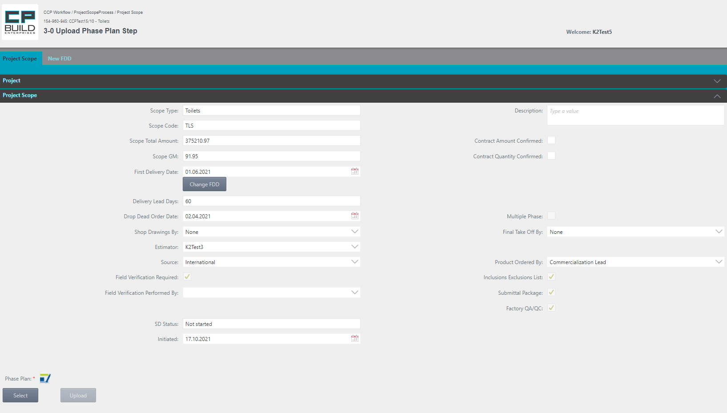

If necessary, by clicking on the icon, you can download the latest version of the document template, which must be attached to this step. After uploading the required file, the Phase Plan will appear in the list of Attachments.

If the "First Delivery Date" date does not correspond to the date specified in the uploaded document, the user will be prompted with a message. The user can then change the date value, by using the "Change FDD" button.

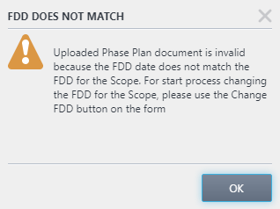

After successful uploading of the document, an additional area "Project Scope Phase" will be displayed.

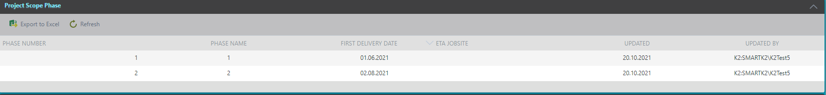

*Screen shot – PM – Step 3-0 Upload Phase Plan – Project Scope Process*

**Action for Step 3-0 Upload Phase Plan**

In this step, the user must:

1. The button "Start the field validation process" is available. In this case, step "52-1 Order Field Verification" will be launched ahead of schedule.
2. Select and upload the “Shop Drawings SOP.” If you select the wrong document, click Cancel and try again.
3. Then Set the Action "Done" and click Submit.

The Action **"Done"** takes the process to the next step.

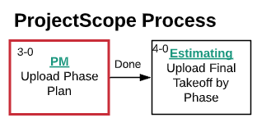

*Screen shot –* *Lucid Chart* *– Step 3-0 Upload Phase Plan – Project Scope Process*

### **7-1 Upload SD SOP Step**

Step 7-1 starts from the Project Scope tab, where you can navigate further through the process. On this tab, you can also see all the information about the process from the very beginning of the process in the collapsed Project section. The SD Request tab is available for viewing. The user can learn how to work with the corresponding tabs in the section "Images and descriptions of forms", which is described above.

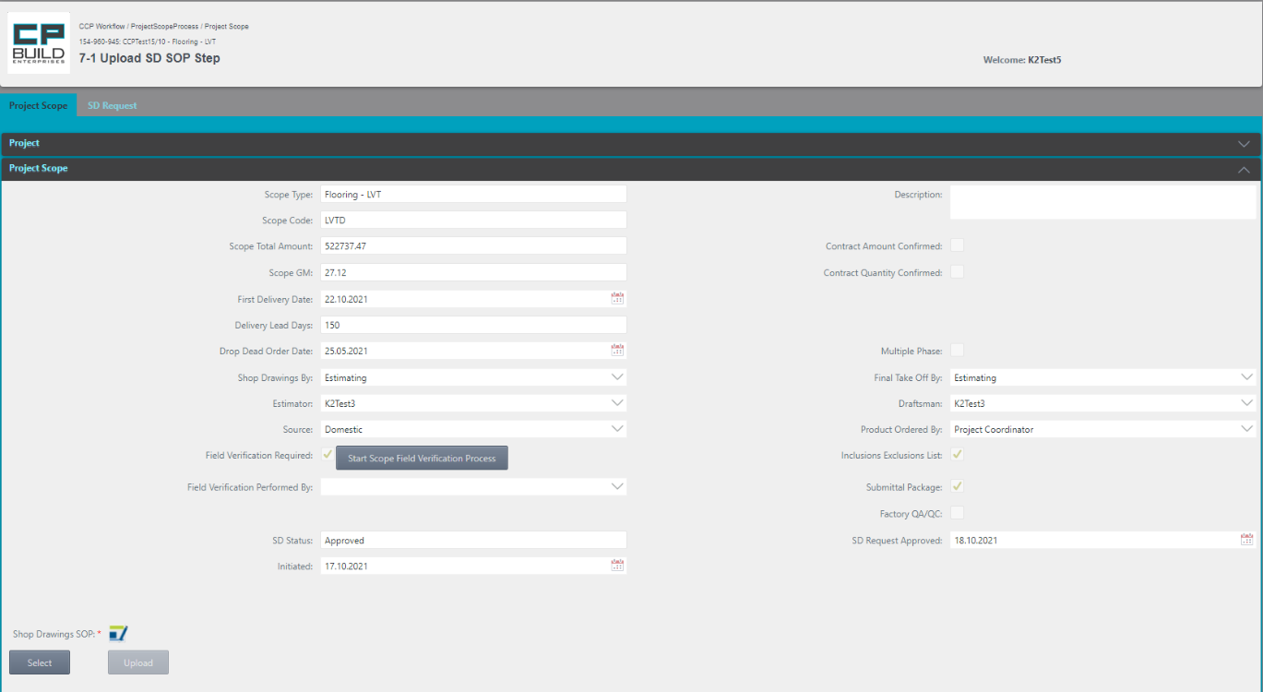

If necessary, by clicking on the icon, you can download the latest version of the document template, which must be attached to this step. After uploading the required file, Shop Drawings SOP will appear in the list of Attachments

PM can Start Scope Field Verification Process - by pressing a button.

*Screen shot – PM – Step 7-1 Upload SD SOP – Project Scope Process*

**Action for Step 7-1 Upload SD SOP**

In this step, user must:

1. The button "Start the field validation process" is available. In this case, step "52-1 Order Field Verification" will be launched ahead of schedule.
2. Select and upload the “Shop Drawings SOP.” If you select the wrong document, click Cancel and try again.
3. Then Set the Action "Done" and click Submit.

The Action **"Done"** takes the process to the next step.



*Screen shot –* *Lucid Chart* *– Step 7-1 Upload SD SOP – Project Scope Process*

### **8-0 SD DRAFT and SD SOP Review Meeting Step**

Step 8-0 starts from the Project Scope tab, where you can navigate further through the process. On this tab, you can also see all the information about the process from the very beginning of the process in the collapsed Project section. The New FDD tab becomes available for viewing after the first change to the First Delivery Date. The SD Request tab is available for viewing. The user can learn how to work with the corresponding tabs in the section "Images and descriptions of forms," which is described above.

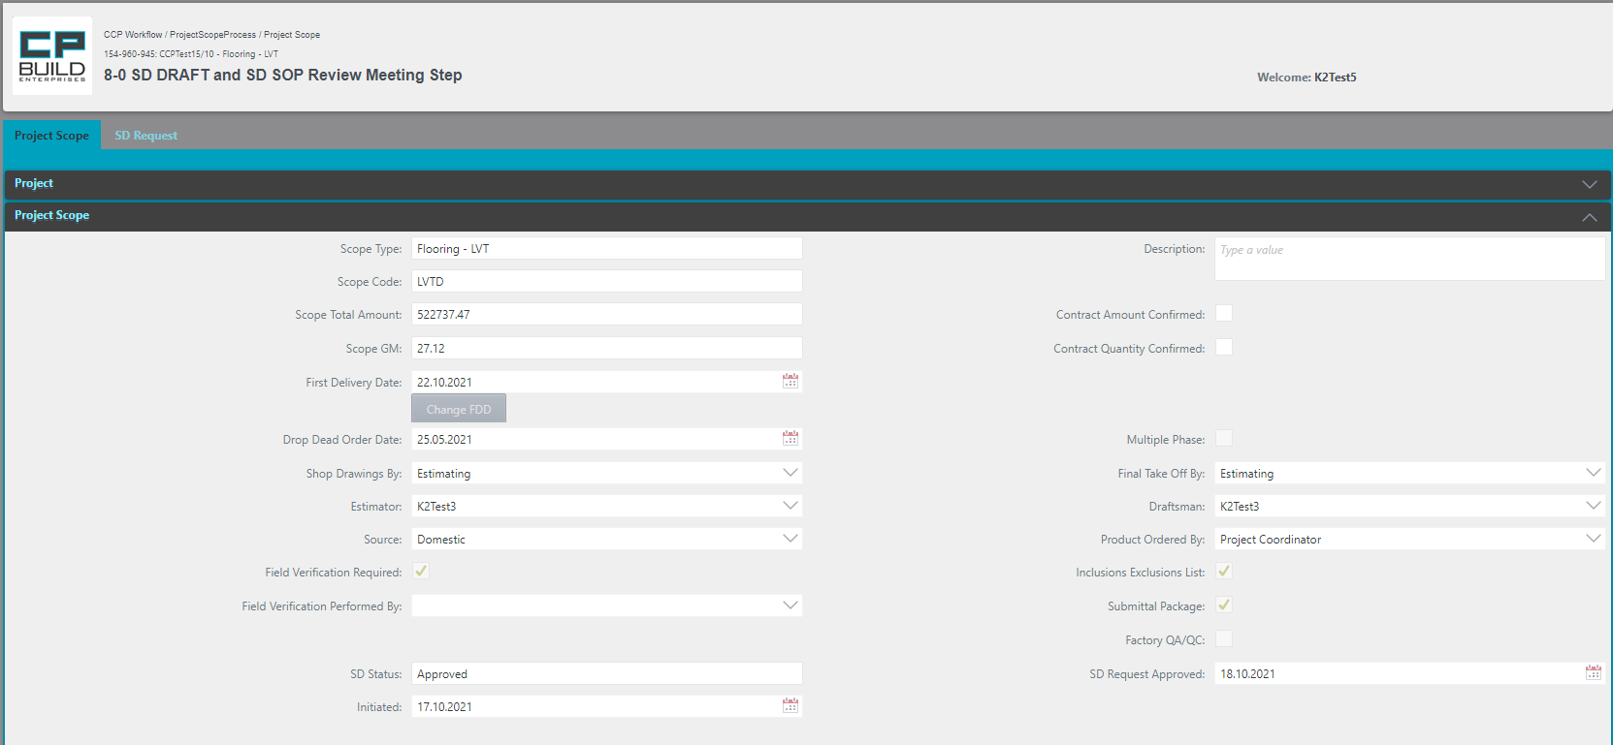

You can start the process of changing FDD. To do this, use the button "Change FDD".

*Screen shot – PM – Step 8-0 SD DRAFT and SD SOP Review Meeting– Project Scope Process*

**Action for Step 8-0 SD DRAFT and SD SOP Review Meeting**

At this step, user need:

1. You can start the process of changing FDD. To do this, use the Change FDD button.

*Note The user can find a step-by-step description of how to change the FDD in the description of the "New FDD" tab.

1. If needed, add Description and Contract Amount Confirmed, Contract Quantity Confirmed.
2. Set Action to "Approve", "Rework" or "SD Setup Rework" and Click Submit.

* Action “Approve” go to the next step “CA Reconciliation Meeting”
* “Rework” returns to the " Upload New or Revised SD " step
* Action “SD Setup Rework” returns to the “Update SD Request for Scope” step.

*\*Note that the “Rework” and “SD Setup Rework” actions require a comment.*

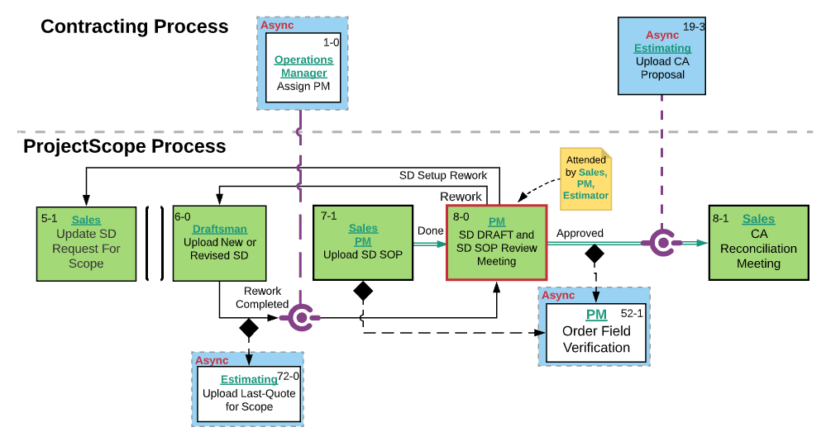

*Screen shot –* *Lucid Chart* *– Step 8-0 SD DRAFT and SD SOP Review Meeting – Project Scope Process*

### **52-1 Orders Field Verification Step**

Step 52-1 starts from the Project Scope tab, where you can navigate further through the process. On this tab, you can also see all the information about the process from the very beginning of the process in the collapsed Project section. The user can learn how to work with the corresponding tabs in the section "Images and descriptions of forms", which is described above.

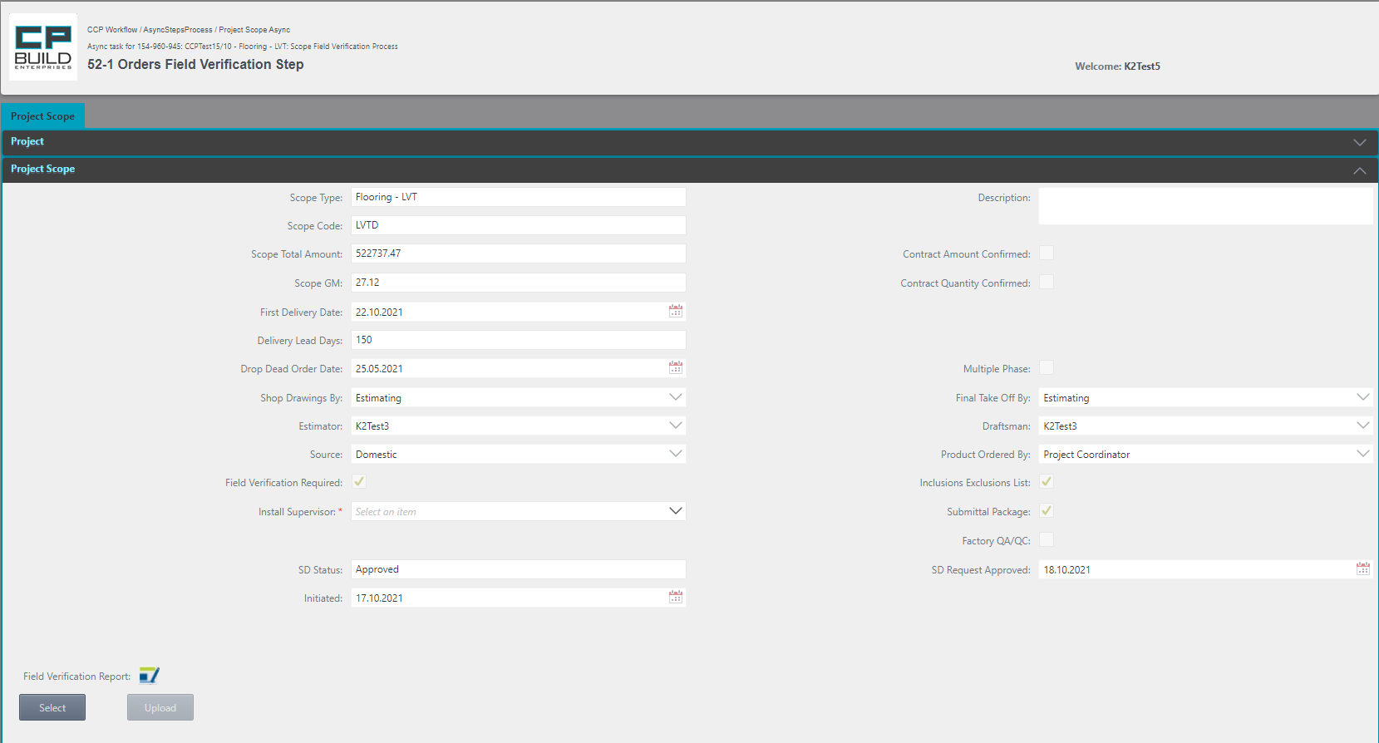

If necessary, by clicking on the icon, you can download the latest version of the document template, which must be attached to this step. After uploading the required file, Field Verification Report will appear in the list of Attachments

If the FV is ordered, you need to select Install Supervisor.

*Screen shot – PM – Step 52-1 Orders Field Verification – Project Scope Process*

**Action for Step 52-1 Orders Field Verification**

In this step, the user must:

1. If the FV is ordered, you need to select Install Supervisor.
2. Select and upload the "Field Validation Report." iI you select the wrong document, click Cancel and try again.
3. Set Action “Order FV” or “FV Not Possible” and click Submit.

* The “Order FV” action will proceed to the step “Field Verification;”
* The “FV Not Possible” action will proceed to the step “Upload New or Revised SD Final.”

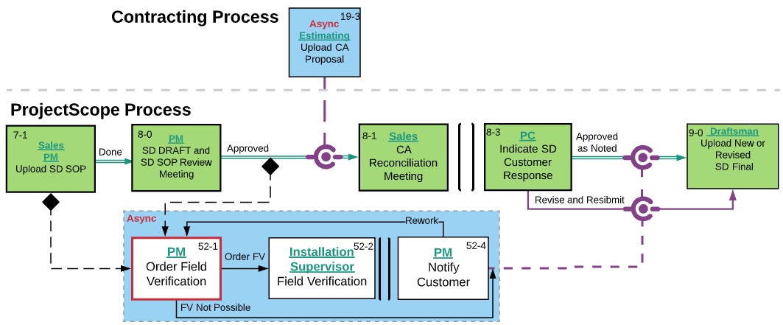

*Screen shot –* *Lucid Chart* *– Step 52-1 Orders Field Verification – Project Scope Process*

### **52-3 Review Field Verification Step**

Step 52-3 starts from the Project Scope tab, where you can navigate further through the process. On this tab, you can also see all the information about the process from the very beginning of the process in the collapsed Project section. The user can learn how to work with the corresponding tabs in the section "Images and descriptions of forms", which is described above.

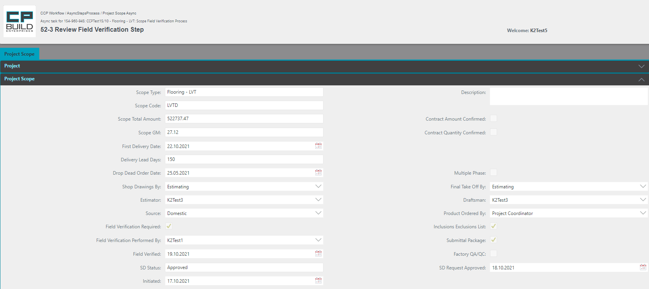

*Screen shot – PM – Step 52-3 Review Field Verification – Project Scope Process*

**Action for Step 52-3 Review Field Verification**

In this step, the user must:

1. Review the Field Verification Report.
2. Set Action “FV Done”, “Rework” or “Site Unacceptable” and click Submit.

* The “FV Done” action will proceed to the step “Upload New or Revised SD Final”;
* The “Site Unacceptable” action will proceed to the step “Notify Customer”;
* The “Rework” returns to the “Field Verification” step.

*\*Note that the “Rework” or “Site Unacceptable” Actions require a comment.*

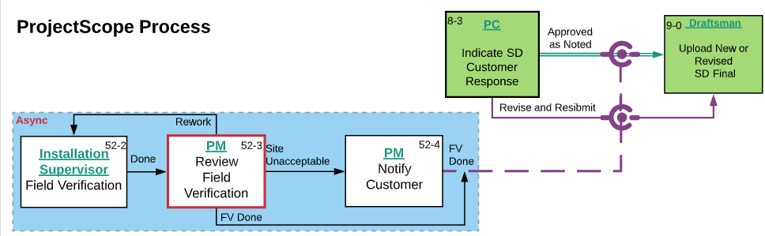

*Screen shot –* *Lucid Chart* *– Step 52-3 Review Field Verification – Project Scope Process*

### **52-4 Notify Customer Step**

Step 52-4 starts from the Project Scope tab, where you can navigate further through the process. On this tab, you can also see all the information about the process from the very beginning of the process in the collapsed Project section. The user can learn how to work with the corresponding tabs in the section "Images and descriptions of forms," which is described above.

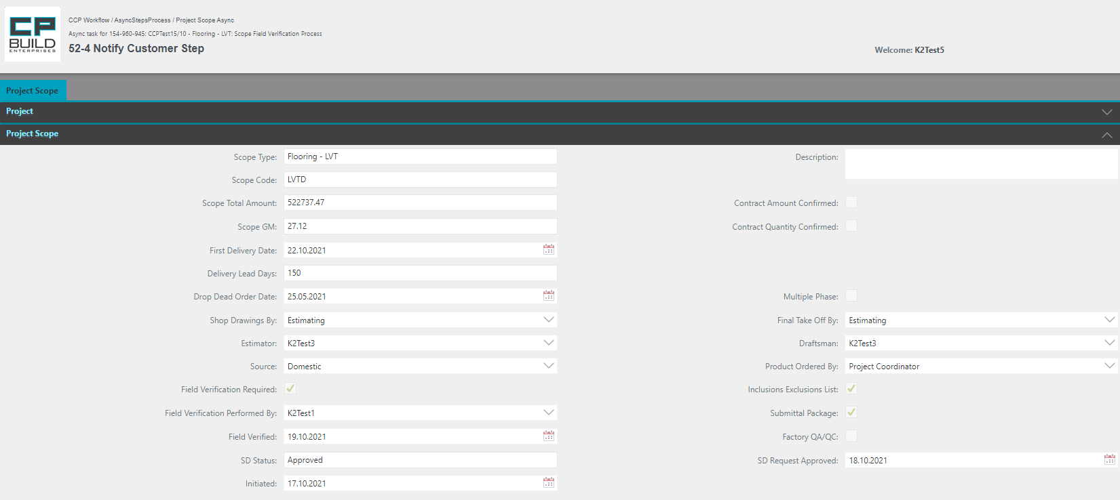

*Screen shot – PM – Step 52-4 Notify Customer – Project Scope Process*

**Action for Step 52-4 Notify Customer**

In this step, the user must:

1. Notify customer and based on customer response, select an action.
2. Set Action “FV Done” or “Rework” and click Submit.

* The “FV Done” action will proceed to the step “Upload New or Revised SD Final,”
* The “Rework” returns to the “Order Field Verification” step.

*\*Note that the “Rework” Action requires a comment.*

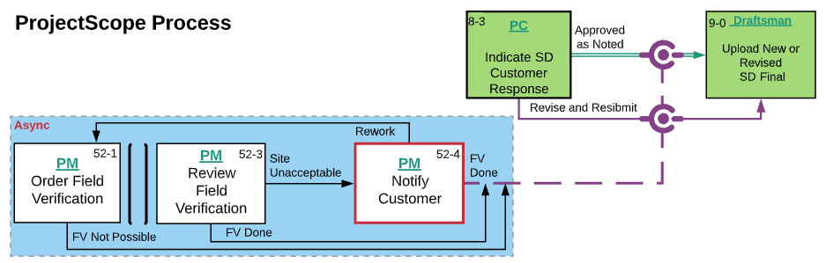

*Screen shot –* *Lucid Chart* *– Step 52-4 Notify Customer – Project Scope Process*

### **64-1 Send CO Quote to Customer Step**

Step 64-1 starts from the Project Scope tab, where you can navigate further through the process. On this tab, you can also see all the information about the process from the very beginning of the process in the collapsed Project section. The Submittals tab is available for viewing. The user can learn how to work with the corresponding tabs in the section "Images and descriptions of forms," which is described above.

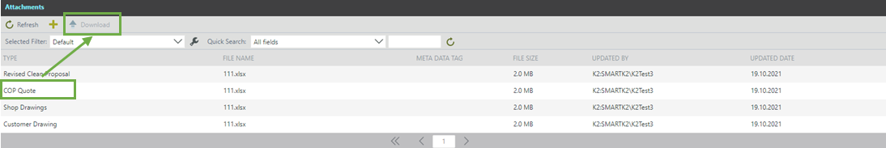

*Screen shot – PM – Step 64-1 Send CO Quote to Customer –Project Scope Process*

**Action for Step 64-1 Send CO Quote to Customer**

In this step, the user must:

1. Download the COP Quote from the link and send to the customer.
2. Set Action “Done” and click Submit.

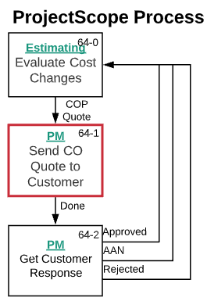

*Screen shot -* *Lucid Chart* *– Step 64-1 Send CO Quote to Customer –Project Scope Process*

### **64-2 Get Customer Response Step**

Step 64-2 starts from the Project Scope tab, where you can navigate further through the process. On this tab, you can see all the information about the process from the very beginning of the process in the collapsed Project section. The Submittals tab is available for viewing. After Get Customer Response, the user can Add enter approval conditions on the Approval Notes tab. The user can learn how to work with the corresponding tabs in the section "Images and descriptions of forms," which is described above.

1. On the Note column, enter the note text.



1. From the Attachments List, view select required Quote file.
2. On the Approval Notes, click the Add button and a new row will appear.
3. In the Scope column, select from the drop-down list scope name that you need.
4. Click the Save button.

*Screen shot – PM – Step 64-2 Get Customer Response–Project Scope Process*

**Action for Step 64-2 Get Customer Response**

In this step, the user must:

1. After Get Customer Response, the user can choose to Select the Approval Notes tab and enter approval conditions.
2. Select Action "Rejected", "AAN" or "Approved" and Click Submit. The process will go to the Evaluate Cost Changes step.

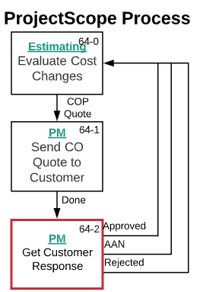

*Screen shot -* *Lucid Chart* *– Step 64-2 Get Customer Response –Project Scope Process*

### **14-0 Review SD Final Step**

Step 14-0 starts from the Project Scope tab, where you can navigate further through the process. On this tab, you can also see all the information about the process from the very beginning of the process in the collapsed Project section. The New FDD tab becomes available for viewing after the first change to the First Delivery Date. The SD Request and Submittals tabs is available for viewing. The user can learn how to work with the corresponding tabs in the section "Images and descriptions of forms," which is described above.

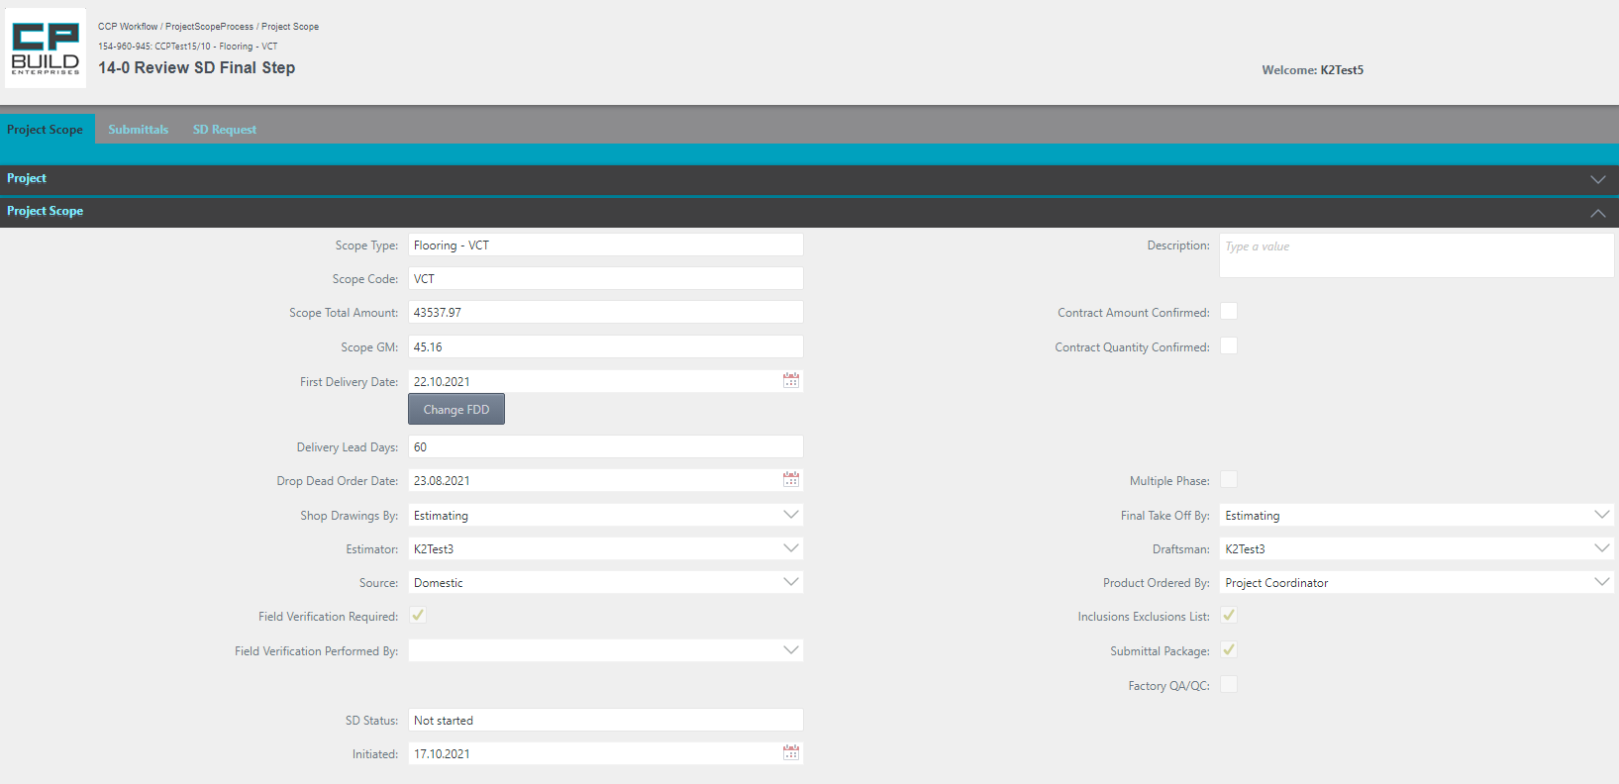

You can start the process of changing FDD. For this, use the button "Change FDD".

You can add Description, Confirmed Contract Amount and Contract Quantity

*Screen shot – PM – Step 14-0 Review SD Final –Project Scope Process*

**Action for Step 14-0 Review SD Final**

In this step, the user must:

1. You can start the process of changing FDD. For this, use the Change FDD button.
2. The User can add Description, Confirmed Contract Amount and Contract Quantity.
3. Set Action to “Approved AAN”, “Approved RAR”, “Optional AAN Meeting” or “Rework” and Click Submit.

* Action “Approved AAN,” go to the “Send SD for Customer Record” step;
* Action “Approved RAR,” returns to step “Send SD to Customer”;
* Action “Optional AAN Meeting,” go to the step “SD Final Review Meeting”;
* Action “Rework” returns to step “Upload New or Revised SD Final”.

*\*Note that the “Rework” Action requires a comment.*

* AAN actions will be available if the customer response to Shop drawings was “Approved as Noted”;
* RAR Action will be available, if the customer response to Shop drawings was “Revise and Resubmit “.

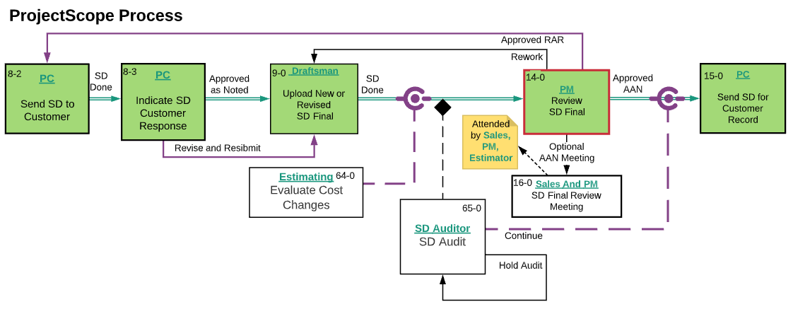

*Screen shot -* *Lucid Chart* *– Step 14-0 Review SD Final –Project Scope Process*

### **15-2 Upload Phase Plan Step**

Step 15-2 starts from the Project Scope tab, where you can navigate further through the process. On this tab you can also see all the information about the process from the very beginning of the process in the collapsed Project section. The Submittals tab is available for viewing. The user can learn how to work with the corresponding tabs in the section "Images and descriptions of forms", which is described above.

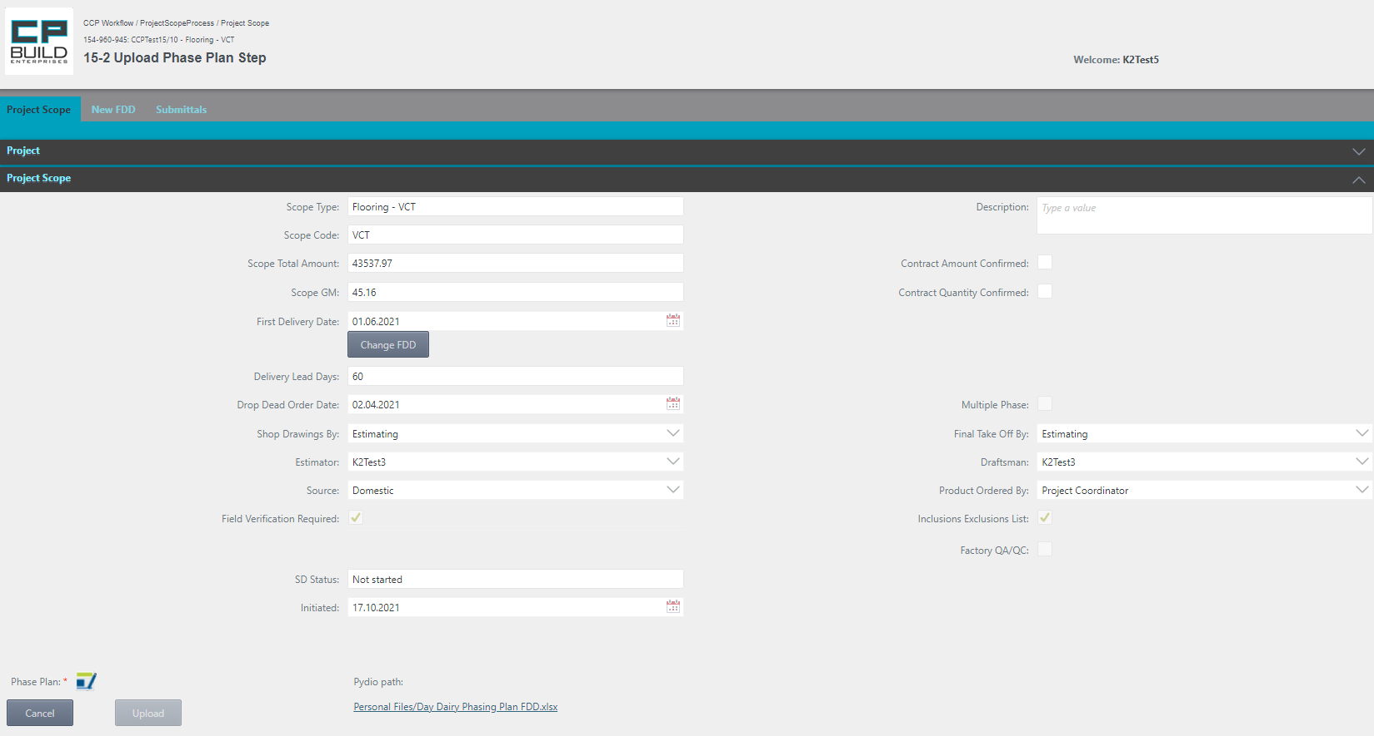

If necessary, by clicking on the icon, you can download the latest version of the document template, which must be attached to this step. After uploading the required of the file, Phase Plan will appear in the list of Attachments

If the "First Delivery Date" date does not correspond to the date specified in the uploaded document, the user will be prompted with a message. The user can then change the date value, by using the "Change FDD" button.



After the successful uploading of the document, an additional area "Project Scope Phase" will be displayed.



*Screen shot – PM –Step 15-2 Upload Phase Plan –Project Scope Process*

**Action for Step 15-2 Upload Phase Plan**

In this step, the user must:

1. Select and Upload the required “Phase Plan.” If you select the wrong document, click Cancel and try again.
2. You can start the process of changing FDD. For this purpose, use the Change FDD button.
3. You can add Description and Confirmed Contract Amount and Contract Quantity.
4. Set Action “Done” and click Submit.

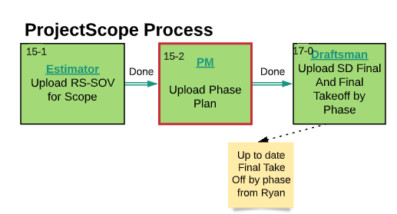

*Screen shot -* *Lucid Chart* *– Step 15-2 Upload Phase Plan –Project Scope Process*

### **16-0 SD Final Review Meeting Step**

Step 16-0 starts from the Project Scope tab, where you can navigate further through the process. On this tab, you can also see all the information about the process from the very beginning of the process in the collapsed Project section. The Submittals tabs is available for viewing. The user can learn how to work with the corresponding tabs in the section "Images and descriptions of forms," which is described above.



*Screen shot – PM – Step 16-0 SD Final Review Meeting –Project Scope Process*

**Action for Step 16-0 SD Final Review Meeting**

In this step, the user must:

1. Follow-up to the Final SD Review Meeting.
2. Set Action to “Approved”, “SD Setup Rework” or “Rework” and Click Submit.

* Action “Approved,” go to the next step “Upload Phase Plan;”
* Action “SD Setup Rework” returns to step “Update SD Request for Scope;”
* Action “Rework” returns to step “Upload New or Revised SD Final.”

*\*Note that the “Rework” Action requires a comment.*



*Screen shot -* *Lucid Chart* *– Step 16-0 SD Final Review Meeting –Project Scope Process*

### **18-1 Set Spares in Consolidated PO Setup Step**

Step 18-1 starts from the Project Scope tab, where you can navigate further through the process. In this tab, you can see all the information about the process from the very beginning of the process in the collapsed Project section. The Submittals tab is available for viewing. The user can learn how to work with the corresponding tabs in the section "Images and descriptions of forms", which is described above.

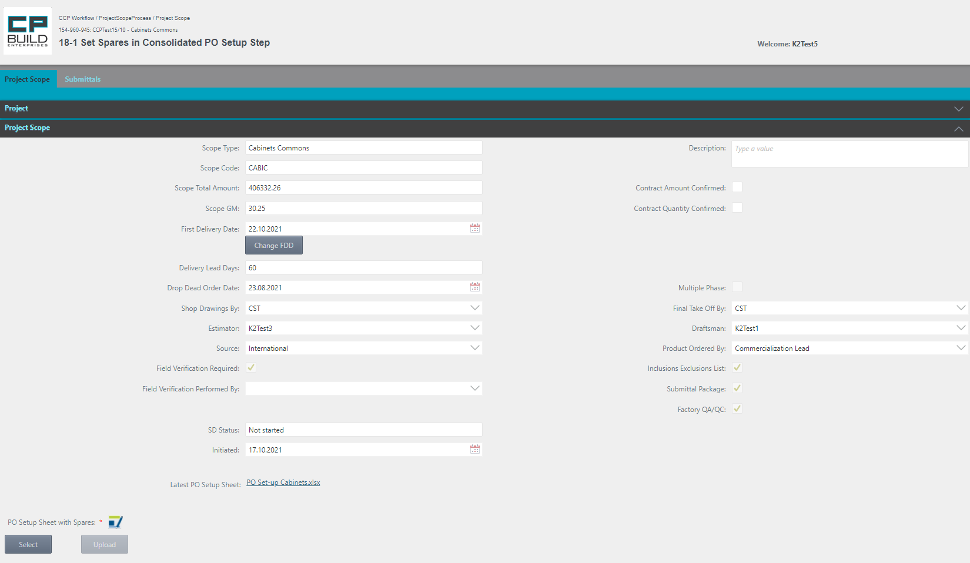

If necessary, by clicking on the icon, you can download the latest version of the document template, which must be attached to this step. After uploading the required of the file, PO Setup Sheet with Spares will appear in the list of Attachments

You can start the process of changing FDD, For this, use the button "Change FDD".

You can add Description, Confirmed Contract Amount and Contract Quantity

*Screen shot – PM –Step 18-1 Set Spares in Consolidated PO Setup –Project Scope Process*

**Action for Step 18-1 Set Spares in Consolidated PO Setup**

In this step, the user must:

1. Download the Consolidated PO Setup Sheet and add spares. (e.g., Spare Cabinets).
2. Select and Upload "PO Setup Sheet with Spares." If you Select wrong document, click Cancel and try again.
3. You can start the process of changing FDD. For this, use the Change FDD button.
4. User can add Description and Confirmed Contract Amount, Contract Quantity.
5. Set Action “Done” and click Submit.

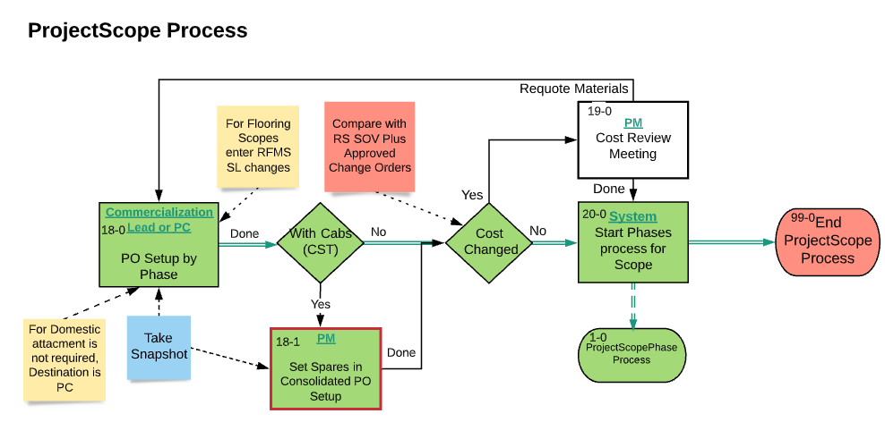

*Screen shot -* *Lucid Chart* *– Step 18-1 Set Spares in Consolidated PO Setup–Project Scope Process*

### **19-0 Cost Review Meeting Step**

Step 19-0 starts from the Project Scope tab, where you can navigate further through the process. On this tab, you can see all the information about the process from the very beginning of the process in the collapsed Project section. The Submittals tabs is available for viewing. The user can learn how to work with the corresponding tabs in the section "Images and descriptions of forms," which is described above.

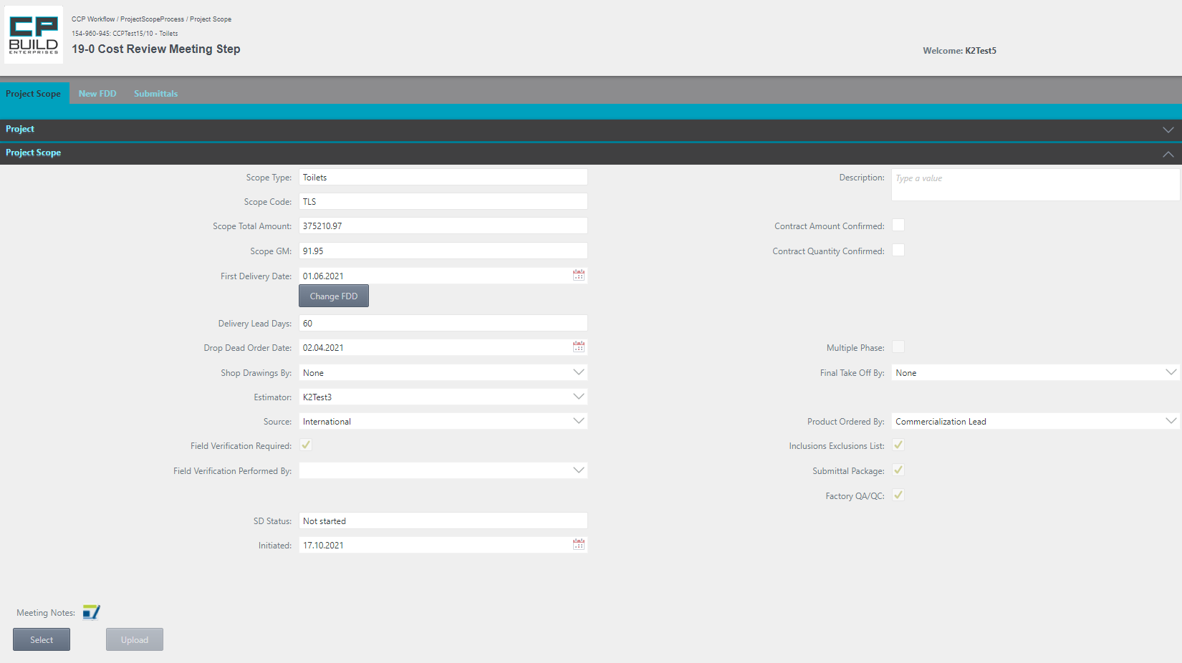

If necessary, by clicking on the icon, you can download the latest version of the document template, which must be attached to this step. After uploading the required file, Meeting Notes will appear in the list of Attachments.

You can start the process of changing FDD. For this, use the button "Change FDD".

You can add Description, Confirmed Contract Amount and Contract Quantity

*Screen shot – PM –Step 19-0 Cost Review Meeting–Project Scope Process*

**Action for Step 19-0 Cost Review Meeting**

In this step, the user must:

1. After Meeting Cost Review, the PM can select and upload meeting notes. If the PM selected the wrong document, they can click Cancel and try again.
2. You can start the process of changing FDD. For this, use the Change FDD button.
3. You can add Description and Confirmed Contract Amount, Contract Quantity.
4. Set Action to “Done” or “Requote Materials” and Click Submit.

* The “Done” action will proceed to the step “Start Phases process for Scope”;
* Action “Requote Materials” returns to step “Submit Consolidated PO Setup”.

*\*Note that the “Requote Materials” Action requires a comment.*

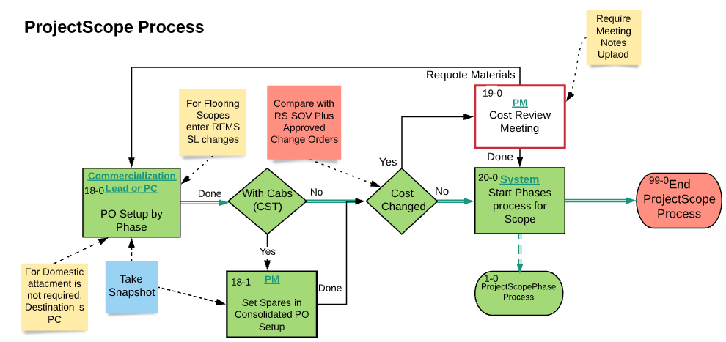

*Screen shot -* *Lucid Chart* *– Step 19-0 Cost Review Meeting –Project Scope Process*

### PC

### **82-0 Start or Update Procore Submittals Step**

Step 82-0 starts from the Project Scope tab, where you can navigate further through the process. On this tab, you can also see all the information about the process from the very beginning of the process in the collapsed Project section. The Submittals tab becomes available for work. The user can learn how to work with the corresponding tabs in the section "Images and descriptions of forms", which is described above.

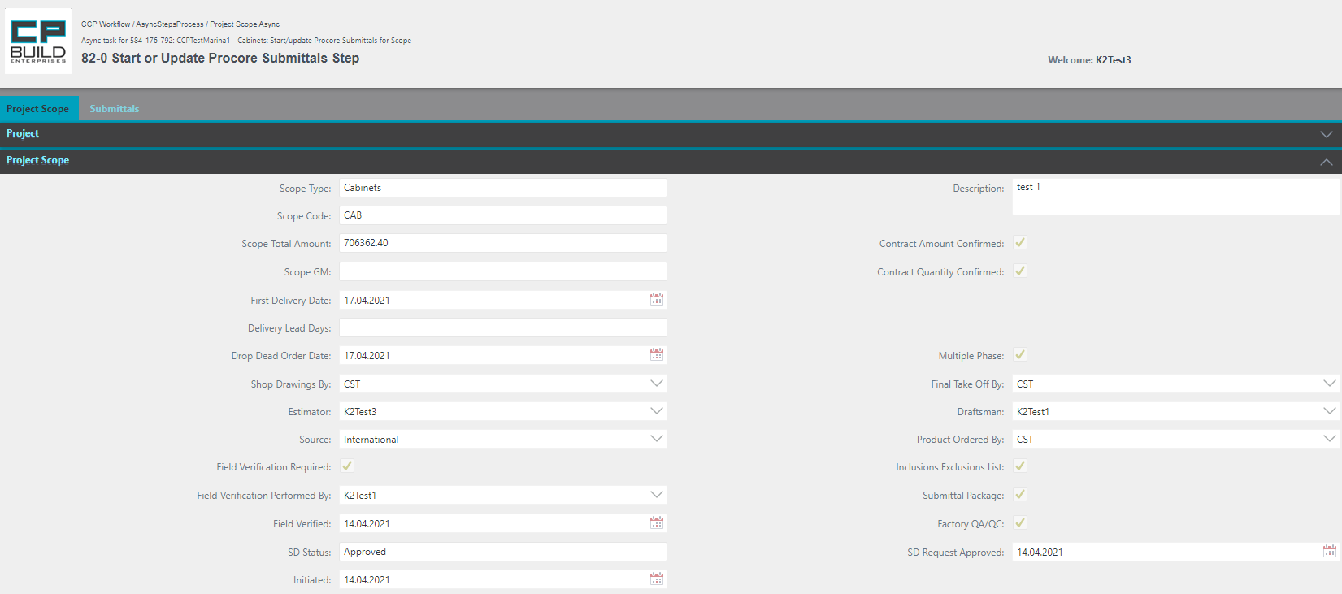

*Screen shot – PC – Step 82-0 Start or Update Procore Submittals –Project Scope Process*

**Action for Step 82-0 Start or Update Procore Submittals**

In this step, the user must:

1. Use Submittals Tab, Start or Update Procore Submittals for Scope.
2. Go to Project Scope Tab, Set Action to “Done” and click Submit.

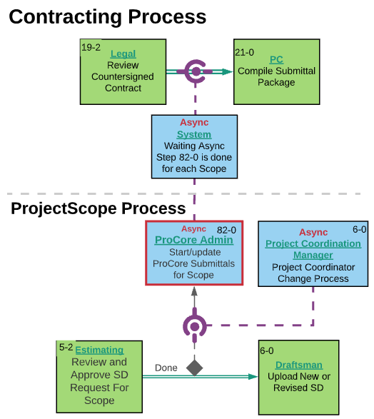

*Screen shot -* *Lucid Chart* *– Step 82-0 Start or Update Procore Submittals –Project Scope Process*

### **8-2 Send SD to Customer Step**

Step 8-2 starts from the Project Scope tab, where you can navigate further through the process. On this tab, you can see all the information about the process from the very beginning of the process in the collapsed Project section. The Submittals tab is available for viewing. The user can learn how to work with the corresponding tabs in the section "Images and descriptions of forms", which is described above.

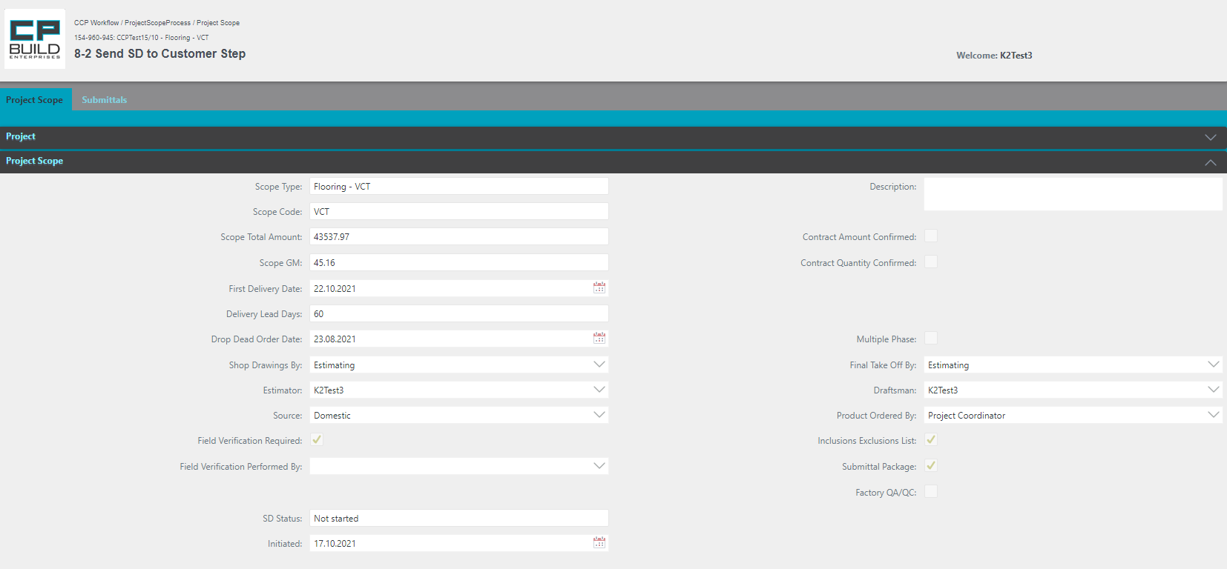

*Screen shot – PC – Step 8-2 Send SD to Customer –Project Scope Process*

**Action for Step 8-2 Send SD to Customer**

In this step, the user must:

1. After Sending the Shop Drawings to the Customer, set Action “Done” and click Submit.

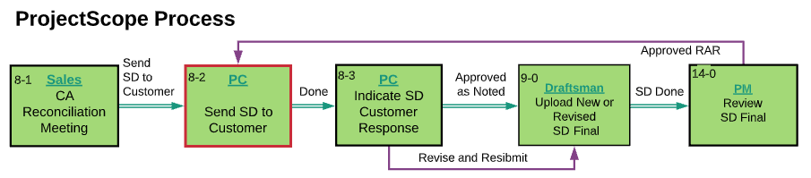

*Screen shot -* *Lucid Chart* *– Step 8-2 Send SD to Customer –Project Scope Process*

### **8-3 Indicate SD Customer Response Step**

Step 8-3 starts from the Project Scope tab, where you can navigate further through the process. On this tab, you can also see all the information about the process from the very beginning of the process in the collapsed Project section. The Submittals tab is available for viewing. The user can learn how to work with the corresponding tabs in the section "Images and descriptions of forms", which is described above.

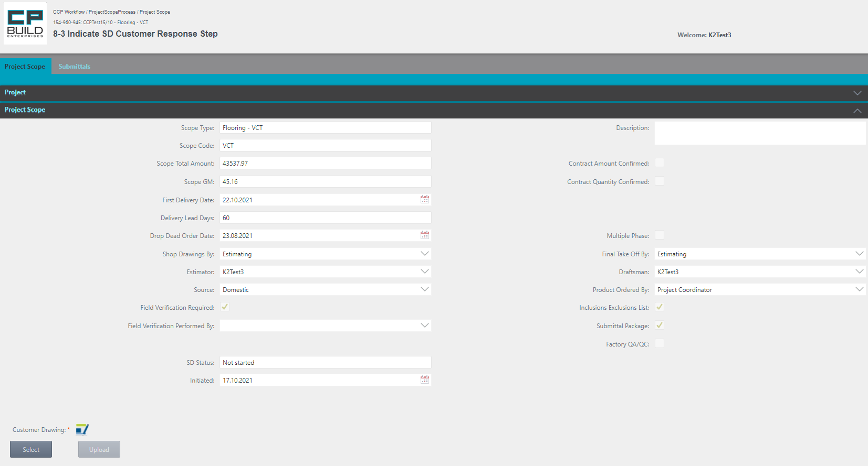

If necessary, by clicking on the icon, you can download the latest version of the document template, which must be attached to this step. After uploading the required file, Customer Drawing will appear in the list of Attachments.

*Screen shot – PC – Step 8-3 Indicate SD Customer Response –Project Scope Process*

**Action for Step 8-3 Indicate SD Customer Response**

In this step, the user must:

1. Select and upload the “Customer Drawing” and indicate customer response. If you select the wrong document, click Cancel and try again.
2. Set Action “Approved”, “Approved as Noted” or “Revise and Resubmit” and click Submit.

* The “Approved “action will proceed to the step “Upload RS-SOV for Scope”;
* The “Approved as Noted” or “Revise and Resubmit” action will proceed to the step “Upload New or Revised SD Final.”

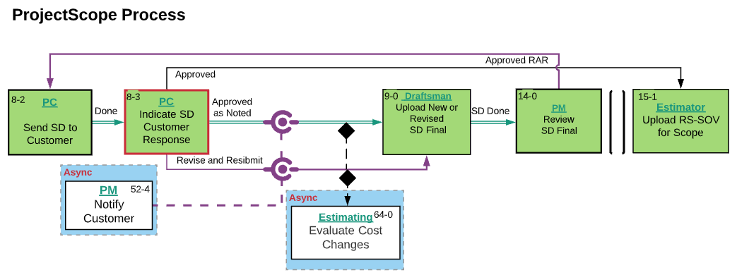

*Screen shot -* *Lucid Chart* *– Step 8-3 Indicate SD Customer Response –Project Scope Process*

### **15-0 Send SD for Customer Record Step**

Step 15-0 starts from the Project Scope tab, where you can navigate further through the process. On this tab, you can also see all the information about the process from the very beginning of the process in the collapsed Project section. The Submittals tabs are available for viewing. The user can learn how to work with the corresponding tabs in the section "Images and descriptions of forms", which is described above.

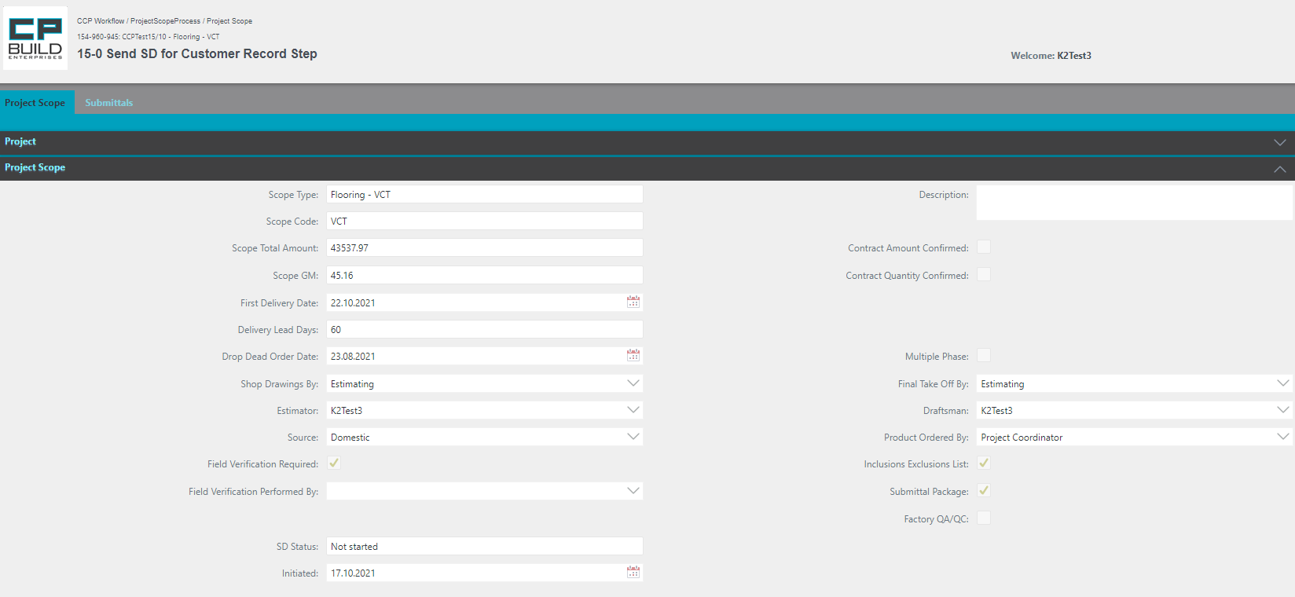

*Screen shot – PC – Step 15-0 Send SD for Customer Record –Project Scope Process*

**Action for Step 15-0 Send SD for Customer Record**

In this step, the user must:

1. Send SD for Customer Record.
2. User can add Description and Confirmed Contract Amount, Contract Quantity.
3. Set Action “Done” and click Submit.

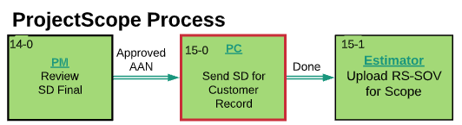

*Screen shot -* *Lucid Chart* *– Step 15-0 Send SD for Customer Record –Project Scope Process*

### **18-0 PO Setup by Phase Step**

Step 18-0 starts from the Project Scope tab, where you can navigate further through the process. On this tab, you can also see all the information about the process from the very beginning of the process in the collapsed Project section. The Submittals tab is available for viewing. The user can learn how to work with the corresponding tabs in the section "Images and descriptions of forms", which is described above.

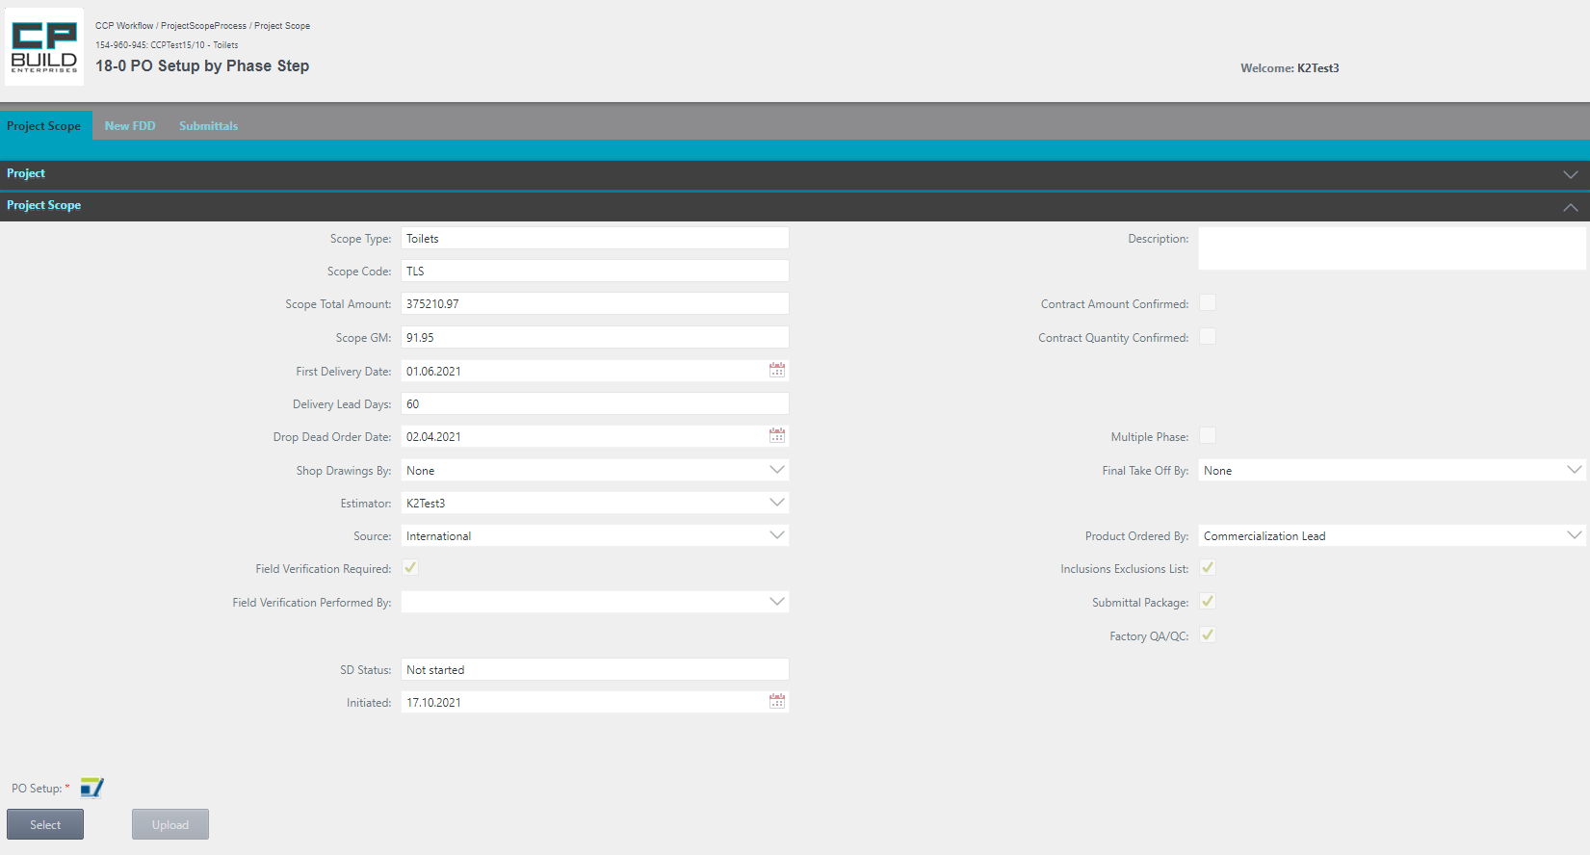

If necessary, by clicking on the icon, you can download the latest version of the document template, which must be attached to this step. After uploading the required file, PO Setup will appear in the list of Attachments.

*Screen shot - PC – Step 18-0 PO Setup by Phase –Project Scope Process*

**Action for Step 18-0 PO Setup by Phase**

At this step, user need:

1. Select and Upload “PO Setup.” If you select the wrong document, click Cancel and try again. For Domestic Update PO Setup by Phasing Plan.
2. Set Action “Done” and click Submit.

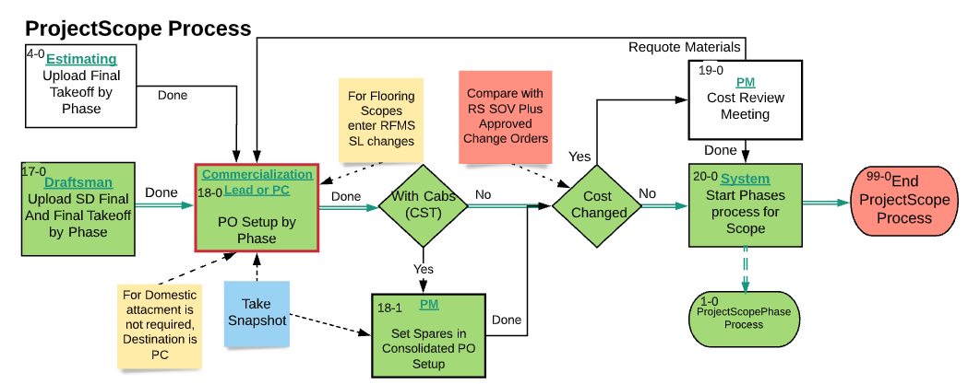

*Screen shot -* *Lucid Chart* *– Step 18-0 PO Setup by Phase –Project Scope Process*

### Installation Supervisor

### **52-2 Field Verification Step**

Step 52-2 starts from the Project Scope tab, where you can navigate further through the process. On this tab, you can see all the information about the process from the very beginning of the process in the collapsed Project section. The user can learn how to work with the corresponding tabs in the section "Images and descriptions of forms", which is described above.

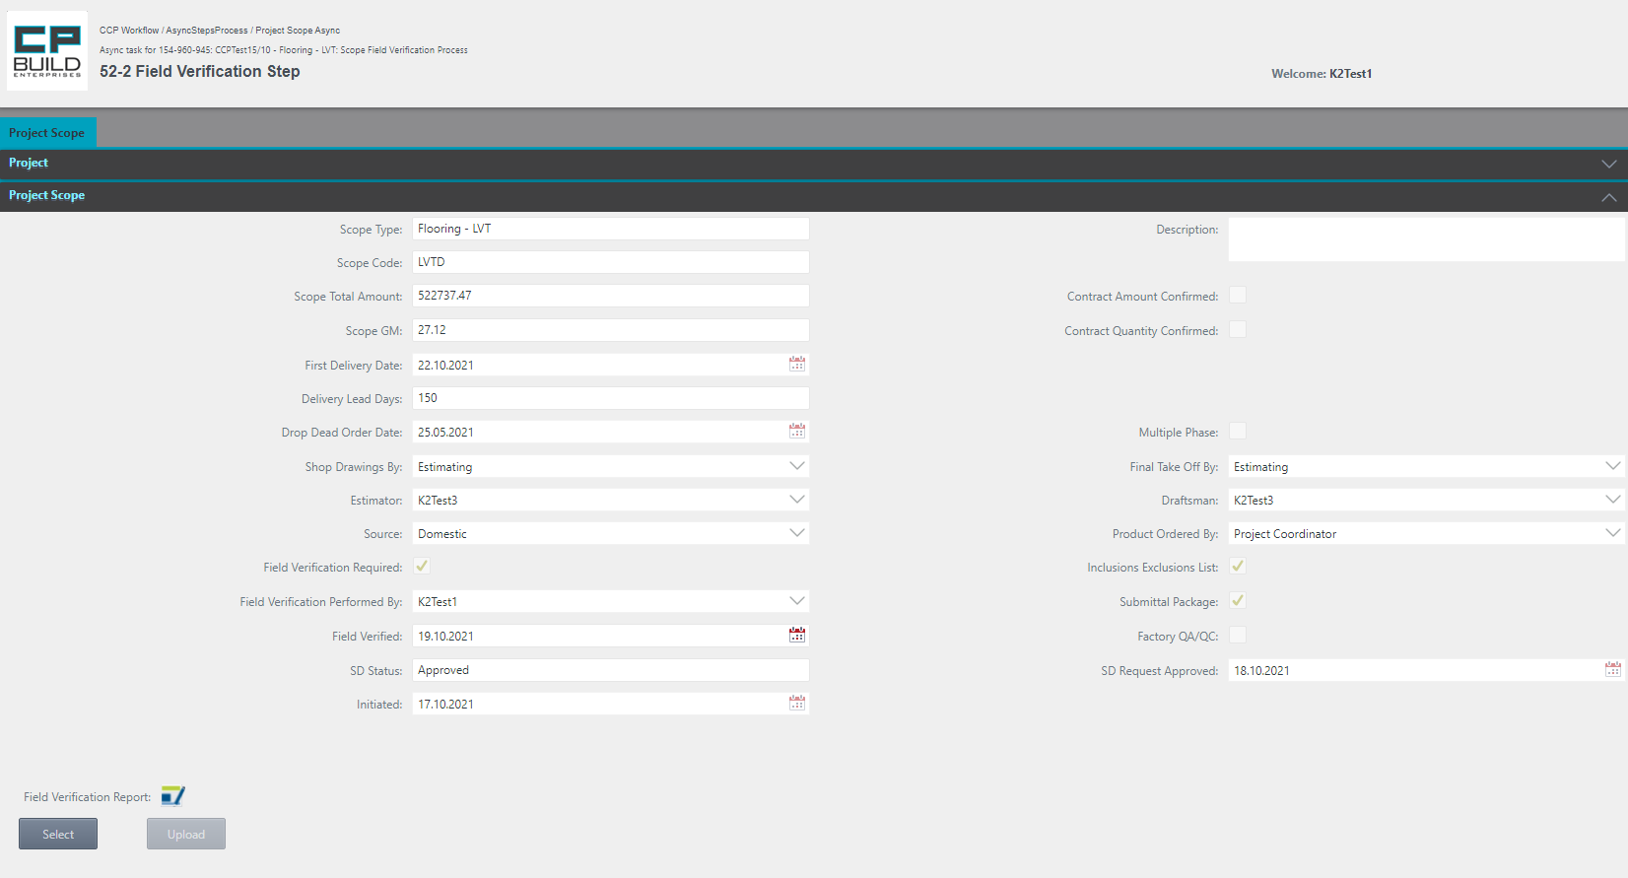

If necessary, by clicking on the icon, you can download the latest version of the document template, which must be attached to this step. After uploading the required file, Field Verification Report will appear in the list of Attachments.

Set Field Verified date if necessary

*Screen shot - Installation Supervisor – Step 52-2 Field Verification – Project Scope Process*

**Action for Step 52-2 Field Verification**

In this step, the user must:

1. Set Field Verified date, if necessary.
2. Select and Upload, if necessary, the "Field Verification Report." If you select the wrong document, click Cancel and try again.
3. Set Action “Done” and click Submit.

* The Action **"Done"** takes the process to the next step.

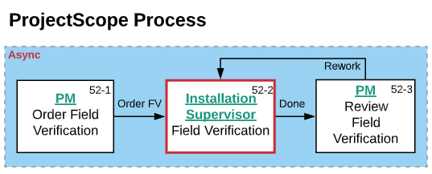

*Screen shot –* *Lucid Chart* *– Step 52-2 Field Verification – Project Scope Process*

### SD Auditor

### **65-0 SD Audit Step**

Step 65-0 starts from the Project Scope tab, where you can navigate further through the process. On this tab, you can also see all the information about the process from the very beginning of the process in the collapsed Project section. The Submittals tab is available for viewing. The user can learn how to work with the corresponding tabs in the section "Images and descriptions of forms", which is described above.

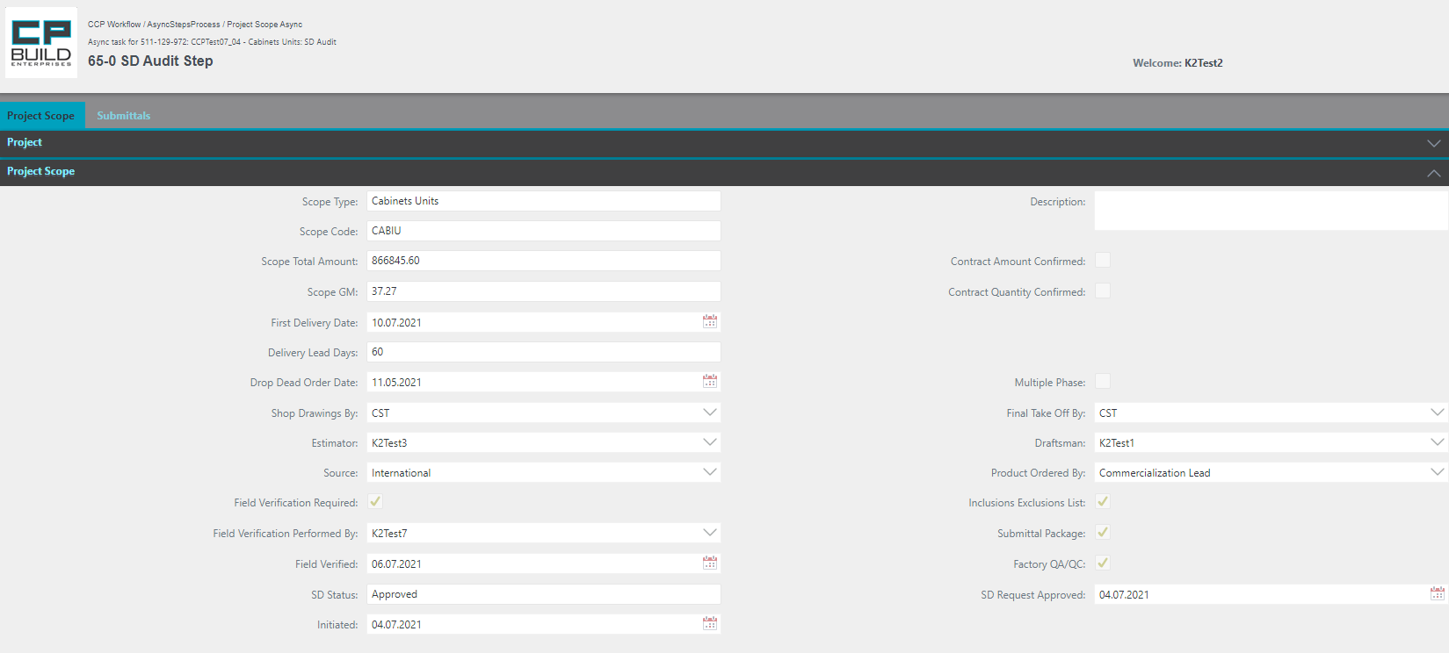

*Screen shot - SD Auditor – Step 65-0 SD Audit –Project Scope Process*

**Action for Step 65-0 SD Audit**

In this step, the user must:

1. SD Audit
2. Set Action “Continue” or “Hold for Audit” and click Submit.

* The “Hold for Audit” action loops back to the same step
* The "Continue" action takes the process to the next step "Send SD for Customer Record."

*\*Note that the “Hold for Audit” Action requires a comment.*

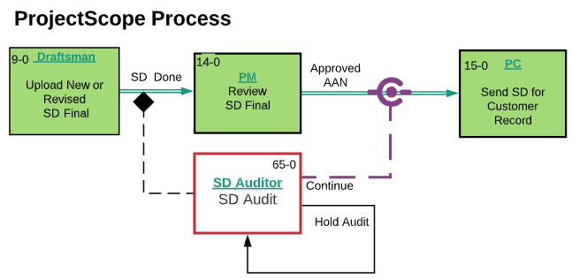

*Screen shot -* *Lucid Chart* *– Step 65-0 SD Audit –Project Scope Process*

### Commercialization Lead

### **18-0 PO Setup by Phase Step**

Step 18-0 starts from the Project Scope tab, where you can navigate further through the process. On this tab, you can also see all the information about the process from the very beginning of the process in the collapsed Project section. The Submittals tab is available for viewing. The user can learn how to work with the corresponding tabs in the section "Images and descriptions of forms", which is described above.



If necessary, by clicking on the icon, you can download the latest version of the document template, which must be attached to this step. After uploading the required file, PO Setup will appear in the list of Attachments.

*Screen shot - Commercialization Lead – Step 18-0 PO Setup by Phase –Project Scope Process*

**Action for Step 18-0 PO Setup by Phase**

In this step, the user must:

1. Select and Upload “PO Setup.” If you select the wrong document, click Cancel and try again. For Domestic Update PO Setup by Phasing Plan.
2. Set Action “Done” and click Submit.



*Screen shot -* *Lucid Chart* *– Step 18-0 PO Setup by Phase –Project Scope Process*

# Project Scope Process General Schema

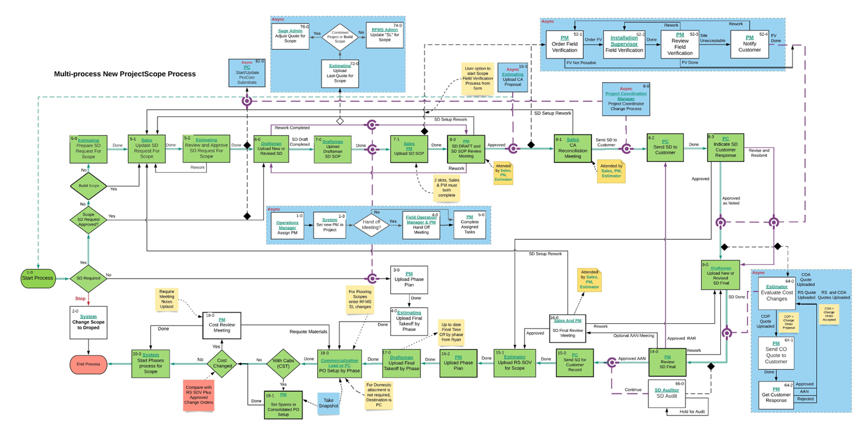

# Designations on the diagram

 The project will not proceed to the next step, until the asynchronous step is closed.



Indicates the transition of the project to the next stage.



Means that after the step, an asynchronous step will be launched. This will block the further progress of the project.

Asynchronous steps section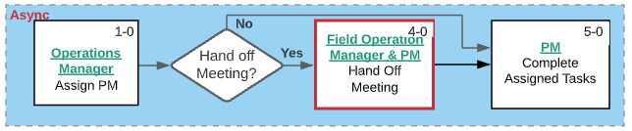;

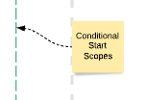

Note;

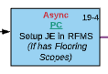 Shows the asynchronous step of the main process, where the recipient's role and step name are spelled out.

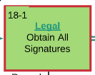 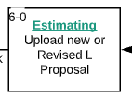Shows the step of the main process, where the role of the recipient and the name of the step are registered. The red frame shows which step you are in.

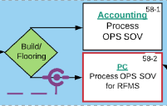

Decision under which the task can follow one of the paths.

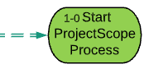

Start Process

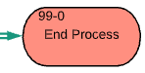

End Process